***ST. ANTHONY***

***NURSERY AND***

***PRIMARY***

***SCHOOLS- KAJJANSI***

***PRIMARY THREE***

***MATHEMATICS***

***LESSON NOTES***

***TEACHER’S NAME: …………………………………………………………..***

***CLASS: ………………………………………………………………………….***

***STREAM: …………………………………… YEAR: ……………………….***

***TABLE OF CONTENT***

|  |  |  |
| --- | --- | --- |
| ***NO*** | ***TOPIC/ THEME*** | ***PAGE*** |
| ***TERM ONE.*** | | |
| ***1*** | ***TOPICAL BREAK DOWN FOR SETS*** | ***3-4*** |
| ***2*** | ***SETS*** | ***5-33*** |
| ***3*** | ***NUMERATION SYSTEM AND PLACE VALUES (BREAK DOWN)*** | ***33- 34*** |
| ***4*** | ***NUMERATION SYSTEM AND PLACE VALUES.*** | ***34-49*** |
| ***5*** | ***ROMAN NUMERALS.*** | ***50-54*** |
| ***6*** | ***OPERATION ON WHOLE NUMBERS.*** | ***55-91*** |
| ***7*** | ***NUMBER PATTERNS AND SEQUENCE.*** | ***92-99*** |
| ***8*** | ***COMPLETING DIAGRAMS BY FILLING IN MISSING NUMBERS*** | ***99-102*** |
| ***9*** | ***MAGIC SQUARE*** | ***103-105*** |
| ***TERM TWO*** | | |
| ***10*** | ***FRACTIONS*** | ***106-119*** |
| ***11*** | ***GRAPHS AND INTERPRETATION OF INFORMATION*** | ***120-124*** |
| ***12*** | ***GEOMETRY*** | ***125-129*** |
| ***13*** | ***TIME*** | ***130-150*** |
| ***14*** | ***MONEY*** | ***151-159*** |
| ***15*** | ***SHOPPING*** | ***160-161*** |
| ***TERM THREE*** | | |
| ***16*** | ***LENGTH*** | ***162-167*** |
| ***17*** | ***PERIMETER AND AREA*** | ***168-176*** |
| ***18*** | ***CAPACITY*** | ***177-186*** |
| ***19*** | ***MASS*** | ***187-195*** |
| ***20*** | ***ALGEBRA*** | ***196-212*** |
| ***21*** | ***CORRECTIONS AND FINDINGS.*** | ***213*** |

**TERM ONE**

**THEME: SETS**

**TOPIC: SET CONCEPTS**

Definition

Naming sets

Drawing sets

Counting members in a set

Grouping members of a set-in twos

Grouping members of a set-in threes

Grouping members of a set-in fives

Grouping members of a set-in tens

More on grouping of members in a set

Comparing sets using more or less

Set symbols

Equal sets

Matching/ equivalent sets

Non matching sets

Empty sets

Listing members of a set

Union of sets

Intersection offsets

Venn diagrams (definition)

Putting members of sets on a Venn diagram

Finding number of members using the symbol “n”

**THEME: SETS**

**SET CONCEPTS**

What is a set?

A set is a collection of well-defined members.

**NAMING SETS**

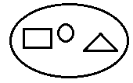 **Examples**

1.

A set of 3 shapes

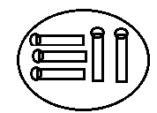

2. A set of 5 match sticks

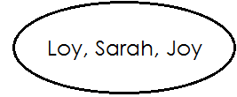

3. A set of 3 names

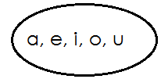**Activity**

1. ______________________________________

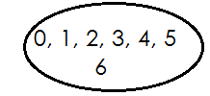

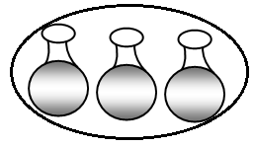2. ______________________________________

3. _______________________________________

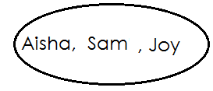

4. _____________________________________

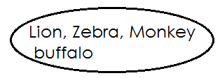

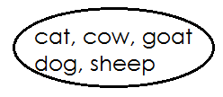5. _________________________________

6. ______________________________

**DRAWING SETS**

**Examples**

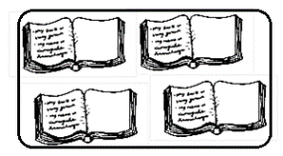1. Draw a set 4 books

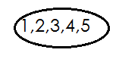2. Draw a set the first 5 counting numbers

**Activity**

**Draw the sets below**.

1. A set of the first 5 letters of alphabets.

2. A set of 4 trees.

3. A set of 6 balls.

4. A set of 2 cars

5. A set of 3 dolls

6. A set of 6 names

7. A set of 3 birds

8. A set of 4 shapes.

**COUNTING MEMBERS IN A SET**

**Examples**

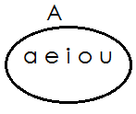

1.

How many members are in set A?

Set A has 5 members

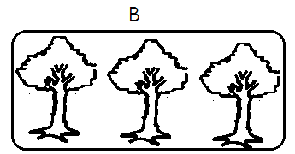2.

How many members are in set B?

There are 3 members in set B

**Activity**

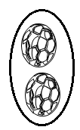 Count the number of members in the sets below

1.

**__________________________________________**

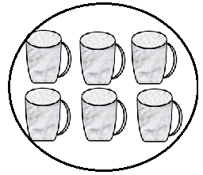

2. _____________________________________

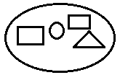

___________________________________

3.

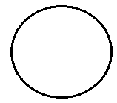

_____________________________________

4.

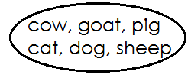

5.  **________________________________**



**________________________________**

6.

**GROUPING MEMBERS OF A SET**

(a) Grouping members of a set-in twos.

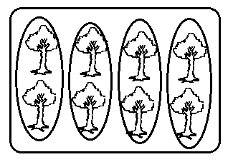 **Examples**

1.

There are **4** groups of **2** trees.

There are **8** trees altogether.

**Activity**

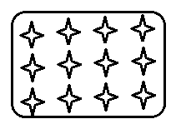Count and pair the members in the sets.

1.

There are _____________ groups of 2 stars.

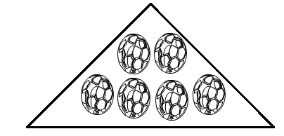There are _____________ stars altogether.

2.

There are ________ groups of 2 balls.

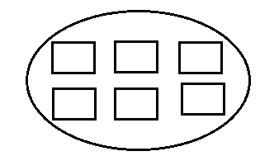There are__________ balls altogether

3.

There are _____________groups of 2 squares

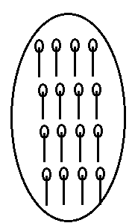There are___________ squares altogether.

4.

There are________ groups of 2 match sticks.

There are_________ match sticks altogether.

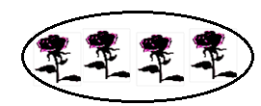5.

There are _____groups of 2 trees.

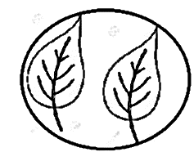There are___________ trees altogether.

6.

There are ____________groups of 2 leaves.

There are _____________ leaves altogether.

B. **GROUPING MEMBERS OF A SET IN THREES**

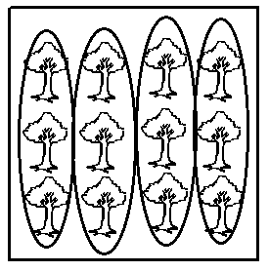 **Examples**

There are ______________groups of 3 trees.

There are ____________trees altogether.

**Activity**

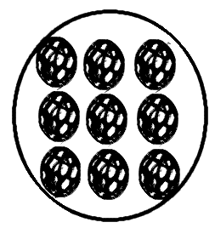**Count and group members in threes.**

1.

There are _____________groups of 3 balls.

There are______________ balls altogether.

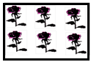

2. There are _____________groups of 3 trees.

There are_____________ trees altogether.

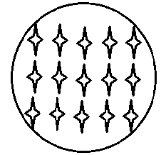

3. There are______________ groups of 3 stars.

There are________________ stars altogether

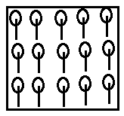4. There are___________ groups of_________ match sticks.

There are ____________matchsticks altogether.

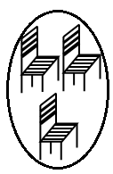

5. There are ______________groups of _________chairs.

There are ___________ chairs altogether.

C. **GROUPING MEMBERS OF A SET IN FIVES**

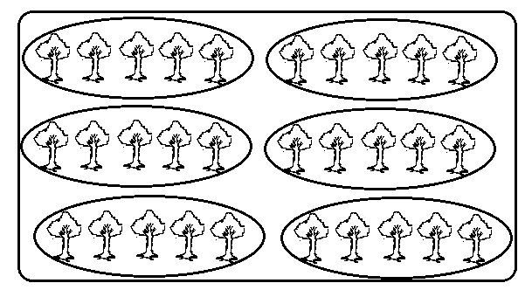 **Examples**

1.

There are **6** groups of **5** matchsticks.

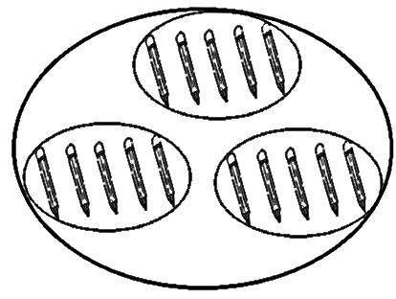There are 30 matchsticks altogether.

2.

There are **3** groups of **5** pencils.

There are **15** pencils altogether.

**Activity**

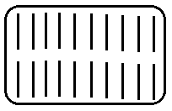1. Count and group members

There are ________________groups of 5 sticks.

There are____________ sticks altogether.

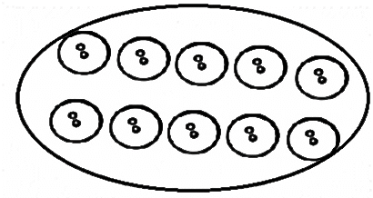

2. There are ___________group of 5 buttons.

There are________ buttons altogether.

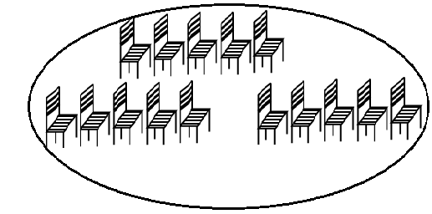3. There are __________group of 5 chairs.

There are __________ chairs altogether.

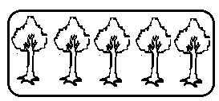

4. There are_______ groups of 5 trees.

There are _____ trees altogether.

**MORE ON GROUPING MEMBERS IN A SET.**

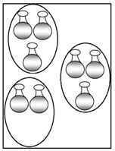 **Example**

1.

= **8** groups of______ pots.

=_________pots.

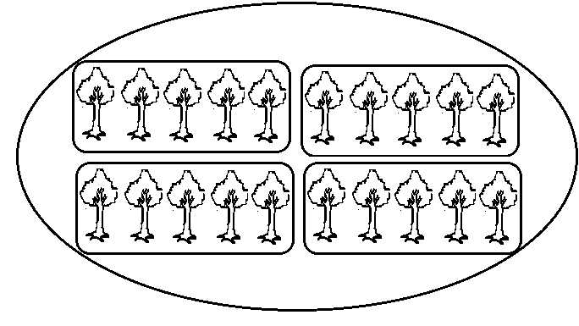

=________groups of______ trees.

2.

=_________cups.

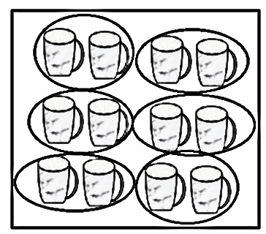

3.

=_______groups of______ apples.

=______apples

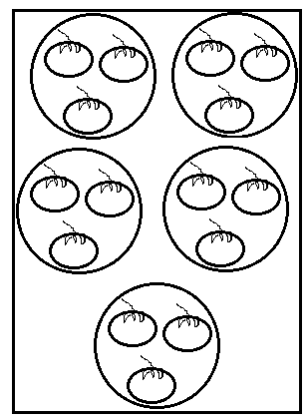

4. =___________groups of __________apples.

=___________apples.

**COMPARING SETS USING “MORE” OR “LESS”**

**Compare the sets below**

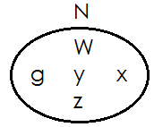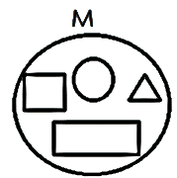**Examples**

1.

Set **M** has **4** members.

Set **N** has **5** members.

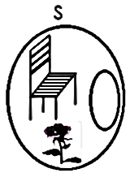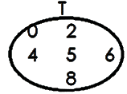Set **N** has more members than set **M**.

2.

Set **T** has **6** members.

Set **S** has **3** members.

Set **S** has less members than set **T**

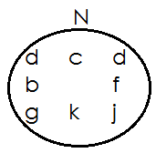 **Activity**

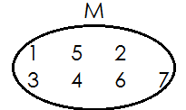1.

1. How many members has set **M**?
2. How many members has set **N**?
3. 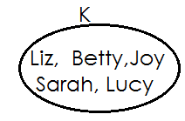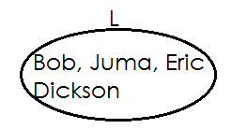Which set has more members?

2.

1. How many members are there in set **K**?
2. How many members are there in set **L**?
3. Which set has more members?

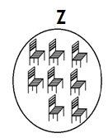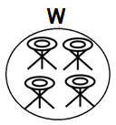3.

(a) How many members has set **Z**?

(b) How many members has set **W**?

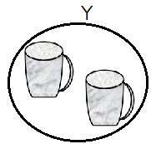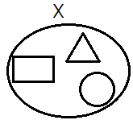(c) Which set has less members?

4.

1. How many members has set **Y**?
2. How many members has set **X**?
3. Which set has less members?

5. **Q={0,2,4,6,8} R= {1,3,5,7,9,11,13}**

(a) How many members has set **R**?

(b) How many members has set **Q**?

(c) Which set has more members?

**TYPES OF SETS**

**Set symbols**

1. Universal set **Σ**

2. Equal sets

3. Non equal sets

4. Equivalent sets or

5. Non-equivalent sets or

6. Empty set

7. Union of sets

 8. Intersection of sets

9. Matching sets or

10. Non-matching sets or

11. Is a member of **Σ**

12. Number of members of n ( )

13. Is not a member of

**EQUAL SETS**

What are equal sets?

 Equal sets are set with the same number and same members

 The set symbol for equal sets is “ ”

The set symbol for non-equal sets is “ ”

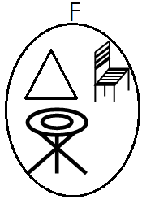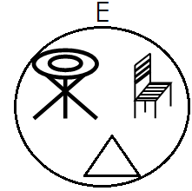 **Examples of equal sets**

1.

Set **E** and set **F** have the same type and number of members

Therefore set **E** and set **F** are equal sets

2. Set A= **{0, 2, 4, 6}** and set B= **{6, 0, 4, 2}**

**Solution**

Set **A** and set **B** have the same type and number of members.

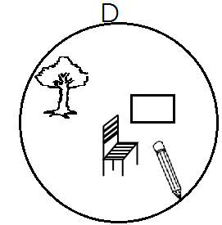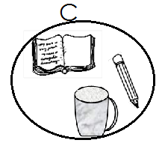 Therefore set **A** is equal to set **B**

3.

Set **C** and set **D** do not have the same type and number of members.

Therefore set **C** is not equal to set **D**

**Activity**

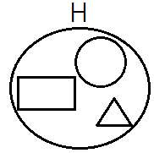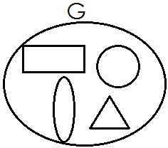Use “**equal**” or “**not equal**”

1.

Set **G** is_____________________ to set H

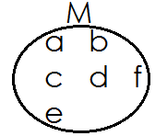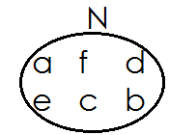2.

Set **M** is _________________to set **N**

3. X={**5,3,7,8,9}** and V**={1,3,5,7,8,9**}

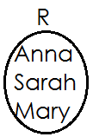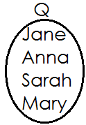 Set **X** is __________________to set **V**

4.

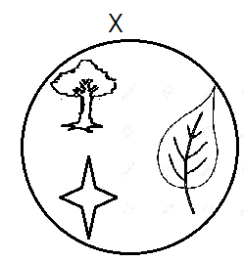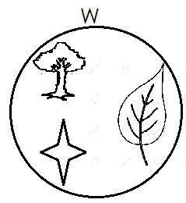 Set **Q** is _________________to set **R**

5.

Set W is ___________________to set X

6. Set S= {3, 5, 7} and T= {5, 7, 3}

Set S is _____________________to set T

**Activity two**

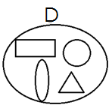 Use or to complete

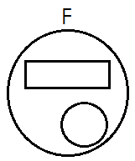1.

Set **D** is_______________ to set **F**

2. **F**= {1, 3, 5, 6, 9} and **Q=** {1, 5, 9}

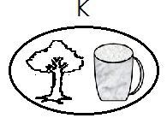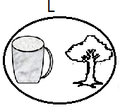 Set **F** is ___________ to set **Q**

3.

Set **K** is_________________ to set **L**

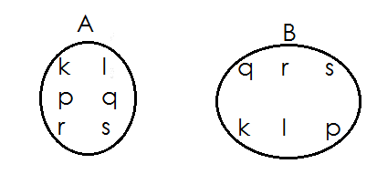

4.

Set **A** is ___________ to set **B**

5. **E**= {**a, b, c, d, e,}** and set **D**= {**b, e, d, a, c**}

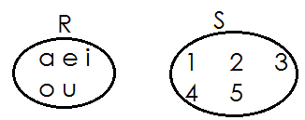 Set **E** is ____________ to set **D**

6.

Set **R** is ____________ to set **S**

**MORE ON EQUAL SETS**

Filing in missing member to make the paired sets equal.

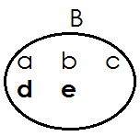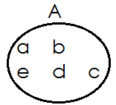 **Examples**

Set **A** and set **B** are now equal.

**Activity**

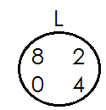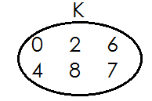 **Make the paired sets equal.**

1.

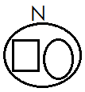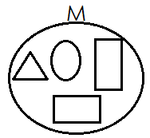

2.

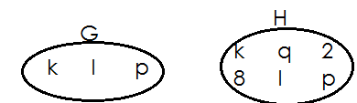

3.

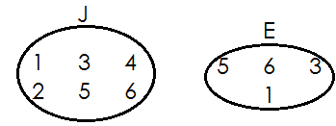4.

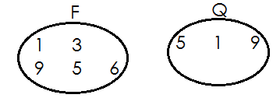

5.

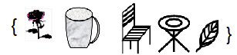

6. A= and B=

**EQUIVALENT SETS**

What are equivalent sets?

Equivalent sets are sets which have the same number of members but maybe of different kind. The symbol for equivalent sets is or or

**Examples of equivalent sets**

1. Set A= {a, d, g, h} and set B= {Annie, Deo, Asha, Ali}

**Solution**

Set A has 4 members and set B has 4 members.

Therefore, set A and set B are equivalent sets.

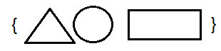

2. Set **P**= and set **Q**=

Set P has **3** members and set **Q** has **3** members.

Therefore, set P is equivalent to set **Q**.

**NON-EQUIVALENT SETS**

 Non-equivalent sets are sets which do not have the same number of members.

**The symbol for non-equivalent sets is** or

**Examples of nonequivalent sets.**

1. Set **A**= {**1, 2, 3, 4**,} and set B = {**a, b, c**}

Set **A**= has **4** members and set B has 3 members

Therefore, set **A** and set **B** Aare non-equivalent sets.

**Or**

Set **A** is not equivalent to set **B**.

**Activity one**

**Use equivalent or not equivalent.**

1. **A**= {**a, b, c**} and **B= {1, 2, 3}**

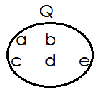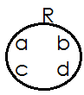 Set **A** is_______________ to set **B**

2.

Set **Q** is_______________ to set **R**

3. Set V= {Anna, Mary, John} and set **X**=

Set **V** is_______________ to set **X**

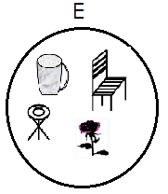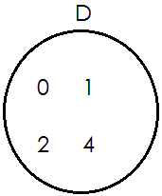

4.

Set **D** is ____________ to set **E**

5. **P**= {**Anna, Mary, Sarah, Joy**} **Q**= {**Anna, Mary, Joy**}

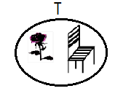 Set **P** is ____________ to set **Q**

6.

Set **T** is ____________ to set **U**

**Activity two**

Use or

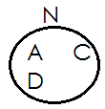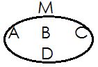

1.

Set **M** is ______________ to set **N**

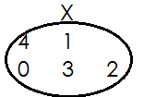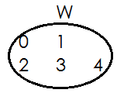

2.

Set **M** is ______________ to set **N**

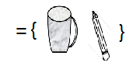

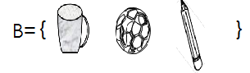3. and C=

**B**______________**C**



4. and

Z_______________Y

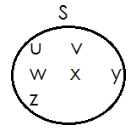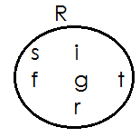

5.

Set **R**_______________ set **S**

6. Set H= {1, 2, 3, 4} and set G=(a, b, c)

H_________________G

**MATCHING AND NON-MATCHING SETS**

 Matching sets are sets with the same number of members.

The symbol for matching set is or

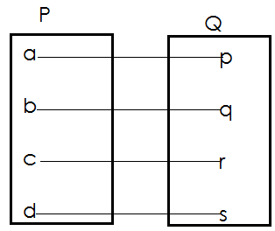 Examples of matching sets

1.

Set **P** has **4** members.

Set **Q** has **4** members.

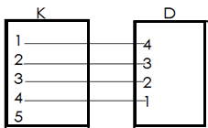Set **P** and set **Q** are matching sets.

2.

Set **K** has **5** members.

Set **D** has **4** members

Set **K** has and d are non-matching sets.

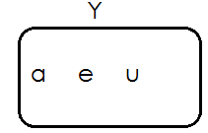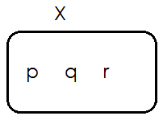 **Activity**

Set **X** has ______________members.

Set **Y** has _____________members.

Set **X** and set y are ___________ sets.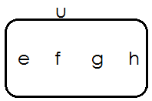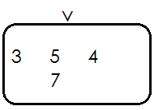

2.

Set **U** has ______________members.

Set **V** has _____________members.

Set **U** and set **V** are ________________sets.

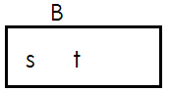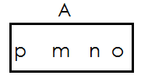3.

Set **U** has ______________members.

Set **V** has _____________members.

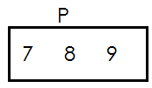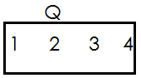Set **A** and set B are _____________ sets.

4.

Set **Q** has ______________members.

Set **P** has _____________members.

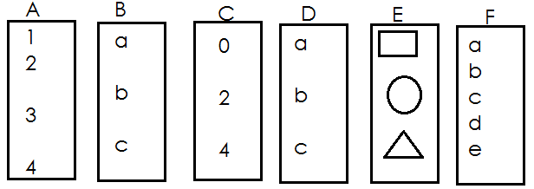Set **Q** and set **P** are_________________ members.

5.

1. set **A** and set **B** are_____________
2. set **A** and set **C** are______________
3. set **A** and set **D** are______________
4. set **C** and set **D** are_______________
5. set **B** and set **D** are_______________
6. set **C** and set **E** are_______________
7. set **A** and set **F** are________________

**EMPTY SETS**

What is an empty set?

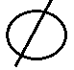An empty set is a set without members. Another name for empty set is null set.

The symbol for empty set is

**Examples of empty sets**

1. Set **K** (pupils in p.3 with 10 legs each)

Set **K** = { } or

2. Set **R** = {our teacher who are less than 3 years of age}

Set **R = { }**

**Activity**

1. Set **X**= (boys in p.3 class with 3 eyes each)

List all members of set x

_____________________________________________________

2. Set **M**= {girls in P.3 who are 90 years old}

List all members of set M.

_________________________________________________________

3. given that t = **{ }.** How many members are in set T?

__________________________________________________________

4. Write empty set or not empty set

(a) A set of parents with 2 babies.

______________________________________

(b) A set of people who have five hands each

__________________________________________

(c) A set of vowels.

___________________________________________

(d) A set of homes with two cars.

_________________________________________

(e) A set of beds with 7 eyes each.

___________________________________________

(f) A set of chair in a house.

____________________________________________

(g) A set of goat with one leg.

____________________________________________

(h) A set of pupils in class

___________________________________________

(i) Three snakes have 6 legs altogether.

_________________________________________________

**LISTING MEMBERS OF A SET**

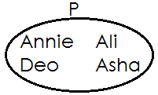 **Examples**

1.

**Set P= {Annie, Deo, Ali, Asha}**

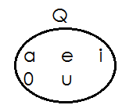

2.

Set **Q** ={**a, e, i, o, u**}

N.B-when listing members of a set, we use curly brackets ie**, {}**

We separate each member from another using a comma

**Activity**

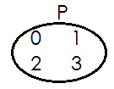List the member of the sets below.

1. Set P = { }

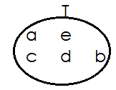

2. Set T= { }

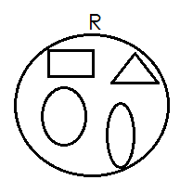

3. Set T= { }

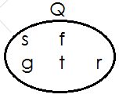

4. Set T= { }

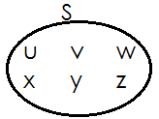

5. Set T= { }

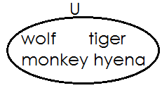

6. Set T= { }

**UNION OF SETS**

A union set is a collection of all members of the given sets without repeating common members.

**N.B**: Common members are written once. The symbol for union sets is “**u**”

**Examples**

1. Given that **W**= **{1, 2, 3}** and set **Z={x, y, z}**

Find **W** **∪** **Z**

**Solution**

**W ∪ Z**={**1, 2, 3, x, y, z}**

2. If set **F**={**c, a, r, e, s**} and G={**c, o, n, e, s**} list down all members of set **F ∪ G**

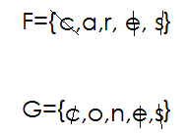 **Solution**

Therefore **FUG ={c, a, r, e, s, o, n}**

**Activity**

1. If set D= **{1, 2, 3, 4, 5} and set C={2,4,6}**

Find **DUC**

2. Given that P= {**a, e, i, o, u}** and Q= {**a, b, c, d}**

What is **PUQ**

3. Set S = {**o, p, q, r, s, t**} and set T= {**m, n, o, p}**

List down all elements of set S **∪** T

4. **M**= {**b, o, y, s**} and N={**c, a, m, b, s}.**

List down all the elements of set **M ∪ N**

5. **A**={**0,2,4,6,8**} and B={**1,2,3,4,5,6,7**}

Find **A ∪ B**

**INTERSECTION OF SETS**

What is an intersection set?

An intersection set is a set of common members.

**Examples**

1. Given that set F={**c, a, r, s}** and G={**c, o, n, e, s**}

Find **F** **∩ G**

**Solution**

F={**c, a, r, s**}

**G**={**c, o, n, e, s**}

**F** **∩** **G** = {**c, s**}

2. **M= {a, b, c, d, e}** and **N= {a, e, I, o, u}. Find M ∩ N**

**Solution**

**M= {a, b, c, d, e}**

**N= {a, e, i, o, u}**

**M ∩ N= {a, e}**

**Activity**

1. If set **A**= **{12, 3, 4, 5}** and set **B= {2, 4, 6, 8}**

Find **A ∩ B**

2. Given that P= **{a, e, i, o, u}**

3. Set w= **{o, p, q, r, s}** and set **R= {m, n, o, p}**

List down all the elements of set **W ∩** **R**

4. **M**= **{b, o, y, s}** and **N={c, a, m, b, s}**

List down all the elements of set **M** **∩ N**

5. IF **y**= {**e, f, g, h**} and X={**r, s, t, u, v**}

Find **Y** **∩** **X**

**FINDING NUMBER OF MEMBERS IN A SET USING SYMBOLS** “n”

**Examples**

1. If **K**= **{a, b, c, d}** find **n{k}**

**K**= **{a, b, c, d}**

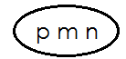 Therefore **n(k)=4**

2. Given that set **R =**

How many members are in set R?

R= {p, m, n}

n(R)=3

3. Set **A**= **{d, i, g}** and set **B= {d, o, n, e}**

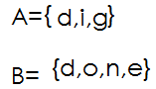 How many embers are in set **A ∪ B?**

**A ∩ B= {d}**

Therefore **n{A ∩ B} = 1**

4. Set **H**= **{d, o, w, n}** and **G={d, a, w, n}**

**H** **∪ G**= **{d, o, w, n, a}**

Therefore **n{H ∪ G}=5**

**Activity**

1. If **Z**= {**a, e, I, o, u**}. Find **n{z}**

2. Given that **x= {1, 2, 3, 4, 0}.** Find **n{x}**

3. R**={1,2,3,4,5}** and **s={2,4,6,8}.**find **n**{**R ∩ S**}

4. W= **{o, p, q, r, s}** and **R= {m, n, o, p}.** Find n{**W ∩ R**}

5. given that **V**={**s, t, r, p}** and **Z={s, t, r, e, a, m**} find **n{V ∪ Z**}

6. If **C**= {**1, 2, 3, 4, 5, 6**} and **D= {0, 3, 6, 9}**

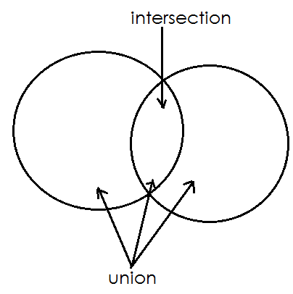 **A VENN DIAGRAM**

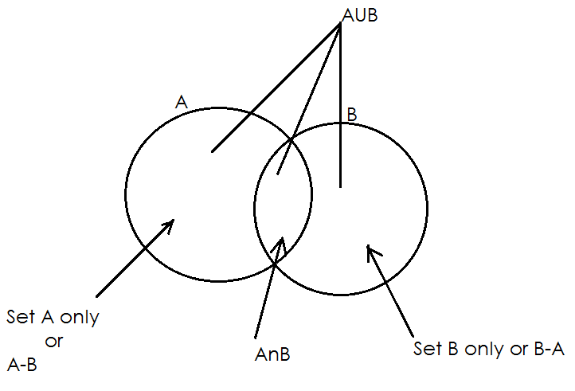**D**i**fferent parts of a Venn diagram**

**SHADING REGIONS ON A VENN DIAGRAM**

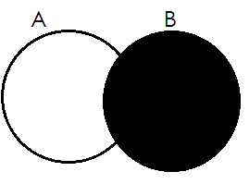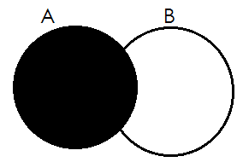1. Set A 2. Set B

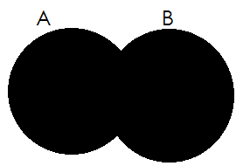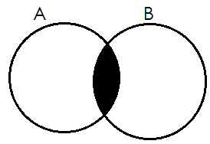3. AnB 4. AuB

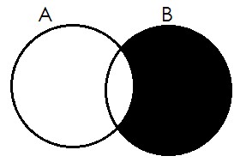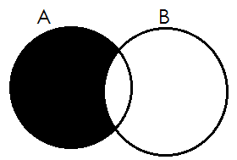5. A only 6. B only

**Activity**

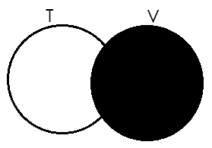**Describe the shaded regions of the Venn diagram below.**

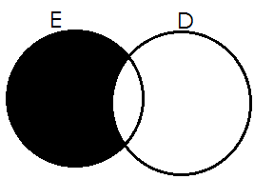

1. 2.

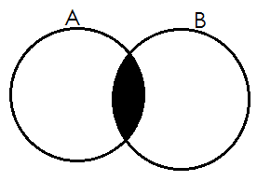____________________ ___________________

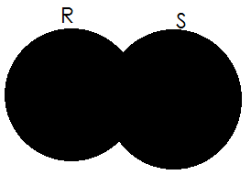3. 4.

________________ ____________________

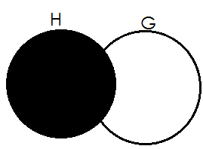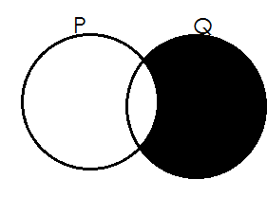

5. 6.

____________________ _______________________

**REPRESENTING MEMBERS /ELEMENTS ON A VENN DIAGRAM**

**Examples**

1. Given that A= {**a, b, c, d}** and B= {**d, a, l, f, e**} show the two sets on a Venn diagram

**A= {a, b, c, d}**

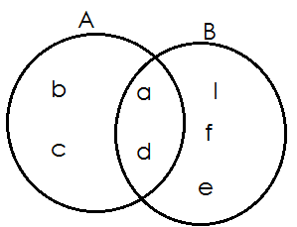 **B= {d, a, l, f, e}**

**Activity**

**Represent the sets below on the Venn diagram**

1. **P= {1, 2, 3, 4, 5,}**

**Q= {0, 2, 4, 6, 8}**

2. **N= {a, e, i, o, u}**

**M= {m, a, n, g, o**}

3. **A={dog, cow, pig, sheep, cat}**

**B= {pig, fig, log, leg, dog}**

4. **K= {5, 10, 15, 20, 25}**

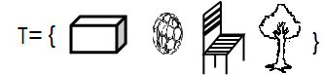 **L= {3, 5, 7, 9, 12, 15}**

5.

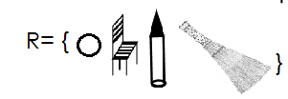

6. **C= {1, 2, 3, 4, 5,}**

**D= {0, 2, 4, 6, 8}**

7. **G= {10, 20, 30, 40}**

**H= {5, 10, 15}**

**USING VENN DIAGRAMS TO SOLVE SET PROBLEMS**

**Example 1**

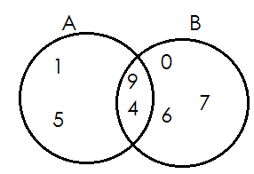 **Study the Venn diagram and answer the questions that follow**.

(a) List down all members of stet **A**

{**1, 5, 4, 9**}

(b) List down all elements of set **B**.

{**0, 6, 7, 4, 9**}

(c) Write down all members of **A** **∪ B**

**{1, 5, 9, 4, 0, 6, 7}**

(d) Find n {**A** **∩** **B**}

**N {A ∩ B}= {4,9}**

Therefore n{**A** **∪** **B}=2**

(e) Find **n{A-B}**

**n{A-B}={1,5}**

**Therefore n{A-B} =2**

**Example 2**

Given that set **P= {a, b, c, d}** and set **M= {d, e, f}**

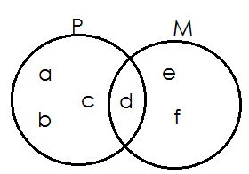a. Represent set **P** and **K** on the Venn diagram below.

b. Find

(i) **P ∩ M**

**P ∩ M** = {d}

(ii) **P ∪ M**

P **∪** M= {a, b, c, d, e, f}

(iii) n(P)

n(P) = {a, b, c, d}

**Therefore n(P)=4**

(iv) n(M) = {d, e, f}

n(M) = 3

(v) n{M-P}

n{M-P} = {e, f}

Therefore n{M-P} = 2

(vi) n(P-M)

n(P-M) = {a, b, c}

Therefore n(P-M) = 3

**Activity**

1. Study the Venn diagram below and answer the questions

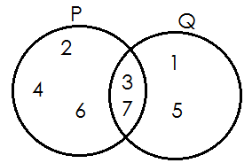

(a) List down all elements of set **P**

(b) Find P **∪** Q

(c) How many members are in set **P ∩ Q.**

(d) What is n(Q)?

2. If set M= {1, 2, 3, 4, 5} and set N= {0, 2, 4}

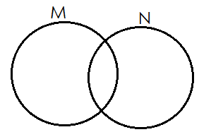(a) Fill in the Venn diagram below using set M and N.

(b) Find n(M)

(c) How many elements are in set N?

(d) Find:

(i) **n (M ∩ N)**

(ii) **n (M ∪ N)**

3. Given that set A**= {a, e, i, o, u}** and set B= **{a, b, c, d}**

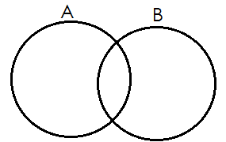(a) Fill in the Venn diagram below using set A and set B

(b) How many members are in set A?

(c) Find

(i) **n(B)**

(ii) **A ∩ B**

(iii) **n(A ∪ B)**

(iv) **n(A)**

**THEME: NUMERACY**

**TOPIC: NUMERATION SYSTEMS AND PLACE VALUES**

**SUB-TOPIC: Thousands, Hundreds, Tens and Ones**

* Place values of whole numbers
* Values of whole numbers
* Expanding numbers
* Adding values of numbers
* Subtracting values of numbers
* Multiplication
* Using place values
* Using values
* Finding expanded numbers
* Writing numbers shown on the abacus
* Drawing the abacus for the number
* Filling in thousands, hundreds, tens and ones
* More on filling in thousands, hundreds, tens and ones
* Drawing bundles for thousands, hundreds, tens and ones
* Writing numbers in words
* Writing number word in figures
* Roman numerals
* Examples of major Roman numerals
* Types of Roman numerals
* Roman numerals 1-50
* Changing roman numerals to Hindu-Arabic numerals
* Changing Hindu Arabic numerals to roman numerals.

**THEME: NUMERACY**

**TOPIC: NUMERATION SYSTEMS AND PLACE VALUES**

**SUB-TOPIC: THOUSANDS, HUNDREDS, TENS AND ONES**

**PLACE VALUES OF WHOLE NUMBERS**

**Qn. What is a place value?**

* A place value is the position of a digit in a number.

Finding place values of numbers

**Examples**

1. Write the place value of each digit in the number

**TH-thousands**

**H-hundreds**

**T-tens**

**O-ones**

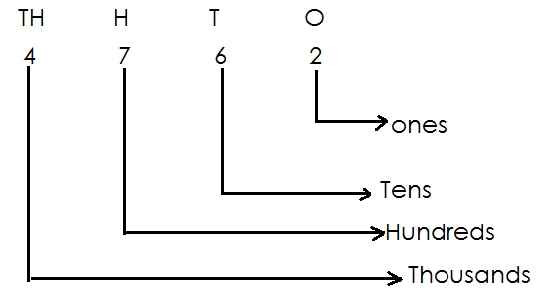

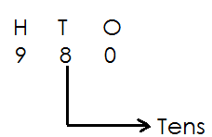2. Find the place value of 8 in 980

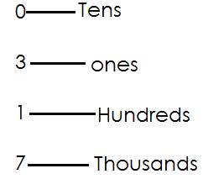3. Write the place value of each digit in 1703?

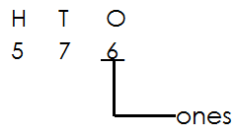4. Find the place value of the underlined digit in the number

**Activity**

1. Write the place value of each digit in

(a) **4073**  (c) **9467** (b) **871** (d) **59**

2. Find the place value of the underlined digits in the number

(a) **9321** (b) **3204** (c) **6821** (d) **5297**

3. Write the place value of the underlined digits in

(a) **4094** (b) **681** (c) **9764** (d) **5723**

4. What is the place value of **2** in **8026**?

5. Find the place value of **6** in **1640**

6. What is the place value of **9** in **9000**?

**VALUES OF WHOLE NUMBERS**

**A value** is the amount a digit holds in a number

**Examples**

1. Write the value of each digit in **6932**.

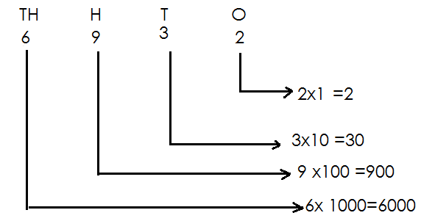 **Solution**

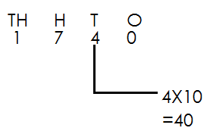2. Find the value of 4 in 17 40

**Activity**

1. Find the value of each digit in

(a) **9476**

(b) **524**

(c) **1725**

2. What is the value of **7** in **7185**?

3. Find the value of the underlined digits

(a) **6931**  (c) **7320** (b) **8321** (d) **5631**

4. Calculate the value of 6 in the number

(a) **6800**

(b) **4361**

(c) **9674**

**ADDITION OF VALUES OF NUMBERS**

Examples

1. 7 tens + 5 ones=

(7x10) + (5x1)

70 + 5

75

2. **2** hundreds + **7** tens + **3** ones

(2x100)+ (7x10) + (3x1)

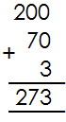 200 + 70 +3

**Activity**

Add the value of the following numbers

1. **2** tens + **5** ones=

2. **5** hundreds + **4** tens=

3. **6** thousands + **6** hundreds + **7** tens + **3** ones =

4. **8** thousands + **9** hundred =

5. **7** thousands + **4** hundreds+ **7** ones=

6. **1** thousand + **3** tens + **4** ones=_______________

**SUBTRACTING VALUES OF NUMBERS**

**Examples**

1. **5** tens- **3** tens=

(5x10)- (3x10)

=50-30

=20

2. **5** hundreds-**6** tens=

(5x100) – (6x10)

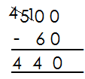 500-60

**Activity**

**workout the following**

1. **8** thousands - **7** thousands =

2. **9** tens - **2** tens =

3. **4** tens - **1** ten =

4. **3** hundreds - **5** tens =___________

5. **6** hundreds - **5** tens =

6. **5** thousands - **2** thousands =

7. **7** hundreds - **8** tens =

**MULTIPLYING VALUES OF NUMBERS**

**Examples**

1. **4** tens x **6** ones=

(4x10) x (6x1)

40x6

**= 240**

2. **6** hundreds x **2** ones =

(6x100) x (2x1)

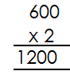 600 x 2

3. **1** thousand x **3** ones =

(1x1000) x 3 x1

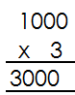1000x3

**Activity**

1. **2** tens x **2** ones=____________

2. **8** tens x **4** =__________________

3. **4** hundreds x **4** ones =_________

4. **5** thousands x **3** ones =__________

5. **2** hundreds x **6** ones =___________

6. **7** thousands x **2** ones =_____________

**EXPANDING NUMBERS**

**EXPANDING NUMBERS USING VALUES**

**Examples**

1. Expand 312 using values

(3X100) + (1X10) + (2X1)

300+10+2

2. Expand **5146** using values

(5x1000) + (1x100) + (4x10) + (6x1)

5000+100+40+6

**Activity**

Expand the following numbers using values

1. 275

2. 7856

3. 1002

4. 5471

5. 8909

6. 58

7. 560

8. 317

9. 28

10. 4846

**EXPANDING NUMBERS USING PLACE VALUES**

**Examples**

1. 586=5 hundreds + 8 tens + 6 0nes

(5x100) + (8x10) + (6x1)

2. 6135=6 thousands + 1hundred+ 3 tens + 5 ones

(6x1000) + (1x100) + (3x10) + (5x1)

**Activity**

Expand the following numbers using place values

1. 792

2. 46

3. 1381

4. 5092

5. 1234

**FINDING THE EXPANDED NUMBERS**

**Examples**

1. Which number is shown by expansion?

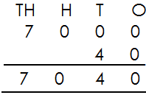 7000+40+8

2. What number has been expanded to give?

(4x1000) + (7x100) + (5x10) + (6x1)

4000 + 700 + 50 + 6

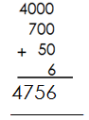

**Activity**

**What number has been expanded?**

1. 6000+60+6

2. (2x100) + (3x10) + (8x1)

3. 7000+300+50+4

4. 4000+500+60+2

5. (9x1000) + (2x100) + (7x10) + (5x1)

6. 700+70+0

7. (6x10) + (2x1)

**WRITING NUMBERS SHOWN ON THE ABACUSES**

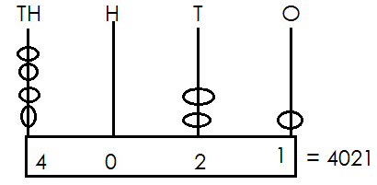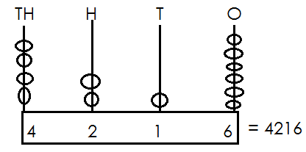 Examples

1. 2.

**Activity**

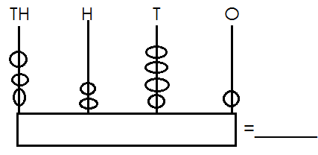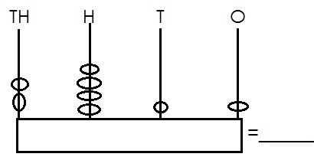Write the number shown on the abacuses.

1. 5.

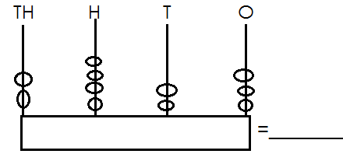

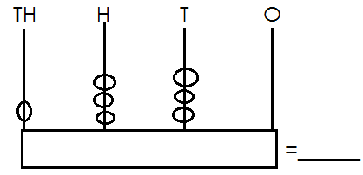

2. 6.

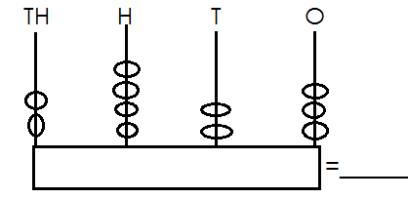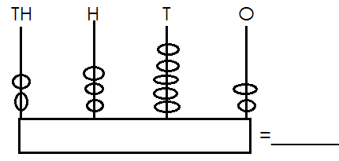3. 7.

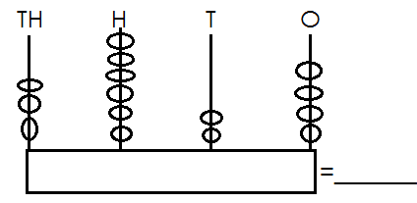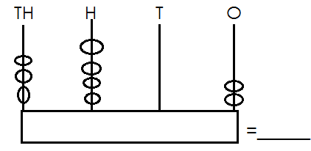

4. 8.

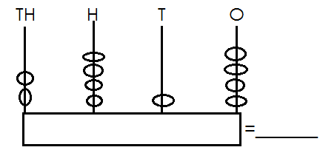

9.

**Drawing abacuses for the number**

**Examples**

1. 1254 = 2. 3052 =

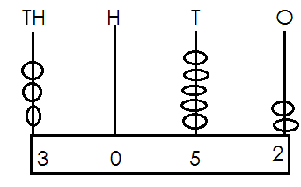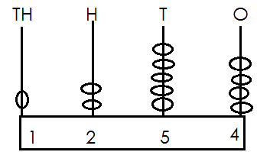

**Activity**

**Show the following numbers on the abacuses**

1. 1306 6. 6289

2. 9700 7. 8447

3. 7924 8. 6024

4. 8143 9. 8142

5. 5677 10. 5677

**FILLING IN THOUSANDS, HUNDREDS, TENS AND ONES.**

**Examples**

1. **9** thousands **4** hundreds **6** tens **0** ones

=9460

2. 2478= **2** thousands **4** hundreds **7** tens **8** ones

**Activity**

**Fill in thousands hundreds tens and ones**

1. **7** thousands **2** hundreds **3** tens **6** ones =_______________

2. **8** thousands/hundreds **6** tens **5** ones =_____________

3. **6** thousands **7** hundreds **1** ten **2** ones =______________

4. **1** thousand **0** hundreds **0** tens **4** ones =_____________

5. **2** thousands **0** hundreds **2** tens **0** ones =____________

6. **7214** =______ thousands _____hundreds ____ tens ____ones

7. **696** =______ thousands _____hundreds ____tens ____ones

8. **5218** =______ thousands _____hundreds ____tens ____ones

9. **2020** =______ thousands _____hundreds ____tens ____ones

10. **1995** =______ thousands _____hundreds ____tens ____ones

**MORE ON WRITING THOUSANDS, HUNDREDS, TENS AND ONES**

**Examples**

1. **4** thousands **3** hundreds **2** tens **5** ones = **4325**

2. **6** thousands **5** hundreds **2** tens **0** ones = **6520**

3. **2875** = **2** thousands **8** hundreds **7** tens **5** ones

4. **7029**= **7** thousands **0** hundreds **2** tens **9**ones

**Activity**

**Write thousands, hundreds, tens and ones**

1. ______ thousands _____hundreds ____tens ____ones=1934

2. ______ thousands _____hundreds ____tens ____ones=7453

3. ______ thousands _____hundreds ____tens ____ones= 3200

4. ______ thousands _____hundreds ____tens ____ones= 1731

5. ______ thousands _____hundreds ____ tens ____ones=5527

6. ______= **1** thousand **4** hundreds **3** tens **7** ones

7. ______= **0** thousand **9** hundreds **4** tens **8** ones

8. ______= **4** thousand **2** hundreds **5** tens **2** ones

9. ______= **7** thousand **7** hundreds **2** tens **0** ones

10. ______= **8** thousand **0** hundreds **0** tens **0** ones

**DRAWING BUNDLES OF THOUSANDS, HUNDREDS, TENS AND ONES**

**Examples**

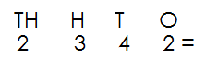1. Draw bundles to represent 2342

|  |  |  |  |
| --- | --- | --- | --- |
| Th | H | T | O |
| 2 | 3 | 4 | 2 |
|  |  |  |  |

2. Draw bundles to represent 215

|  |  |  |
| --- | --- | --- |
| H | T | O |
| 2 | 1 | 5 |
|  |  |  |

3. Draw bundles to represent 39

|  |  |
| --- | --- |
| T | O |
| 3 | 9 |
|  |  |

**Activity**

Draw bundles to represent

1. 13

2. 47

3. 123

4. 325

5. 1248

6. 246

7. 2290

8. 23

9. 1147

**WRITING NUMBERS IN WORDS**

**Note**: When reading numbers in words, read tens and ones together.

**Examples**

1. Write **48** in words

**48**= forty eight

2. Write **219** in words

**219** = two hundred nineteen

**Activity**

Write the following numbers in words

1. 14 6. 718

2. 35 7. 199

3. 96 8. 528

4. 49 9. 500

5. 421 10. 672

**WRITING NUMBER WORDS IN FIGURES**

**Examples**

1. Write ninety six in figures

**Ninety six =96**

2. Write two hundred twelve in figure

Two hundred=**200**

Twelve= +**12**

**Two hundred twelve=212**

3. Write eight hundred fifty in figures

Two hundred= **200**

Fifty = +**50**

Two hundred fifty= **250**

**Activity**

Write number word in figures

1. three hundred thirty-four.

2. ninety-five

3. seven hundred fifty-three

4. eight hundred thirty-nine

5. seventy-three

6. four hundred sixty-seven

7. seven hundred forty-nine

8. eight hundred one

9. seventy-two

10. eleven

**WRITING WHOLE NUMBER IN WORD**

(Thousands, hundreds, tens and ones)

**Note**: when writing numbers in words read tens and one together

**Examples**

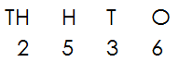1. Write **2536** in words

Two thousand five hundred thirty-six

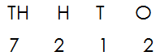2. Write **7212** in words

Seven thousand two hundred twelve

3. Write **310**4 in words

Three thousand one hundred four.

**Activity**

Write the following in words

1. 4718 6. 2538

2. 8000 7. 1840

3. 7049 8. 2116

4. 5399 9. 4009

5. 6411 10. 5234

**Write number words in figures**

**Examples**

1. Write two thousand five hundred thirty-six in figure

Two thousand= 2000

Five hundred= + 500

Thirty-six = 36

2536__

2. Write seven thousand two hundred twelve in figures

Seven thousand = 7000

Two hundred = 200

Twelve = 12

7212

**Activity**

1. One thousand, six hundred thirty-six

2. One thousand, nine hundred fifteen.

3. Two thousand, six hundred four.

4. Three thousand four hundred fifty.

5. Nine thousand two hundred eleven.

6. Eight thousand seven hundred twenty.

7. Three thousand one hundred eighty-one

8. Five thousand two hundred nineteen.

9. One thousand

10. Three thousand six hundred seventy-nine.

**NUMERALS**

A numeral is a symbol that represents a number.

**Example**

|  |  |
| --- | --- |
| **Number** | **Numeral** |
|  | 4 |

**Types of numerals**

1. Hindu Arabic numerals

2. Roman numerals

**Hindu Arabic numerals**

**Examples of Hindu Arabic numerals**

0,1,2,3,4,5,6,7,8,9……………

**ROMAN NUMERALS**

These are numerals that were introduced by the Asians.

Types of Roman Numerals

(a) Major roman numerals

|  |  |
| --- | --- |
| I  V  X  L  C | 1  5  10  50  100 |

(b) Roman numerals got by repeating I or x

(i) Repeating.

2= I+I

=II

3=I + I +I

=III

(ii) By repeating X

20=X + X

=XX

30=X + X +X

=XXX

(c) **Roman numerals got by adding I, III, to v**

6=5+1

= VI

7= 5+2

VII

(d) **Roman numerals got by adding, I, ii, iii to x**

11= 10+1

**= XI**

12= 10+2

=X II

**= XII**

13=10+3

**XIII**

(e) **Roman numerals got by subtracting 1 from 5**

4=5-1

**VI**

**Roman numerals got by subtracting**

1 from 10

9=10-9

**= IX**

(g) **Roman numerals got by subtracting**

10 from 50

40=50-10

**= XL**

**ROMAN NUMERALS FROM 1-50**

|  |  |
| --- | --- |
| 1 | I |
| 2 | II |
| 3 | III |
| 4 | IV |
| 5 | V |
| 6 | VI |
| 7 | VII |
| 8 | VIII |
| 9 | IX |
| 10 | X |
| 11 | XI |
| 12 | XII |
| 13 | XIII |
| 14 | XIV |
| 15 | XV |
| 16 | XVI |
| 17 | XVII |
| 18 | XVIII |
| 19 | XIX |
| 20 | XX |
| 21 | XXI |
| 22 | XXII |
| 23 | XXIII |
| 24 | XXIV |
| 25 | XXV |
| 26 | XVI |
| 27 | XVII |
| 28 | XVIII |
| 29 | XXIX |
| 30 | XXX |
| 31 | XXXI |
| 32 | XXXII |
| 33 | XXXIII |
| 34 | XXXIV |
| 35 | XXXV |
| 36 | XXXVI |
| 37 | XXXVII |
| 38 | XXXVIII |
| 39 | XXXIX |
| 40 | XL |
| 41 | XLI |
| 42 | XLII |
| 43 | XLIII |
| 44 | XLIV |
| 45 | XLV |
| 46 | XLVI |
| 47 | XLVII |
| 48 | CLVIII |
| 49 | XLIX |
| 50 | L |

**Changing Hindu Arabic to roman numerals**

**Examples**

1. Change **7** to Hindu Arabic numerals

7= 5+2

= VII

7= VII

2. Tony is **14** years old. Express his years in roman numerals.

14 = 10 + 4

14 = XIV

**Activity**

1. Change **9** to Roman numerals

2. Express **26** in Roman numerals

3. Change **48** to Roman numerals

4. There **7** days in a week. Express the days in Roman numerals.

5. John has **29** cows. How many cows does he have in Roman numerals?

6. Write **15** in Roman numerals.

7. Daniel weighs **42**kg. Express his weight in Roman numerals.

8. Change the following to Roman numerals

(a) **8** (b) **15** (c) **24**  (d) **39**  (e) **12**  (f) **28**

**CHANGING ROMAN NUMERALS TO HINDU ARABIC NUMERALS**

**Examples**

**Note:** expand and change to Hindu Arabic numerals

XIX

|  |  |
| --- | --- |
| X | IX |
| 10 | 9 |

= 10+9

= 19

2. Change IV to Hindu Arabic numerals

IV = 5 - 1

= 4

3. Jane is XXVI years old. Write her age in Hindu Arabic numerals

XXVI

|  |  |
| --- | --- |
| XX | VI |
| 20 | 6 |

= 20 + 6

= 26years

**Activity**

1. Change the following to Hindu Arabic numerals

(a) **XXII** (b) **XXXV** (c) **VII** (d) **XLIII**

2. A boy walked a distance of VIII metres. Express the distance in Hindu- Arabic numerals.

3. Mukisa weighs xix kilograms. Find his weight in Hindu-Arabic numerals.

4. An adult person has **XXXII** teeth. Express the teeth in Hindu -Arabic numerals.

**MATCHING ROMAN NUMERALS TO HINDU -ARABIC**

**Examples**

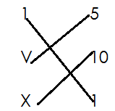 Match Roman numerals to Hindu –Arabic

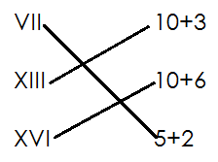Study the numbers and match

**Activity**

**Match roman numerals to Hindu - Arabic**

1. IV 9

VIII 19

IX 4

XIV 14

XXII 22

XIX 8

2. VI 10+8

XI 20+5

XVI 5+1

XVIII 10+6

XIV 10+1

XXV 20+4

**OPERATION OF WHOLE NUMBERS**

**Addition of number without regrouping/ carrying**

**Examples**

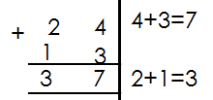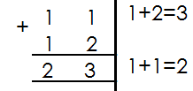1. Add 11+ 12 2. Add 24+13

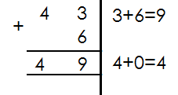3. Add:

**Activity**

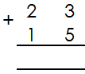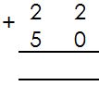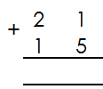 **Add the following**

1. 2. 3.

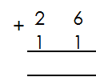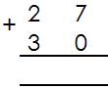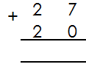

4. 5. 6.

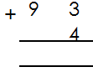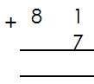

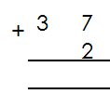8. 9.

7.

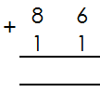

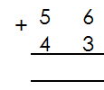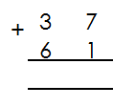

10. 11. 12.

**WORD PROBLEMS INVOLVING ADDITION WITHOUT REGROUPING**

**Examples**

1. Ashaba had 32 mangoes. She picked 17 more mangoes. How many mangoes did she have altogether?

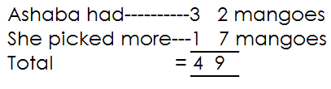

2. Wamanga made 24 pancakes. His friend gave him 30 more pancakes. How many pancakes did he have?

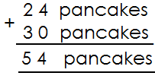

**Activity**

1. Okot had **55** cows. His brother had **21** cows. How many cows did the two brothers have?

2. Ssalongo had **42** goats. Nalongo had **52** goats. How many goats did they have altogether?

3. Epeju had **14** goats. Nalumanssi had **72** goats. How many goats do they have altogether?

4. Agnes collected **43** mangoes and **12** oranges. How many fruits did she collect altogether?

5. Mabale had **38** eggs. Nambozo had **41** eggs. How many eggs did they have altogether?

6. Opio made **33** pots. His wife made **24** more pots. How many pots did they make altogether?

7. Acen picked **40** guavas and A can picked **7**. How many guavas did they pick altogether?

**MORE ON ADDITION OF NUMBERS WITHOUT REGROUPING**

**Examples**

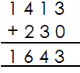1. Add: 1413+230

2. Add: 542 + 22

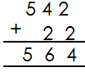

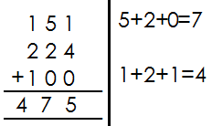3. Add: 151+224+100

**Activity**

**Read and workout**

1. 1230+110

2. 2141+1402+5223

3. 11+130+340

4. 2143+321

5. 1582+6314

6. 246+422

7. 4264+1101+3413

8. 3492+307

**MORE ON WORD PROBLEMS INVOLVING ADDITION OF NUMBERS WITHOUT REGROUPING.**

**Examples**

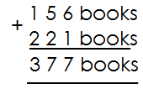1. James had **156** books. He got **221** more. How many books did he have altogether?

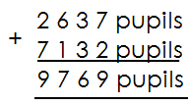2. Our school had **2637** pupils last year. It received **7132** pupils this year. How many pupils are in the school now?

**Activity**

1. Find the sum of **32453** and **41532**

2. Find the sum of sh **56321** and sh **23535**

3. Musa earns sh **63042** and Juliet earns **32416**. How much do both earn?

4. A district education officer gave **25204** books to schools in January and **30242** books in March. How many books were given out altogether?

5. A school A got **53107** books and school B got **41632** books. What is the total number of books which was given to the two school?

6. One parent donated sh **42463** to the school and another parent donated sh **43120**. What was the total amount of money donated to the school?

7. Add **42017** and **54301**.

**ADDITION OF NUMBERS INVOLVING REGROUPING**

**Examples**

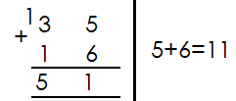 **Add the following**

1.

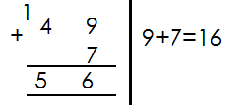2.

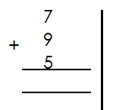3. 7+9+5=

**Activity**

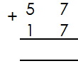 **Add the following numbers**

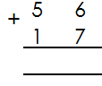

1. 8+9+8=

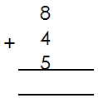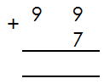

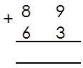

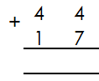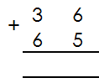

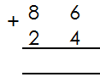

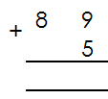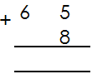

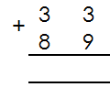

**MORE ON ADDITION OF NUMBERS INVOLVING REGROUPING**

**Examples**

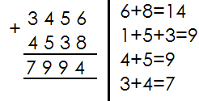1. Add: 3456+4538

2. Add: 323 + 24 6 + 453

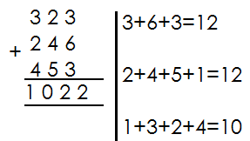

3. Add: 345 + 96

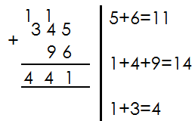

**Activity**

**Add the following numbers**

1. 1684+ 1469 =

2. 267+69 =

3. 5834+2487 =

4. 899+27 =

5. 1574+188 =

6. 2853 +987 =

7. 1876+2547 =

8. 582+49 =

**WORD PROBLEMS INVOLVING ADDITION OF NUMBERS WITH REGROUPING**

**Example**

1. Juma had **4156** books. He got **786** more books. How many books did he have altogether?

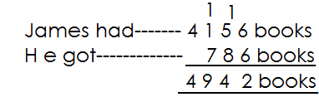 **Solution**

**Activity**

**Read and add**

1. Find the sum of **496** and **174**

2. What is the sum of **24, 37** and **425**?

3. What is **4798** plus **3362**?

4. A train carried **120** children **236** men and **325** women. How many people did it carry altogether?

5. A farmer has **494** cows and 847 sheep. How many animals does he have altogether?

6. Our school had **639** pupils last year. It received **97** more pupils this year. How many pupils are in the school altogether?

7. A village had **4837** men and **7246** girls. How many people are in the village altogether?

8. Agnes had **790** bags of millet Joan had **1724** bags and rose had **365** bags. How many bags do they have altogether?

**SUBTRACTION OF NUMBERS WITHOUT REGROUPING**

**Examples**

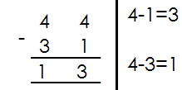1. Subtract:

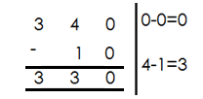2. Subtract:

**Activity**

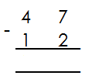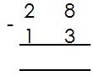 Subtract the following numbers.

1. 4. 7. 999 - 89

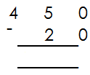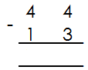2. 5. 8. 72 - 30

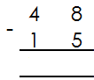 9. 424 - 14

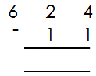3. 6.

10. 1324 - 112

**WORD PROBLEMS INVOLVING SUBTRACTION OF NUMBERS WITHOUT REGROUPING**

**Examples**

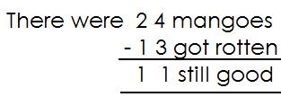1. There were **24** mangoes in a box **13** of them got rotten. How many mangoes are still good?

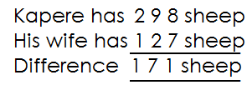2. Kapere has **298** sheep. His wife has **121** sheep. What is the difference between their number of sheep?

**Activity**

**Read and subtract**

1. What is the difference between **94** and **61**?

2. Find the difference between sh. **970** and sh. **250**?

3. Sandra had **65** cows. She sold off **35** cows. How many cows were left?

4. There are **186** cars in a hire. **80** of them were red in colour. How many cars were not red in colour?

5. Subtract**474** from **997**.

6. Subtract **57**kg from **689**kg.

7. Mukasa bought **780** crates of soda. He sold **480** crates. How many crates remained?

8. A farmer packed **738** litres of milk 615 liters were sold. How many litres were not sold?

**MORE ON SUBTRACTION OF NUMBERS WITHOUT REGROUPING**

**Examples**

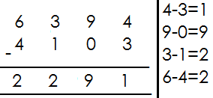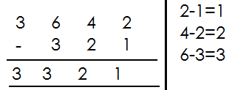 Subtract:

1. 2. Workout:

**Activity**

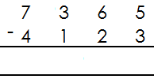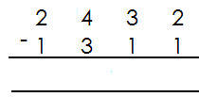 **Work out the following**

1. 5.

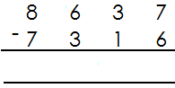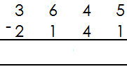

2. 6.

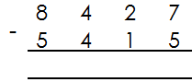

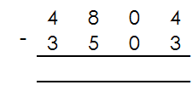3. 7.

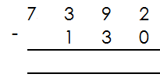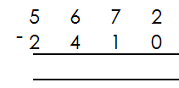4. 8.

**MORE ON WORD PROBLEMS**

**Examples**

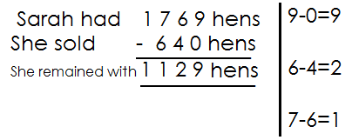1. Sarah had **1769** hens. She sold **460** hens. How many hens remained?

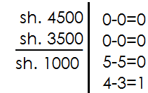2. Find the difference between sh. 4500 and sh. 3500.

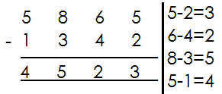3. Subtract: 5865 - 1342

**Activity**

**Read and workout**

1. Mugga had **1667** chicks. He sold off **441** chicks. How many chicks did he remain with?

2. What is the difference between **8456** and **3214**?

3. In a village of **8652** people, **6231** were females. How many males are there?

4. A teacher had **5720** pencils and she gave **3220** pencils to the pupils. How many pencils did she remain with?

5. There were **9729** eggs in the basket and **2315** of them got broken. How many eggs were left?

6. A carpenter made **2964** desks and he sold **350** desks. How many desks were left?

7. Subtract **456** from **9697**.

8. Workout the difference between **2440** years and **2020** years.

**SUBTRACTION OF NUMBERS WITH REGROUPING**

**Examples**

1. Subtract: 91-53

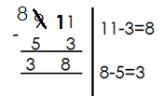 **Solution**

2. Subtract: 124-35

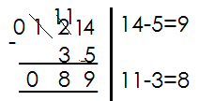 **Solution**

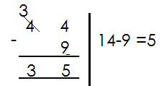3. Subtract 44-9

**Activity**

Subtract the following numbers

1. 94-6 6. 897-29

2. 82-7 7. 568-278

3. 95-17 8. 935-277

4. 84-39 9. 629-79

5. 413-144 10. 811-245

**WORDS PROBLEMS INVOLVING SUBTRACTION OF NUMBERS WITH REGROUPING**

**Key words**

- Difference - remove

- Takeaway - less

- Remain - subtract

- Reduce - minus

- Left - gave away

**Examples**

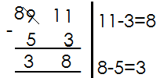1. Subtract 53 from 91

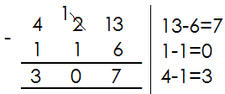2. What is left when I remove 116 from 423?

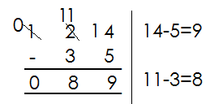3. Remove 35 from 124

**Activity**

**Read and subtract**

1. What is the difference between **653** and **175**?

2. Take away **87** from **199**.

3. Find the difference between **376** and **297**.

4. A boy did **400** numbers and failed **130** numbers. How many numbers did he get correct?

5. By how much is **851kg** greater than **364kg**?

6. Kabundi had sh. **500**. He gave away some to Andrew leaving sh. **250.** How much money did he give away?

7. Remove **93** from **231.**

8. Mwanje had **413** books. He removed **175** of them and gave them to Mr. Lindo. How many remained?

**MORE ON SUBTRACTION INVOLVING REGROUPING**

**Examples**

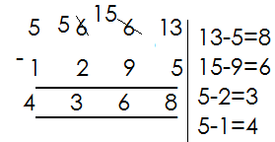1. Subtract: **5663** - **1295**

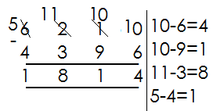2. Subtract: **6210** - **4396**

**Activity**

**Subtract the following numbers**

1. 3664 - 1395

2. 9564 - 5362

3. 9058 - 3749

4. 7683 - 2799

5. 9500 - 5769

6. 3541 - 1021

8. 8504 - 7694

9. 8330 - 6879

10. 6210 – 4396

**WORD PROBLEMS INVOLVING SUBTRACTION OF NUMBERS WITH REGROUPING**

**Examples**

1. Reduce **1776** by **469**

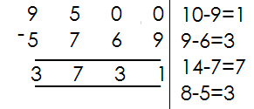2. What number is **5769** less than **9500**?

3. Safina bought 4750 bottles of soda. She sold 1965 bottles. How many were left?

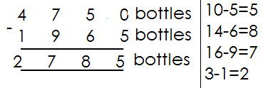 **Solution**

**Activity**

**Read and workout**

1. Subtract **3248** from **7368**.

2. Reduce **4232** by **2186**.

3. What number is **4397** less than **5642**?

4. A farmer had **4075** litres of milk **3986** litres were sold. How many litres remained?

5. Sudhir imported **3568** bicycles. He gave away **1698** bicycles to other traders. How many bicycles did he remain with?

6. Betty was born in **1997**. How old was she in **2005**?

7. In a class of **1205** pupils, **987** are boys. How many are girls?

**MULTIPLICATION OF WHOLE NUMBERS**

**Multiplying numbers by 0**

**Examples**

1. Multiply 8x0

8 x 0

**= 0**

2. Multiply 14 x 10

14 x 0

**= 0**

**Note**: When we multiply a number by 0 or o by a number, the answer is 0.

**Activity**

Multiply the following

1. 9 x 0

2. 10 x 0

3. 17 x 0

4. 144 x 0

5. 0 x 21

6. 37 x 0

7. 0 x 412

8. 111 x 0

9. 83 x 0

10. 100 x 0

11. 0 x 2

**WORKING OUT MULTIPLICATION USING REPEATED ADDITION**

**Multiplication is repeated addition**

**Examples**

1. Workout **4 x 6** using repeated addition

**4 x 6** means four groups of six or four sixes

**4 6**

= 6 + 6 + 6 + 6

**= 24**

2. Simplify 3x7 using repeated addition

3 x 7

= 7 + 7 + 7

**= 21**

**Activity**

**A. Workout the following using repeated addition**

1. 4 x 2

2. 6 x 5

3. 2 x 8

4. 3 x 9

5. 7 x 8

6. 5 x 3

7. 8 x 4

8. 5 x 9

9. 9 x 4

10. 10 x 6

**B. Workout addition statement using multiplication**

a. 4 + 4 + 4

b. 6 + 6 + 6 + 6

c. 3 + 3 + 3 + 3 + 3 + 3 + 3

d. 7 + 7

e. 9 + 9 + 9

f. 5 + 5 + 5 + 5 + 5 + 5

g. 8 + 8 + 8 + 8 + 8

**SIMPLE MULTIPLICATION**

**Multiplying one by one-digit numbers**.

**Examples**

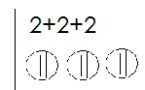 Multiply

a. 3 x 2

**6**

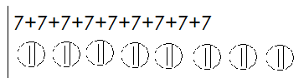b. 9 x 7

9 x 7

**63**

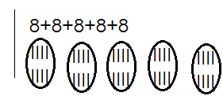

c. 5 x 8

5 x 8

**= 40**

**Activity**

Multiply the following numbers

1. 3 x 9

2. 4 x 7

3. 2 x 3

4. 1 x 5

5. 7 x 6

6. 9 x 7

7. 8 x 3

8. 6 x 2

9. 5 x 7

10. 9 x 1

11. 4 x 8

12. 8 x 2

**WORD PROBLEMS INVOLVING MULTIPLICATION OF NUMBERS**

**Key words**

- Multiply - multiple

- Times

- Product

**Examples**

1. A spider has **8** legs. How many legs do **3** spiders have?

**Solution**

One spider has **8** legs

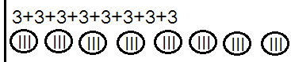 **3** spiders have (**8 x 3**) legs

**= 24 legs**

2. 1 book costs sh. 700. Find the cost of 4 similar books

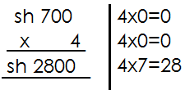 **Solution**

1 book costs sh. 700

4 books cost sh. 700 x 4

**Activity**

1. A pupil walks **3**km every day. How km does the pupils cover in **9** days?

2. A home uses **9** litres of milk a day. How many litres does the home use in **8** days?

3. A car has **8** wheels. How many wheels are there on **7** cars?

4. A car carries6 people. How many people are carried by **9** cars?

5. One pen costs sh. **900**. Find the cost of **5** pens.

6. One book has **8** pages. How many pages do **6** similar books have?

7. What is the product of **6** and **7**?

8. **3kg** of sugar were given to each family. If there were **9** family. How many kilograms were given out altogether?

9. Multiply **8** by **3**.

**MULTIPLICATION OF 2 DIGIT NUMBER BY 1 DIGIT WITHOUT CARRYING**

**Examples.**

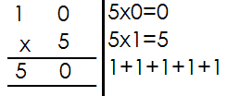1. **Multiply 10 x 5**

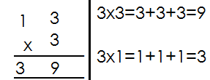2. **Multiply 13 x 3**

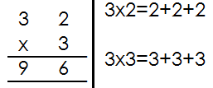3. **Multiply 32 x 3**

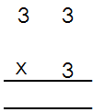

**Activity**

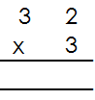 **Multiply the following** 8.

1. 24 x 3 6.

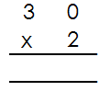2. 30 x 3

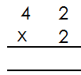3. 20 x 4 7. 9.

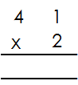4. 14 x 2

5.

**WORD PROBLEMS INVOLVING MULTIPLICATION OF 2 DIGIT NUMBER BY 1 DIGIT WITHOUT REGROUPING.**

**Examples**

1. One year has **12** months. How many months are in **4** years?

**Solution**

1 year_______12 months

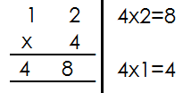 4 years--------- (12x4) months

**4** years have **48** months.

2. What is the product of **13** and **3**?

**Solution**

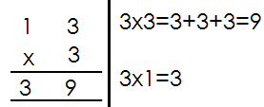 13x3

**Activity**

1. A car has **4** wheels. How many wheels are there on **20** cars?

2. One set contains **12** pencils. How many pencils do **4** similar sets contain?

3. A stool has **3** legs. How many legs do **33 s**tools have?

4. What is the product of **42** and **3**?

5. Multiply **30** by **4**

6. How many days are in **11** weeks?

7. There are **5** books in a box. How many books are there in **30** boxes?

8. A school uses **102** boxes of chalk in a month. How many boxes use in **4** months?

**MULTIPLICATION BY 2 BY 1 DIGITS WITH REGROUPING**

**Examples**

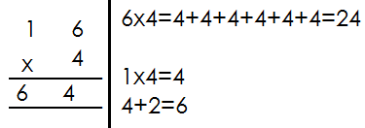1. Multiply 16 x4

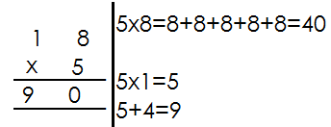2. Multiply: 18x5

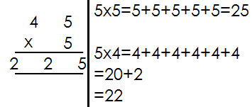3. Multiply 45 x5

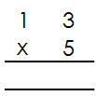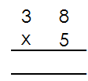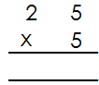 Multiply the following

1. 2. 3.

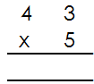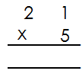

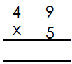 5. 6.

4.

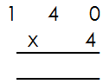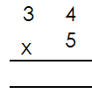 9.

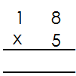 8.

7.

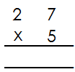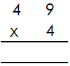

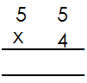 11. 12.

10.

**WORD PROBLEMS INVOLVING MULTIPLICATION WITH REGROUPING**

**Examples**

1. Alice sells **40kg** of sugar every day. How many kgs are sold in **4** days?

In **1** day, she sells------ **40** kgs

In **4** days, she sells-------**40kg x 4**

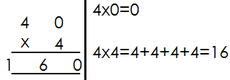

2. What is the product of **27** and **4**?

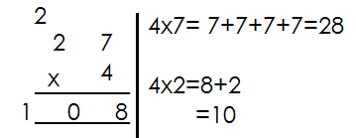 **27 x 4**

3. Multiply **46** by **3**

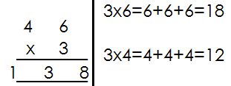 **46 x 3**

**Activity**

**Read and multiply**

1. One box holds **18** plates. How many plates will **7** boxes hold?

2. There are **84** stools with **3** legs each. What is the total number of legs?

3. One car carries **65** bags. How many bags do **5** cars carry?

4. What is the product of 148 and 5?

5. Multiply **23** by **5**?

6. **14** boxes are arranged in one line. If there are **9** lines. How many boxes are there altogether?

7. Multiply **507** by **6**

8. One cow has **4** legs. How many legs do **25** cows have?

9. Eight buses were used to take children for a trip. Each bus carried **32** pupils. How many pupils went for the trip?

**MULTIPLYING 3 BY 1 DIGITS WITH REGROUPING**

**Examples**

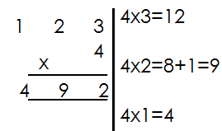1. Multiply: 23 x 4

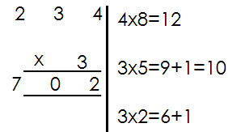2. Multiply: 234 x 3

**Activity**

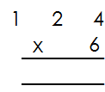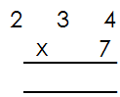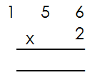 Multiply the following

1. 2. 3.

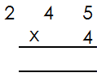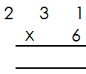

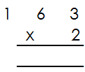 5. 6.

4.

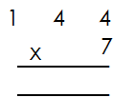

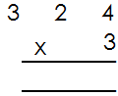 9.

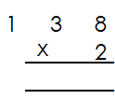 8.

7.

**MULTIPLY 4 DIGIT NUMBER BY 1 DIGIT WITH REGROUPING**

**Examples**

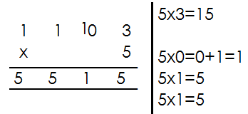1. Multiply: 1103 x 5

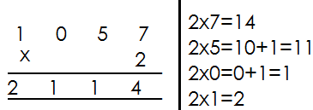2. Multiply: 1057 x 2

**Activity**

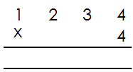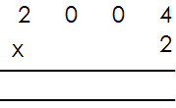 Multiply the following

1. 6.

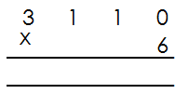

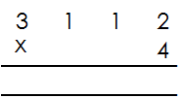 7.

2.

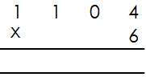

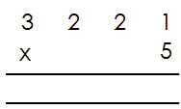

3. 4.

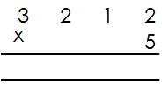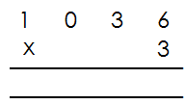5. 6.

**DIVISION OF WHOLE NUMBERS**

**Dividing numbers using repeated subtraction**

**Examples**

Workout **12 ÷ 3** using repeated subtraction

12 ÷ 3

12 - 3 =9

9 - 3 = 6

6 – 3 = 3

3 – 3 = 0

**4** times of subtraction

**Therefore 12 ÷ 3 =4**

2. Use repeated subtraction to workout

28 ÷ 4

28 ÷ 4

28 – 4 = 24

24 – 4 = 20

20 – 4 = 16

16 – 4 = 12

12 – 4 = 8

8 - 4 = 4

4 – 4 = 0

7 times of subtraction

Therefore 28 ÷ 4=7

**Activity**

Workout the division statement below using repeated subtraction

1. 9 ÷ 3

2. 10 ÷ 5

3. 20 ÷ 4

4. 18 ÷ 3

5. 27 ÷ 3

6. 40 ÷ 5

7. 50 ÷ 10

8. 36 ÷ 4

9. 15 ÷ 3

10. 12 ÷ 3

**DIVIDING 1 DIGIT NUMBER BY 1 DIGIT NUMBER USING LONG DIVISION WITH REMAINDERS**

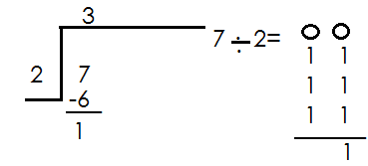 **Examples**

1.

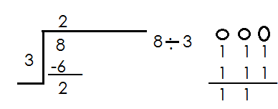 Therefore 7 ÷ 3=3 remainder 1

2.

Therefore 8÷3= 2 remainder 2

**Activity**

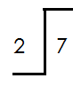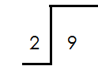 Divide numbers with remainders

1. 3.

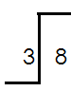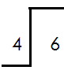

2. 4.

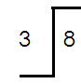

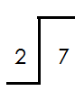5. 6.

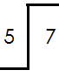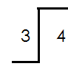

7**.** 8.

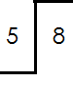

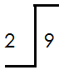9. 10.

**DIVIDING 2 DIGIT NUMBER BY 1 DIGIT NUMBER WITH REMAINDERS**

**Examples**

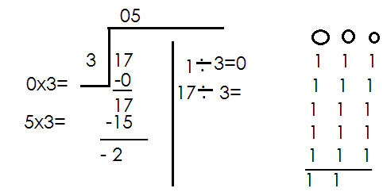1. Divide: 17 ÷ 3

**Therefore 17÷ 3=5 remainder 2**

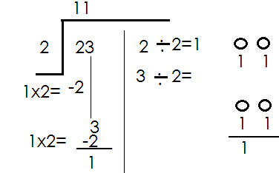2. Divide 23 ÷ 2

**Therefore 23 ÷ 2 = 11 remainder 1**

**Activity**

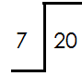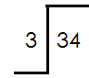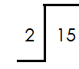Divide the numbers with remainders

1. 6. 7.

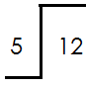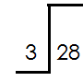

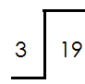3. 8.

2.

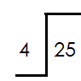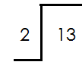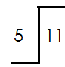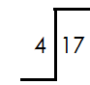

4. 5. 9. 10.

**DIVIDING 1 DIGIT NUMBER BY 1 DIGIT WITHOUT REMAINDERS**

**A. Without using long division**

1. Divide: 6 ÷ 6

6 - 6

=1

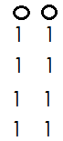2. Divide: 8 ÷ 2

8 ÷ 2

**= 4**

**Activity**

**Divide without using long division**

1. 9 ÷ 3

2. 6 ÷ 2

3. 5 ÷ 5

4. 4 ÷ 2

5. 6 ÷ 3

6. 8 ÷ 4

7. 4 ÷ 2

8. 7 ÷ 7

9. 9 ÷ 3

10. 8 ÷

B. **Using long division**

**Examples**

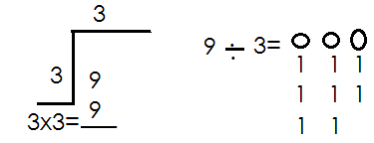1. Divide: 9 ÷ 3

9 ÷ 3 = 3

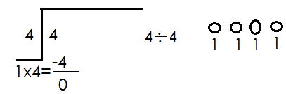2. Divide: 4 ÷ 4

4 ÷4 =1

**Activity**

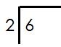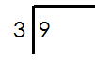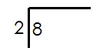**Divide 1 by 1 without remainders using long division.**

1. 2. 3. 4.



5. 6. 7. 8.



9. 10.

**DIVIDING 2 DIGIT NUMBERS BY 1 DIGIT NUMBER WITHOUT REMAINDERS USING LONG DIVISION**

**Examples**

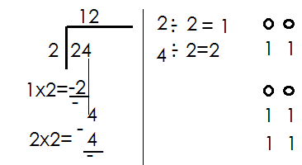1. Divide: 24 ÷ 2

**Therefore 24 ÷ 2=12**

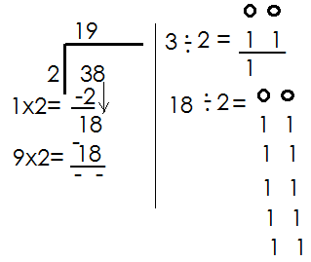2. **Divide:** 38 ÷ 2 = 19

Therefore 38 ÷ 2=19

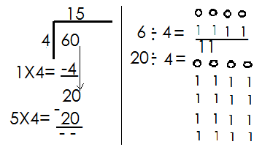3. Divide: 60 ÷ 4 = 15

Therefore 60 ÷ 4 15

**Activity**

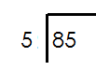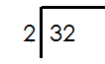Divide the following using long division

1. 5.

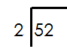

2. 6.



3. 7.

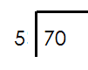

4. 8.

**WORD PROBLEMS INVOLVING DIVIDING 2 DIGIT NUMBER BY 1 DIGIT NUMBERS.**

Key words

Divide

Share

Quotient

**Examples**

1. Share 36 pens equally among 6 pupils

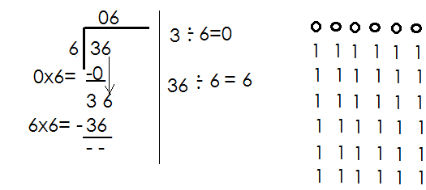 36 ÷ 6

Each pupil gets **6** pens

2. Share **24** balls equally among **4** schools. How many does each school get?

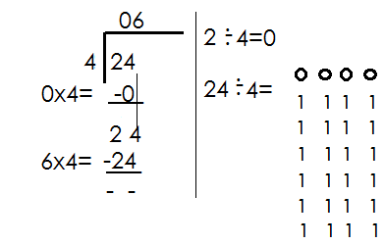 24 balls ÷ 4

Each school gets 6 balls

**Activity**

1. Share **12** oranges among **3** children. How many does each child get?

2. Divide **45** by **5**

3. What is the quotient of **76** and **2**?

4. Divide **54** by **3**

5. There were **42** desks to be shared equally among **3** classes. How many did each class get?

6. Lumonde got **55** eggs from his farm. If each hen laid **7** eggs, how many hens does he have?

7. How many weeks are in **35** days?

8. Find he quotient of **60** and **3**.

9. Share **18** cups equally between two girls. How many does each get?

10. Musoke had **20** pencils had shared them equally among **5** boys. How many did each boy get?

**DIVIDING 3 DIGITS BY 1 DIGIT 1 DIGIT WITHOUT REMAINDERS**

**Examples**

1. Divide: 468 ÷ 2

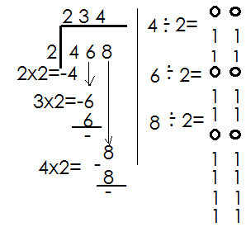

Therefore 468 ÷2=234

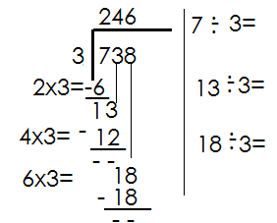**2.**  Divide: 738 ÷ 3

Therefore 738 ÷ 3=246

3. Divide: 128 ÷ 4.

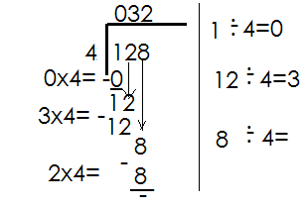

Therefore 128 ÷ 4=32

**Activity**

Divide the following

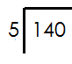

1. 5.

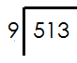

6.

2.

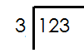7.

3.

 8.

4.

9.

**WORD PROBLEMS INVOLVING DIVIDING 3 BY 1 DIGIT NUMBERS**

**Examples**

1. Share **176** books equally among **8** streams. How many books does each stream get?

**176** books ÷ **8**

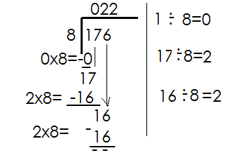

Each stream gets 22 books.

2. Find the quotient of 384 and 3

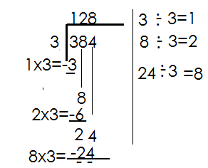 384 ÷ 3

Therefore, the quotient of 384 and 3 is 128.

**Activity**

1. Divide 145 ÷ 5

2. What is the quotient of 252 and 7?

3. Divide **318** by **3**

4. A box contained **505** pencils to be given to 5 schools. How many pencils did each school get?

5. **128** sweets are to be shared equally to **8** children. What does each get?

6. There were **434** desks to be shared among **7** classes. How many desks did each get?

**ADDING NUMBERS USING A NUMBER LINE**

**Examples**

1. Add **3 + 4** using a number line

 **3 + 4 = 7**

2. Use a number line to add **3 + 1**

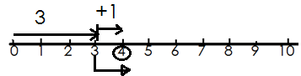 **3 +1 = 4**

3. Workout 7+2 on a number line

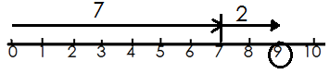 **7+2 = 9**

**Activity**

**Add the following numbers using a number line**

1. 2 + 4 = 6. 1 + 3 =

2. 0 + 4 = 7. 6 + 5 =

3. 1 + 5 = 8. 6 + 2 =

4. 4 + 4 = 9. 8 + 2 =

5. 8 + 1 = 10. 1 + 7 =

**SUBTRACTING NUMBERS USING A NUMBER LINE.**

**Examples**

1. Subtract **8** from **10** using a number line

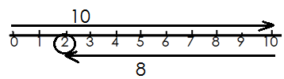 **10 – 8 = 2**

2. What is 5-3 using a number line

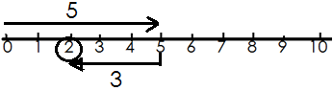 **5 – 3 = 2**

3. Use a number line to subtract 4-0

4 – 0 = 4



**Activity**

**Use a number line to subtract the following numbers**

1. 6 – 3 = 6. 11 – 7 =

2. 10 – 7 = 7. 5 – 4 =

3. 4 – 1 = 8. 9 – 3 =

4. 7 – 2 = 9. 6 – 5 =

5. 12 – 8 = 10. 3 – 1 =

**MULTIPLYING 1 DIGIT NUMBER BY 1 DIGIT NUMBER USING A NUMBER LINE**

**Examples**

1. Workout **3 x 2** on a number line

 **3 x 2 = 6**

2. Multiply **2 x 2** using a number line.

 **2 x 2 = 4**

3. What is 3x3 on a number line?

 **3 x 3 = 9**

**Activity**

Multiply the following numbers using number lines

1. 5 x 2 = 4. 3 x 2 =

2. 1 x 6 = 5. 6 x 2 =

3. 3 x 4 = 6. 1 x 4 =

7. 6 x 2 = 8. 1 x 7 =

9. 4 x 2 = 10. 2 x 2 =

**TERM TWO**

**NUMBER PATTERNS AND SEQUENCES**

**Vocabulary**: number, pattern, sequence

**Number**

**A number** is the idea of knowing how many.

**Pattern**

A pattern is repetition of evens in a particular order.

**Note**: Patterns form a sequence.

**Sequence** is the order of numbers

**Types of numbers**

1. **Whole numbers**

These are numbers that are not fractions.

**Note:** The first whole number is zero (**0**)

**Examples of whole numbers**

{**0, 1, 2, 3, 4, 5, 6, 7, 8, 9, …}**

Their sequence has a pattern of **+1** in ascending order and **-1** in descending order.

2. **Counting number / Natural numbers**

These are numbers that we use to count objects.

**Note**: The first counting number is 1

**Examples of counting numbers**

**1, 2, 3, 4, 5, 6, 7, 8, 9, 10, …**

Their sequence has a pattern of **+1** in ascending order and **-1**in descending order.

**Sequence of whole numbers and counting numbers**

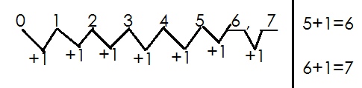 **Examples**

1.

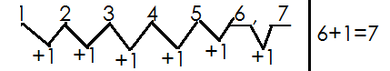2. **Fill in the missing number in the sequence**

3. **Find the missing numbers in the sequence**.

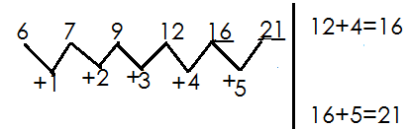

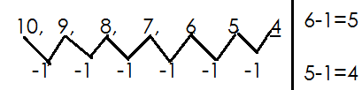4. **Find the missing numbers in the sequence.**

**Activity**

**Fill in the missing numbers in the sequences below**

1. 0, 1, 2, 3, 4, ___, _____, ____

2. 4, 5, 6, 7, 8, 9, ____, ____

3. 10, 20, 30, 40, 50, ____, ____

4. 4, 20, 19, 18, 17, ____, _____

5. 12, 11, 10, 9, 8, ____, _____, ____

6. 10, 11, 12, 13, _____, ____, ____

7. 3, 4, 6, 7, 9, ______, ______

3. **Even numbers**

Even numbers are numbers that are exactly divisible by 2.

**Examples of even numbers**

0, 2, 4, 6, 8, 10, 12, 14, 16, 18, 20, …

**Note:**

Their sequences have a pattern of **+**2 in ascending order and **-**1 in descending order.

4. **Odd numbers**

Odd numbers are numbers that are not exactly divisible by 2.

**Examples of odd numbers**

**1, 3, 5, 7, 9, 11, 13, 15, 17, 19, 21, …**

**Note**

Their sequences have a pattern of **+2** in ascending order and **-2** in descending orders.

**Sequences of even numbers and odd numbers**

**Examples**

1. Find the missing numbers in the sequence below

**0, 2, 4, 6, 8, 10**

Keep adding 2

**0 + 2 = 2**

**2 + 2 = 4**

**4 + 2 = 6**

**6 + 2 = 8**

**8 + 2 = 10**

2. Find the next numbers in the sequence

**16, 14, 12, 10, 8, 6, 4**

Keep subtracting **2**

**16 – 2 = 14**

**14 – 2 = 12**

**12 – 2 = 10**

**10 – 2 = 8**

**8 – 2 = 6**

**6 – 2 = 4**

**Activity**

Find the missing numbers

1. **0, 2, 4, 6, 8, 10**, ____, _____

2. **4, 6, 8,** _____, ______

3. **2, 2, 4, 6, 14,** _____, _____

4. **1, 3, 5, 7**, ______, _______

5. **11, 9, 7,** ____, _____

6. **1, 2, 5, 10**, ______

**MORE ON FINDING MISSING NUMBERS IN THE SEQUENCE**

**Examples**

1. Find the next

**0, 2, 4,6,8,10,12**

**Add 2**

**0 + 2 = 2** **6 + 2 = 8**

**2 + 2 = 4** **8 + 2 = 10**

**4 + 2 = 6** **10 + 2 = 12**

2. 1, 4,7,10,13,16,19

**Keep on adding 3**

1 + 3 = 4

4 + 3 = 7

7 + 3 = 10

10 + 3 =13

13 + 3 = 16

16 + 3 = 19

3. **65, 55, 50, 45, 40, 45, 30**

**Keep on subtracting 5**

65 – 5 = 55 45 – 5 = 40

55 – 5 = 50 40 – 5 = 35

50 – 5 = 45 35 – 5 = 30

**Activity**

**Fill in the missing numbers**

1. 0, 1, 2, 3, 4, _____, _____, _____

2. 0, 2, 4, 6, 8, ______, _____, ____

3. 1, 3, 5, 7, 9, ______, _____, _____

4. 1, 4, 7, 10, 13, ______, _____, ____

5. 2, 6, 10, 14, 18, ____, _____, _____

6. 10, 12, 14, 16, _____, _____, _____

7. 5, 10, 15, 20, 25, _____, _____, ____

8. 10, 12, 14, 16, ____, _____, ______

9. 40, ____, 60, ____, 80, ____, _____

10. 100, 90, ____, _____, 60, ____, ____, 30, ____

11. 110, 120, _____140, _____, _____, 160, _____

12. 800, 700, 600, ____, ____3000, _____, _____

13. 190, 180, 170, 160, ____, _____, _____

**MULTIPLES OF NUMBERS**

A multiple is a product of two or more numbers

**Key words used are:-**

Less than, between, up to, from, etc.

**Finding multiples of numbers**

**Examples**

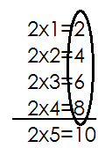1. List all multiples of less than **10**.

Therefore **M2= {2, 4, 6, 8}**

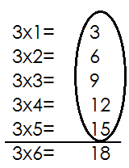**2.** List multiples of **3** from **3** to **15**

**M3 = {3, 6, 9, 12, 15}**

**Activity**

1. List all multiples of **4** from **4** to **20**

2. List all multiples of **3** less than **15.**

3. Write down the first **5** multiples of **2**.

4. Write down all multiples of **6** between **0** and **20**.

5. List all multiples of **10** less than **100**.

6. Write down the first **3** multiples of **4**

**FACTORS**

Factors are numbers that give rise to multiples or product.

A number that divides another exactly is called a factor.

**Finding factors of numbers**

**Examples**

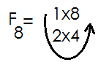1. List all factors of 8

**Therefore F8= {1, 2, 4, 8}**

2. Write down all factors of 4

F8= 1x4

**2x2**

**Therefore F8= {1, 2, 4, 8}**

**Activity**

Find and list all factors of:

1. 6 2. 8

3. 10 4. 12

5. 9 6. 4

7. 15 8. 20

**MULTIPLYING IN TWOS, THREES, FOURS, FIVES AND TENS**

**Revise multiplication of numbers**

1. 5 x 2 = _________ 9. 12 x 4 =________ 16. 8 x 9 =________

2. 6 x 3 = _________ 10. 12 x 5 =________ 17. 8 x 7 =________

3. 6 x 2 =_________ 11. 8 x 4 =_________ 18. 9 x 8 =________

4. 4 x 3 =_________ 12. 9 x 4 =_________ 19. 9 x 9 =________

5. 7 x 2 =_________ 13. 7 x 6 =_________ 20. 10 x 4 =________

6. 8 x 3 =________ 14. 7 x 8 =________ 21. 10 x 6 =________

7. 6 x 4 =________ 15. 8 x 9 =________ 22. 10 x 8 =________

8. 1 x 5 =________

**MULTIPLYING NUMBERS BY 10**

**Examples**

1. 1 x 10 = 10 6. 17 x 10 = 170

2. 4 x 10 = 40 7. 124 x 10 = 1240

3. 7 x 10 = 70 8. 418 x 10 = 4180

4. 13 x 10 = 130 9. 625 x 10 = 6250

5. 15 x 10 = 150 10. 710 x 10 = 7100

**Activity**

**Multiply the following**

1. 6 x 10 =____________ 11. 350 x 10 =__________

2. 9 x 10 =____________ 12. 375 x 10 =__________

3. 11 x 10 =__________ 13. 600 x 10 =___________

4. 13 x 10 =__________ 14. 360 x 10 =__________

5. 23 x 10 =__________ 15. 500 x 10 =__________

6. 200 x 10 =__________ 16. 89 x 10 = ____________

7. 47 x 10 =___________ 17. 56 x 10 =____________

8. 17 x 10 =___________ 18. 16 x 10 =___________

9. 90 x 10 =____________ 19. 5 x 10 =____________

10. 100 x 10 =___________ 20. 111 x 10 =___________

**MORE ON COUNTING AND MULTIPLYING IN TWOS, THREES, FOUR, FIVES AND TENS**

**Examples**

1. **1** two = **1 x 2 = 2**

2. **2** twos = **2 x 2 = 4**

3. **3** fours = **3 x 4 = 12**

4. **5** threes = **5 x 3 = 15**

5, **10** fives = **10 x 5 = 50**

**Activity**

Count in twos, threes, fours, fives and tens

**1.** three= _____ = _____

2. **5** twos= _____ = _____

3. **4** twos=_____ = _____

4. **4** threes=____ = _____

5. **5** threes= ____ = ____

6. **9** threes=____ = ____

7. **3** fours= ____ = ____

8. **10** fours=____ = ____

9. **12** fours=____ = ____

10. **7** fives= ____ = ____

11. **8** fives=____ = ____

12. **2** threes=____ = ____

13. **7** fours=____ = ____

14. Five tens= ____ = ____

15. **6** tens= ____ = ____

16. What is the value of 5 fours using multiplication?

17. Use multiplication to workout 4+4+4+4

**WORD PROBLEMS INVOLVING COUNTING IN TWOS, THREES, FOURS AND FIVES**

**Examples**

1. How many twos make 8?

8 ÷ 2 = 4

Four twos make 8

**Activity**

1. How many twos make **6**?

2. How many threes are in **15**?

3. How many fives are in **20**?

4. How many fours are in **16**?

5. Use addition to get the answer for **5** threes.

6. How many twos are in **20**?

7. How many fours can you get from **24**?

**FINDING MISSING NUMBERS IN DIAGRAMS**

**Examples**

1. 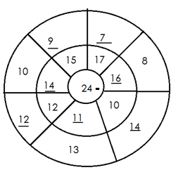 24 – 8 = 16

24 – 10 = 14

24 – 13 = 11

24 – 12 = 12

24 – 10 = 14

24 – 15 = 9

24 – 17 = 7

**Activity 1**

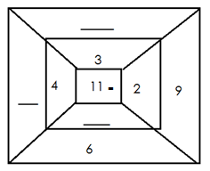1. The sum at the centre is 11. Find the missing numbers.

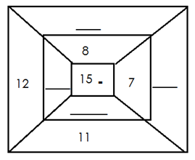2. The sum at the centre is 15. Find the missing numbers

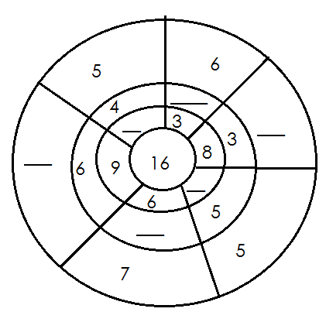3. Find the missing numbers. The sum at the centre is 16.

**Activity 2**

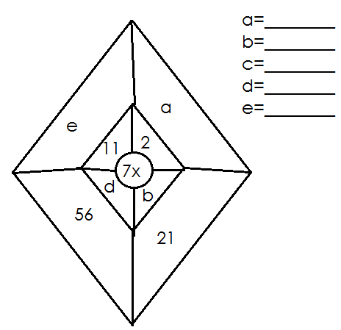1. Find the missing numbers by multiplying and dividing

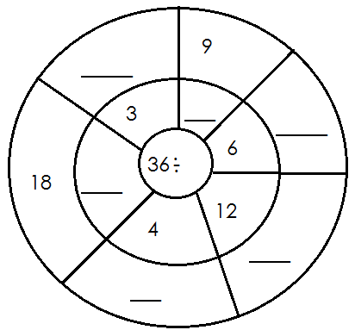2. Find the missing numbers by dividing

**MORE ON FILLING IN THE MISSING NUMBERS IN BLANK SPACES**

**Examples**

Remember 3 x 2 = 6, 6 ÷ 2 = 3 and 6 ÷ 3=2

**Examples**

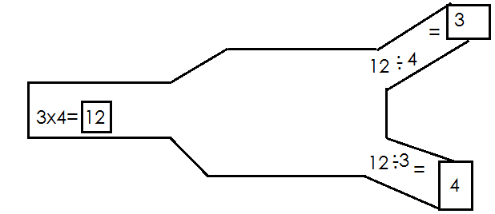

**Activity**

**Fill in the blank spaces**

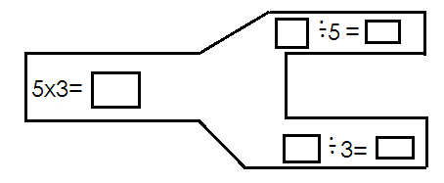1.

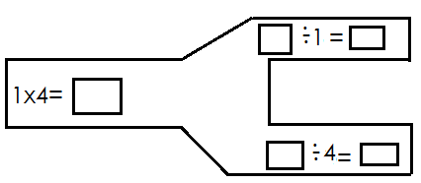

2.

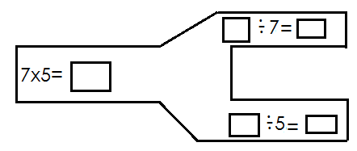

3.

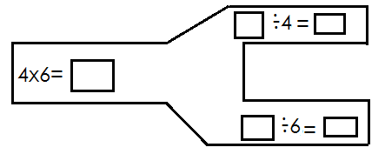4.

**MAGIC SQUARES**

**Addition and finding missing numbers in a magic square**

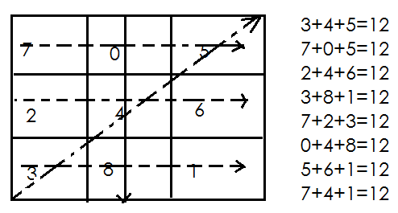**Examples**

**Example 2**

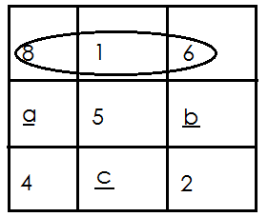Given the magic square bellow.

(a) Find the magic sum

8+1+6

=15

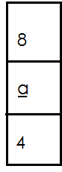(b) Find the value of a, b and c.

a.

a+4+8=15

a +12=15

a +12-12=15-12

a=3

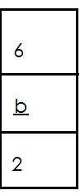 b

b+6+2=15

b+8=15

b+8-8=15-8

b=7

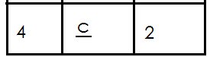

c+4+2=15

c+6=15

c+6-6=15-6

c=9

**Note**: The sum of the numbers arranged in diagonals, columns or row is equal.

**Activity**

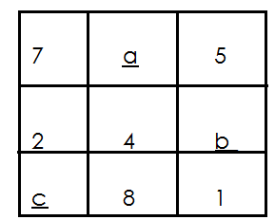 Find and fill in the missing numbers in the magic squares below.

1.

a. Find the magic sum

b. Find the value of

(i)a (ii)b (iii)c

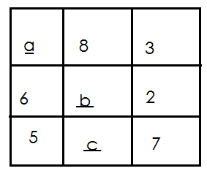2. Use the magic square below to answer questions that follow.

a. Find the magic sum

b. Find

(i)a

(ii)b

(iii)c

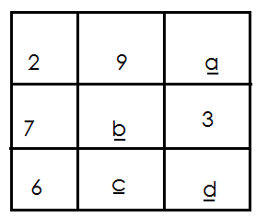3. Use the magic square below to answer questions that follow

a. Find the magic sum

b. Find

(i)a

(ii)b

(iii)c

(iv)d

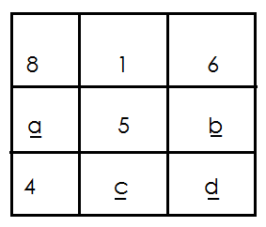4. Use the magic square below to answer questions that follow

a. Find the magic sum

b. Find

(i)a

(ii)b

(iii)c

(iv)d

**FRACTIONS**

**What is a fraction?**

A fraction is part of a whole number

**Parts of fractions.**

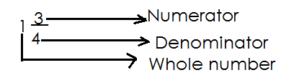

Numerator is the top number of a fraction.

Denominator is the bottom number of a fraction

**WRITING AND READING FRACTIONS**

**Examples**

 a half

a third

 1 = whole

two fifth

 a twelfth

**Activity**

Write the following fractions in words

a. $\frac{1}{4}$ b. $\frac{2}{3}$

c. $\frac{1}{5}$ d. $\frac{1}{9}$

e. $\frac{2}{10}$ f. $\frac{2}{10}$

g. $\frac{2}{7}$ h. $\frac{3}{4}$

i. $\frac{1}{8}$

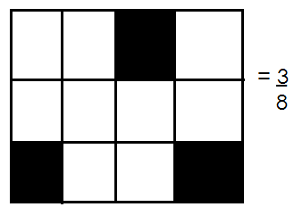Writing the shaded fractions

1.

2. Write the shaded fraction

$\frac{1}{3}$

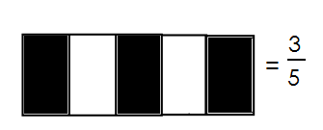3. Name the shaded fraction

**Activity**

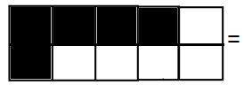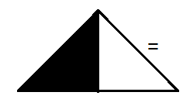Name the shaded fractions

1. 3.

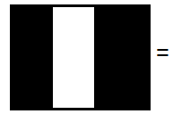2. 4.

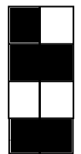

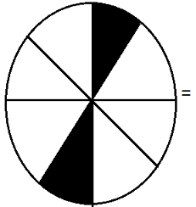5 6.

**=**

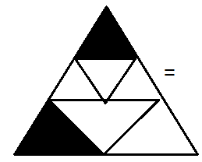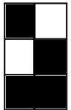7. 8.

**WRITING THE UNSHADED FRACTION**

**Examples**

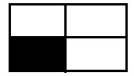1. What fraction is not shaded?

= $\frac{3}{4}$

2. Write the unshaded fraction.

= $\frac{2}{3}$

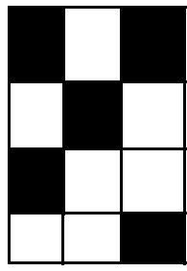3. What fraction is not shaded?

= $\frac{7}{12}$

**Activity**

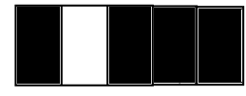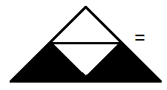**Write the unshaded fractions**

1. 5. =

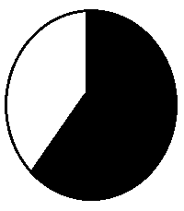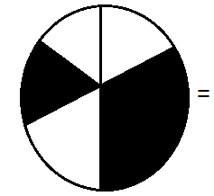

2.6. =

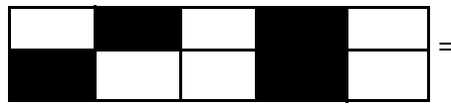

3. 7.

=

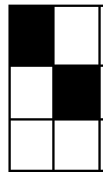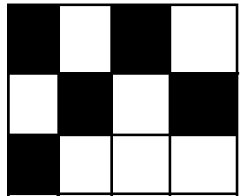

4. 8. =

**DRAWING AND SHADING FRACTIONS**

**Examples**

1. Shade the given fraction.

= $\frac{1}{3}$

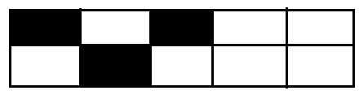2. Shade $\frac{3}{10}$ of diagram below.

$\frac{3}{10}$ =

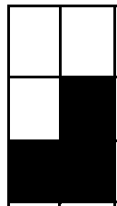3. Draw and shade $\frac{3}{6}$

**Activity**

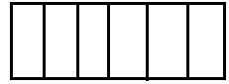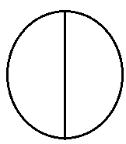1. Shade the given fractions

a. b.

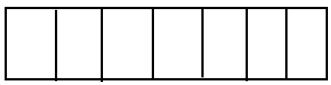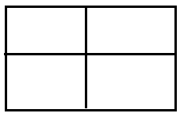

c. d.

2. Draw and shade the following fractions

a. $\frac{3}{6}$ b. $\frac{1}{8}$ c. $\frac{4}{10}$ d. $\frac{3}{9}$

**COMPARING FRACTIONS**

Comparing fractions using greater than/less than or equal to.

**Examples**

Use greater than or less than

1. ----------

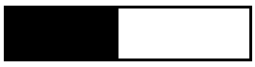

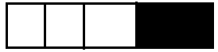

Therefore $\frac{1}{2}$ is greater than $\frac{1}{4}$

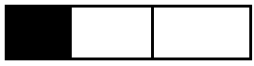2. $\frac{1}{3}$---------- $\frac{1}{4}$

$\frac{1}{3}$

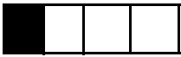

$\frac{1}{4}$

Therefore $\frac{1}{4}$ is less than $\frac{1}{3}$

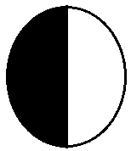3. $\frac{1}{2}$-------------- $\frac{3}{4}$

**= $\frac{1}{2}$ = = $\frac{3}{4}$**

Therefore $\frac{3}{4}$ is greater than $\frac{1}{2}$

**Activity**

**Write greater than or less than**

1.  ***-------*** 2.  **-------**  3.  **--------**

4.  **--------** 5**. --------**  6.  **------**

7.  **--------**  8.  **-------**  9.  **------**

**Comparing fractions using symbols >, < or =**

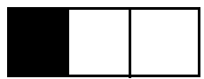1. $\frac{1}{3}$ $\frac{1}{6}$

$\frac{1}{3}$

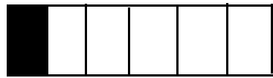

$\frac{1}{6}$

**Therefore $, \frac{1}{3}$ $>$ $\frac{1}{6}$**

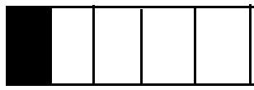2. $\frac{1}{10}$ $\frac{1}{5}$

$\frac{1}{5}$

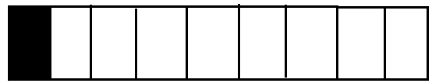

$\frac{1}{10}$

$\frac{1}{10}$ < $\frac{1}{5}$

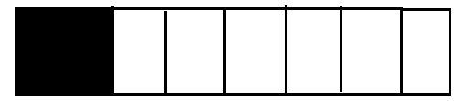3. $\frac{2}{8}$ $\frac{1}{4}$

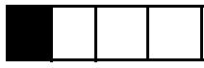

Therefore $\frac{2}{8}$ = $\frac{1}{4}$

**Activity**

Compare fractions using, > or =

1. **________**

2. **________**

3. **________**

4. **_________**

5. **__________**

6. **_________**

7. **__________**

8. **_________**

**ADDING FRACTIONS USING DIAGRAMS**

**Examples**

 Add fractions using diagrams

1. Add:

****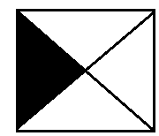

**+ =**

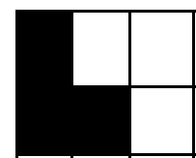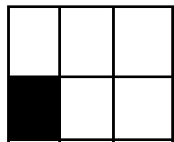 **=** 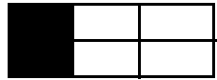

2. + =

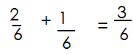

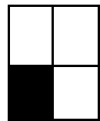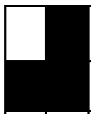

3. + + =

**+ + =**

**Activity**

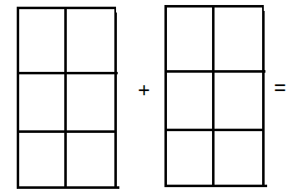**Add the following fractions using diagrams**

1.



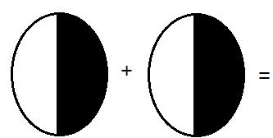2.

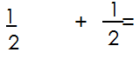

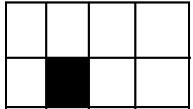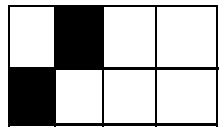3.

**+**



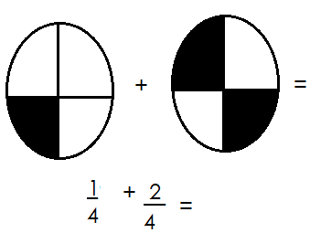4.

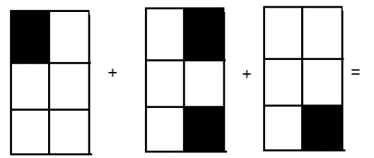5.

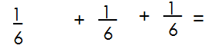

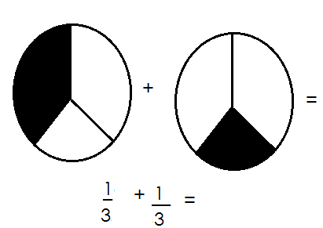6.

**More on addition of fractions**

**Examples**

1.  **+ = = =1**

2.  **+ = =**

3.  **+ = =**

**Activity**

Add the following fractions

1.  **+**  =

2.  **+**  =

3.  **+**  =

4.  **+ +**  =

5.  **+ +**  =

6.  **+**  =

7.  **+**  =

8.  **+ +**  =

**ADDITION OF FRACTIONS INVOLVING WORD PROBLEMS**

**Examples**

1. A pupil read $\frac{1}{8}$ of the book on Monday and $\frac{3}{8}$ of it on Tuesday.

What fraction did he read altogether?

+ = =

Therefore, a pupil read $\frac{4}{8}$ of a book alotogether.

2. Find the sun of $\frac{1}{6}$ and

+ = = =1

**Activity**

**Read and ad fractions**

1. Find the sum of and

2. I walked the $\frac{4}{9}$ of a journey and I ran $\frac{3}{9}$ of it. What fraction did I cover altogether?

3. Musa ate $\frac{7}{10}$ of the cake and Namugga $\frac{2}{10}$ of it. What fraction did they eat altogether?

4. A teacher marked $\frac{2}{5}$ of the books in the morning and $\frac{3}{5}$ in the afternoon. What fraction of the books was marked?

5. What is the sum of , and ?

6. If of the school garden is covered with maize, and $\frac{2}{4}$ with beans. What fraction of the garden is covered with crops?

7. Joy shaded $\frac{2}{6}$ of the picture Agnes shaded $\frac{1}{6}$ of it and Kato shaded $\frac{3}{6}$ of it. What fraction of the picture was shaded?

**SUBTRACTION OF FRACTIONS USING DIAGRAMS**

**Examples**

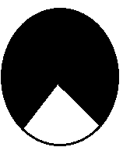1. Use diagrams to subtract: $\frac{2}{3}$ **- $\frac{1}{3}$**

$\frac{2}{3}$**- $\frac{1}{3}$ = $\frac{1}{3}$**

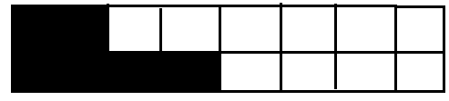2. Subtract: $\frac{5}{10}$ **- $\frac{2}{10}$**

$\frac{5}{10}$**- $\frac{2}{10}$ = $\frac{3}{10}$**

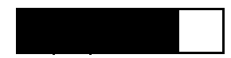3. Subtract: -

- =

**Activity**

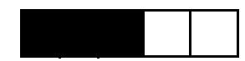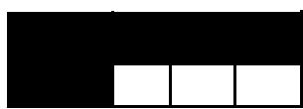Subtract the following fractions

1. 2.

**- = - =**

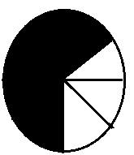

3. 4.





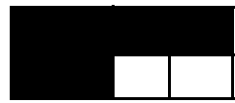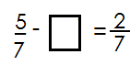5. 6.

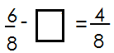

7.



8.

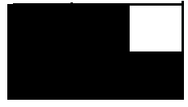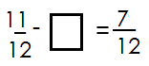

9.

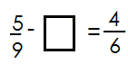

**MORE ON SUBTRACTION OF NUMBERS**

**Examples**

1. Subtract the following;

a. $\frac{4}{5}$ **- $\frac{1}{5}$**

$\frac{4}{5}$**- $\frac{1}{5}$ = $\frac{4-1}{5}$ = $\frac{3}{5}$**

b. $\frac{3}{6}$**- $\frac{1}{6}$**

$\frac{3}{6}$**- $\frac{1}{6}$ = $\frac{3-1}{6}$ = $\frac{2}{6}$**

c. **1- $\frac{3}{7}$**

f. $\frac{7}{7}$**- $\frac{3}{7}$ = $\frac{7-1}{7}$ = $\frac{4}{7}$**

**Activity**

Subtract the fractions below.

**1. $\frac{2}{3}$- $\frac{1}{3}$ = 7. $\frac{17}{20}$- $\frac{12}{20}$ =**

**2. $\frac{3}{4}$- $\frac{1}{4}$ = 8. $\frac{9}{13}$- $\frac{4}{13}$ =**

**3. $\frac{4}{5}$- $\frac{1}{5}$ = 9. $\frac{8}{11}$- $\frac{6}{11}$ =**

**4. $\frac{5}{6}$- $\frac{1}{6}$ = 10. $\frac{13}{50}$- $\frac{10}{50}$ =**

**5. $\frac{7}{10 }$- $\frac{5}{10}$ = 11. 1 - $\frac{2}{3}$ =**

**6. $\frac{19}{41}$- $\frac{11}{41}$ =**

**WORD PROBLEMS INVOLVING SUBTRACTION OF FRACTIONS**

**Key words used**

difference

take away

remain / remained / remainder

minus

subtract from

left

**Examples**

1. A boy had $\frac{5}{6}$ of a cake. He ate $\frac{2}{6}$ of it. What fraction remained?

**- = =**

2. A girl had an orange. She gave away $\frac{3}{4}$ of it. What fraction was she left with?

$\frac{4}{4}$**- $\frac{3}{4}$ = $\frac{4-3}{4}$ = $\frac{1}{4}$**

**Activity**

1. What is the difference between and ?

2. Subtract from

3. Fausta ate $\frac{4}{5}$ of an orange. What fraction remained?

4. John painted $\frac{7}{10}$ of his house on Monday. What fraction of his house has not been painted?

5. A garden has 8 equal parts. 3 parts out of 8 are planted with maize. What fraction was left?

6. What is the difference between and ?

7. What fraction is left after taking away $\frac{3}{4}$ from a whole?

8. What fraction is left after eating $\frac{2}{3}$ of an orange?

**FRACTIONS OF WHOLES**

**Examples**

What is $\frac{1}{2}$ of 6?

= $\frac{1}{2}$ of 6

= $\frac{1}{2}$ x6

= 1x6

2

= (1x6) ÷ 2

= 6 ÷ 2

=3

**Activity**

Workout

1. of 8

2. of 12

3. of 10

4. of 20

5. of 18

6. of 24

7. of 15

**GRAPHS AND INTERPRETATION OF INFORMATION**

**Types of graphs**

1. Column graphs / bar graphs

2. Picture / pictographs

**PICTOGRAPHS/ PICTURE GRAPHS**

A pictograph is a graph where we use pictures to represent information.

**Note:**

When using pictographs, one picture can represent 2 or more items

**FINDING NUMBER OF ITEMS GIVEN PICTURES**

 **Examples**

1. If stands for 2 trees, find number of trees are represented by

 = 2 trees

=5x2 trees =10trees

 Or

 =2 trees

= (2+2+2+2+2) trees

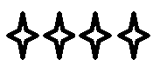 =10 trees

2. If shows 5 stars, how many stars will show?

=5 stars

 =4x5 stars

=20 stars

 **Activity**

1. If stands for 3 chairs, how many chairs will stand for?



2. Given represents 4 balls, how many balls are represent by ?

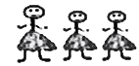

3. stands for 10 girls. How many girls will stand for?

4. Given that =5 stools. How many stools will stand for?

5. If stands for 2 books, how many books will represent?

**FINDING NUMBER OF PICTURES GIVEN ITEMS**

 **Examples**

1. If shows 4 stars. How many pictures will be shown by 2stars?

4 stars=

12 stars = 12 ÷ 4

 = 3 pictures

2. If represents 3 trees, how many pictures will represent 15 trees?

3 trees=

15 trees= 15 ÷ 3 = 5 pictures

 **Activity**

1. Givens that 4 chairs are represented by , then how many chairs are represent by16 chairs?

2. If represents 5 cups, how many pictures represent 20 cups?

3. If shows 6 pencils. How many pictures will show 12 pencils?

4. If 5 trees are represented by , draw pictures to represent 15 trees.

5. = 3 balls. Draw pictures to represent 9 balls.

6. If stands for 3 books, how many pictures will stand for 12 books?

**INTERPRETING PICTOGRAPHS**

**Examples**

2. The pictograph below shows the number of balls given to five clubs in the country. Study it and answer the questions that follow.

|  |  |
| --- | --- |
| **Name** | Number of balls |
| KCC FC |  |
| Vipers FC |  |
| Vila FC |  |
| Jinja SS fc |  |
| Express FC |  |

 Stands for 10 balls.

1. How many balls were given to express FC?

= 10 balls

Express got (3x10 balls)

**=30 balls**

2. How many balls did KCC FC get?

3. How many balls were given to Vipers fc?

4. How many more balls did Jinja fc get than vipers?

5. How many balls were given to villa fc?

6. How many balls did KCC FC and Jinja SS FC get altogether?

7. How many balls were given out altogether?

1. The pictograph below shows the number of flowers picked by six girls. Study it and answer the questions that follow.

|  |  |
| --- | --- |
| Name | Number of flowers |
| Rebecca |  |
| Lynnola |  |
| Jovia |  |
| Frida |  |
| Stella |  |
| Josephine |  |

**QUESTIONS**

1. Who picked the highest number of flowers?

2. How picked the least number of flowers?

3. Which two girls picked the same number of flowers?

4. How many girls picked the same number of flowers?

5. How many flowers were picked by Lynnola?

6. How many more flowers did Stella pick than Jovia?

7. If each flower is sold at sh. 200, how much money will Frida get after selling all her flowers?

8. Workout the total number of flowers picked by all the girls.

**MORE ON PICTOGRAPHS**

**Drawing pictographs to represent information**

**Examples**

The list below shows the number of text books given to different streams at St. Anthony nursery and primary school. Study it and answer questions.

|  |  |
| --- | --- |
| **Class** | **Number of text books** |
| P.3 NORTH | 6 books |
| P.3 CENTRAL | 3 books |
| P.3 EAST | 8 books |
| P.3 WEST | 3 books |

**Questions**

1. Draw a pictograph to represent the above information.

2. Which class got the highest number of text books?

3. What two classes got the same number of text books?

4. Calculate the total number of text books that were given to all classes?

**BAR GRAPHS / COLUMN GRAPHS**

A bar graph is a graph made up of columns / bars

**Examples**

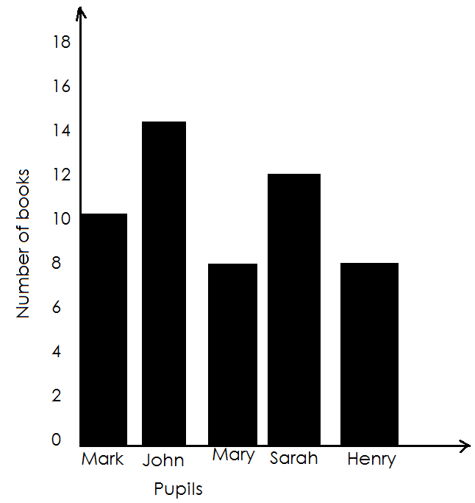 The bar graph shows books each of the following pupils has.

**Questions**

1. How many books does John have?

John has 14 books.

2. Who picked the highest number of books?

John picked the highest number of books?

3. Which two pupils have the same number of books?

Mary and Henry have the same number of books.

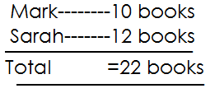4. Find the total number of books that Mark and Sarah have?

**Activity**

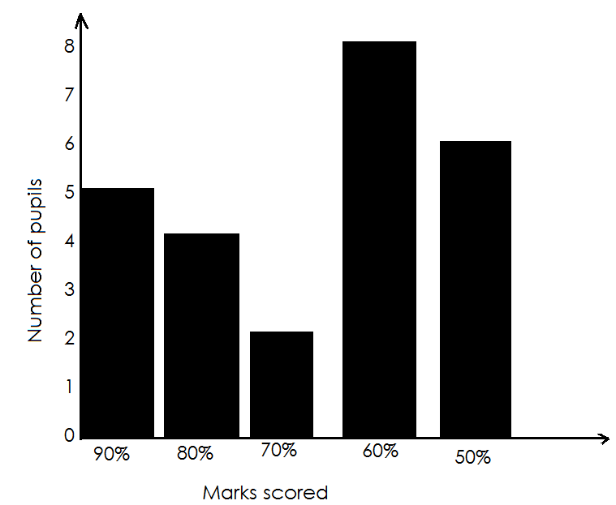The graph below shows scores obtained by primary three pupils in a mathematics test

**Questions**

1. How many pupils scored 90%?

2. How many pupils scored 80%?

3. Which percentage mark did most of the pupils score?

4. Which percentage mark did the least number of pupils score?

5. How many pupils were there in the class?

**GEOMETRY**

Tracing shapes (class activity)

Making shapes (class activity)

**SIMPLE SHAPES**

Simple shapes

Squares semi-circle

Rectangles parallelogram

Kites trapezium

Oval rhombus

and other polygons with more than 4 sides

**POLYGONS**

A polygon is any figure that is closed and has sides.

**Examples of polygons**

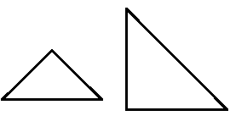1. A triangle

A triangle has 3 sides

2. **QUADRILATERALS**

The 4-sided polygon is called a quadrilateral

Types of quadrilaterals

(a) **Square**

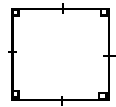 A square has 4 equal sides. All the angles are equal.



(b)

**Rectangle**

A rectangle has opposite sides which are equal. Opposite angles are equal.

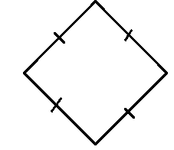c.

**Rhombus**

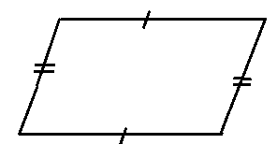All sides are equal. Opposite sides are equal. Opposite angles are equal.

d.

**Parallelogram**

Opposite sides are equal and parallel.

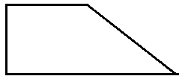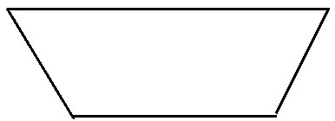e. **Trapezium**

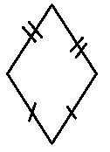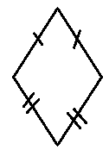f. **kite**

**Solid shapes**

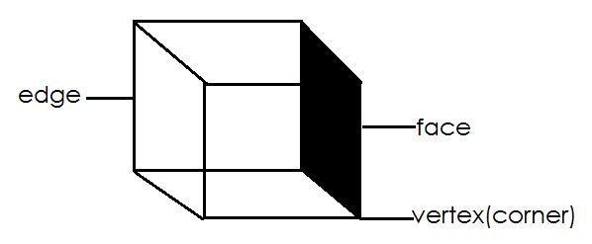**Cube**

It has all sides equal

It has 6 faces

It has 8 vertices

It has 12 edges.

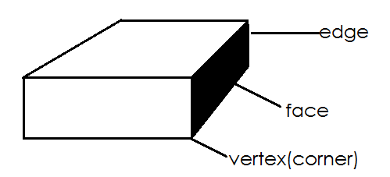**Cuboid**

It has opposite sides equal

It has 6 faces

It has 8 vertices

It has 12 edges

**Cone**

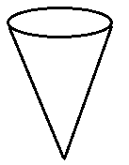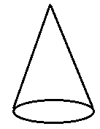

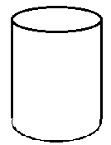

**Cylinder**

**Oval**

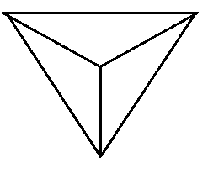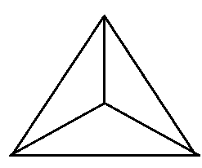**Triangular pyramid**

**Activity**

1. How many shapes have 4 sides?

2. Name these shapes

|  |  |
| --- | --- |
|  |  |
|  |  |
|  |  |
|  |  |

3. Write three examples of polygons

______________ __________________ ____________________

4. A 4 sided closed figure is called? ____________________________

5. Draw a triangular pyramid.

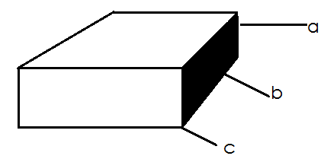6. Name the parts of a cuboid.

**COUNTING SHAPES**

**Examples**

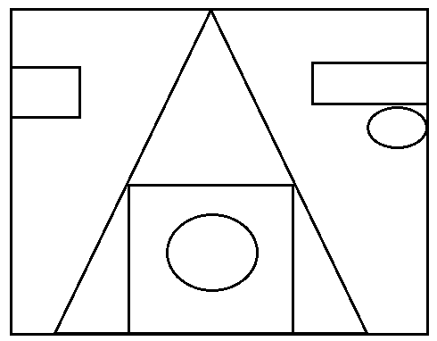Count triangle, squares, circles, rectangles

1. triangles 5
2. squares 2
3. circles 2
4. rectangles 2

**Activity**

1. Count the number of rectangles and squares.

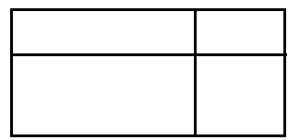(a)

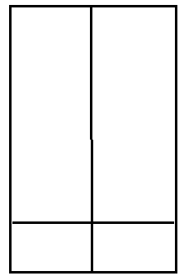(b)

**TIME**

**Definitions**

Time is the quantity of the availability of duration or Time is a way of doing something well.

**Days of the week**

|  |  |
| --- | --- |
| 1. Sunday | 1st day |
| 1. Monday | 2nd day |
| 1. Tuesday | 3rd day |
| 1. Wednesday | 4th day |
| 1. Thursday | 5th day |
| 1. Friday | 6th day |
| 1. Saturday | 7th day |

**Activity**

1. Fill in the missing letters

satur___ay m__nd___ ____

fri__a___y ____uesday

su__d__y w__d___esday

2. How many days make 1 week?

__________________________________________

3. What is the second day of the week?

_________________________________________

4. Write the days of the week which start with letter s.

______________________ _______________________

5. Which day comes after Monday?

______________________________________________

6. Spell the words correctly.

uesTayd __________________ durTshay-

7. Write the last 2 days of the week

_____________________ ________________________

8. If today is Saturday, what will be the day after tomorrow?

______________________________________________________________

9. Given that set T= {days of the week}. List all members of set T.

10. Write the 4th day of the week

______________________________________________________________

**CHANGING DAYS TO WEEKS**

**Examples**

1. Change 28 days to weeks

7 days=1 week

28 days=28 days ÷ 7

=28 ÷ 7

= 4 weeks

2. How many weeks are in 14 days?

7 days =1 week

14 days=14 days ÷ 7

= 14 ÷ 7

= 2 weeks

Therefore 14 days =2 weeks

**Activity**

1. Change the following days to weeks

(a) 21 days

(b) 7 days

(c) 35 days

2. Change 42 days to weeks.

3. How many weeks are in 21 days?

4. Our dog is 28 days old now. Change the age of the dog to weeks.

**CHANGING WEEKS TO DAYS**

**Examples**

1. Change 4 weeks to days

1 week=7 days

4 weeks = 4xt days

=28 days

Therefore 4 weeks =28 days

2. How many days are in 3 weeks?

1 week= 7 days

3 weeks =7+7+7

= 21 days.

**Activity**

1. Change the following weeks to days

(a) 2 weeks

(b) 7 weeks

(c) 3 weeks

2. How many days are in 5 weeks?

3. Mary worked in the garden for 4 weeks. How many days did she work in the garden?

4. Change 6weeks to days.

5. February has 4 weeks. How many days are in the month?

6. Complete the table below

|  |  |  |  |  |  |
| --- | --- | --- | --- | --- | --- |
| weeks | 1 | 2 | _______ | 4 | _______ |
| days | 7 | ______ | 35 | _________ | 21 |

7. There were 13 weeks in last term. How many days were in the term?

8. Change 8 weeks to days

**ADDITION OF DAYS AND WEEKS**

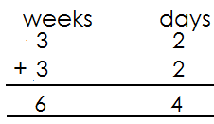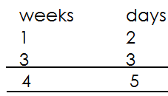 **Examples**

**Activity**

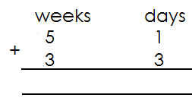 Add days and weeks

1. 2.

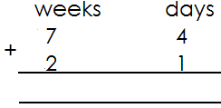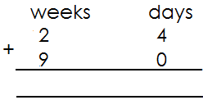

3. 4.

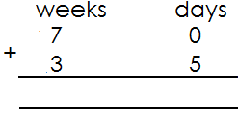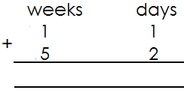

5. 6.

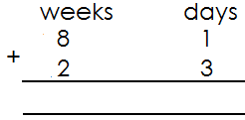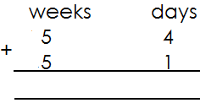

7. 8.

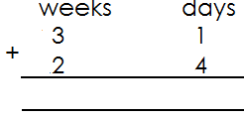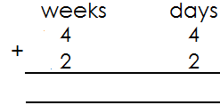

9. 10.

**Subtracting weeks and days**

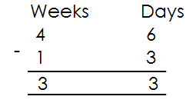**Examples**

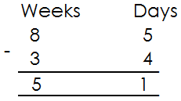

**Activity**

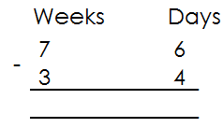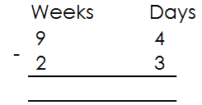**Subtract weeks and days**

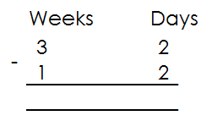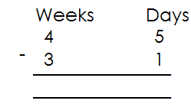

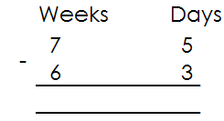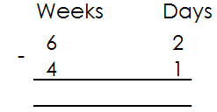

**MONTHS OF THE YEAR**

**Note:**

12 months make a year

|  |  |
| --- | --- |
| **MONTH** | **NUMBER OF DAYS** |
| January | 31 |
| February | 28/29 |
| march | 31 |
| April | 30 |
| may | 31 |
| June | 30 |
| July | 31 |
| August | 31 |
| September | 30 |
| October | 31 |
| November | 30 |
| December | 31 |

**Activity**

1. Fill in the missing letters

(a) J___n___ary (b) F___b__ua__y (c) M__rc__

(d) Ap__r___ e. M__y (f) J__n___ (g) Jul___ (h) A__g__st

(i) S__p__em__er

(j) O__t__b__r k. N__v__mb__r l. D__c__mb__r

2. How many months are in a year?

3. How many months are there in the first half of the year?

4. What is the last month of the year?

5. How many days has the month of May?

6. How many months have 30 days?

7. Which month of the year has 28/29 days?

8. How many letters are in the second month of the year?

9. What is he first month of the year?

**CHANGING YEARS TO MONTHS**

**Examples**

1. Change 2 years to months

1 year=12 months

2 years =2 x12 months

= 24 months

Or

2 x 12 months

12 + 12 months

24 months

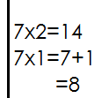2. How many months are in 7years?

1 year =12 months

7years =12 x 7

=84 months

**Activity**

1. Change the following years to months

(a) 3 years (b) 1 year (c)5 years (d) 9 years (e) 10 years (f) 4 years

(g) 6 years (h) 8 years

**Changing months to years**

**Examples**

1. How many years are in 24 months?

12 months =1year

24 months = 24 ÷ 12

=2years

2. Change 48 months to years

12 months =1year

48 months =48 ÷ 12

=4 years

**Activity**

1. Change the following months to years

(a) 12 months

(b) 36 months

(c) 24 months

(d) 60 months

(e) 72 months

2. **Complete the table below**

|  |  |  |  |  |  |
| --- | --- | --- | --- | --- | --- |
| Years | 1 | 2 | ____ | ______ | 7 |
| Months | 12 | _____ | 48 | 36 | _____ |

**Addition of years and months**

**Examples**

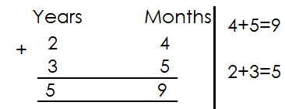1. Workout years and months

**Activity**

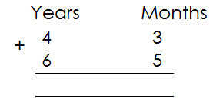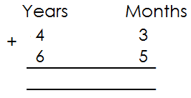**Add the following**

1. 2.

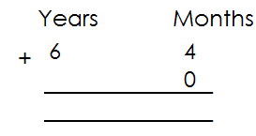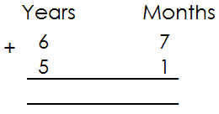

3. 4.

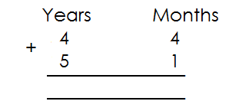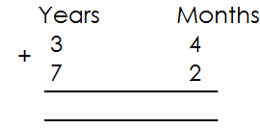

5. 6.

**SUBTRACTION OF YEARS AND MONTHS**

**Examples**

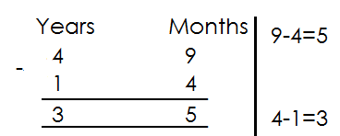1. Subtract

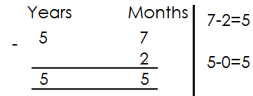2. Subtract

**Activity**

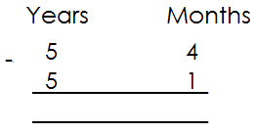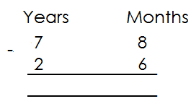**Subtract years and months**

1. 3.

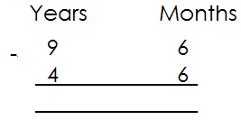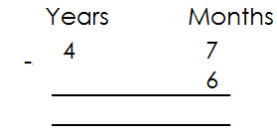

2. 4.

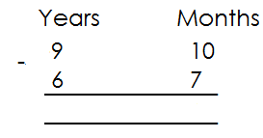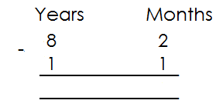

5. 6.

**HOURS AND MINUTES**

**1 hour =60 minutes**

**Changing hours to minutes**

**Examples**

1. How many minutes are in 2 hours?

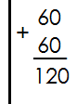 1 hour=60 minutes

2 hours= 2x60 minutes

=60+60

**=120 minutes**

2. Change 8 hours to minutes

1 hour = 60 minute

8 hours=8x60 minutes

**Activity**

Change the following hours to minutes

1. 3 hours 4. 6 hours

2. 1 hours 5. 7 hours

3. 4 hours 6. 5 hours

7. 2 hours 7. 10 hours

**ADDITION OF HOURS AND MINUTES**

**Examples**

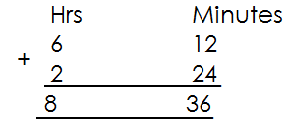1. Add:

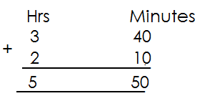

2.

**Activity**

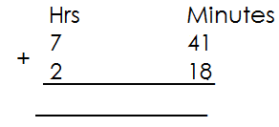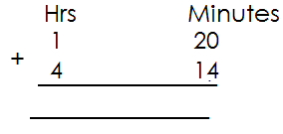**Add hours and minutes**

1. 2.

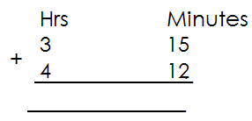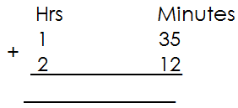

3. 4.

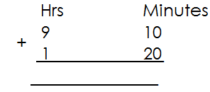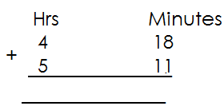

5. 6.

**Subtraction of hours and minutes**

**Examples**

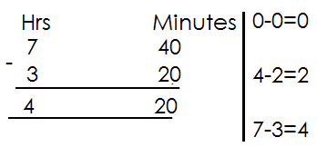1. Subtract:

**Activity**

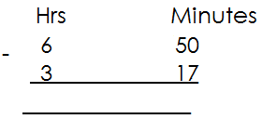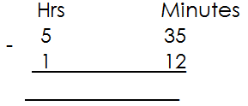**Subtract hours and minutes**

1.

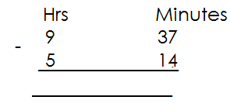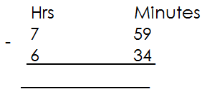

**TELLING TIME**

**Telling time in hours**

**Note**: When telling time in hours, the minute hand must point’s to12.

**Examples**

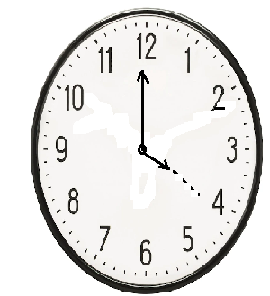1. What is the time?

The time is 4 O’clock.

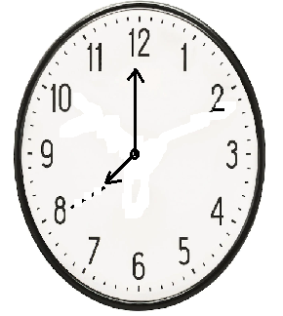2. Tell the time

**Activity**

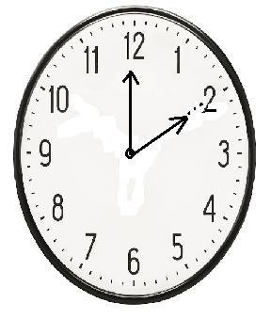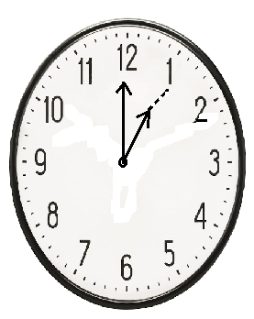Tell the time shown on the clock faces below.

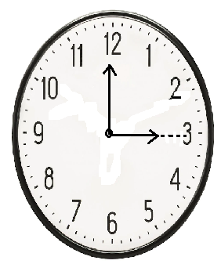 **____________ ___________**

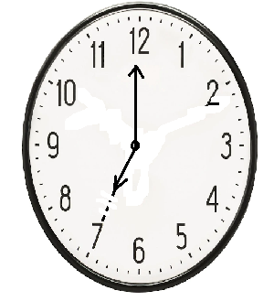

**_____________ ____________**

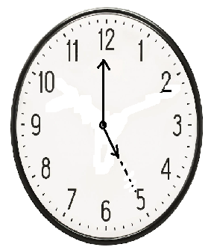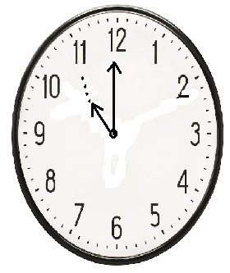

**______________ _______________**

**DRAWING CLOCK FACES TO SHOW THE GIVEN TIME**

**Examples**

1. Draw a clock face and show the time.

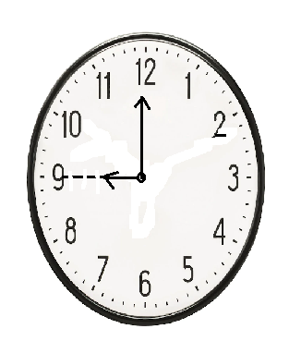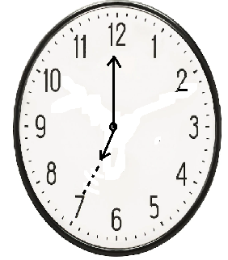(a) 7 O’clock 9 O’clock

**Activity**

**Draw clock faces and on them show the given time**

1. 4 O’clock 4. 11 O’clock

2. 6 O’clock 5. 12 O’clock

3. 1 O’clock 6. 3 O’clock

**TELLING TIME IN HOURS AND MINUTES**

**Note:**

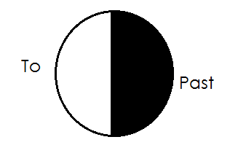The clock face has two major hands; The hour hand and minute hand. A short hand counts hours and a long hand counts minutes.

Shaded part we use minutes “past” unshaded part we use minutes “to”

**Telling time in hours and minutes using past**

**Note:**

When telling time using past, the minute hand must be in the first half of the clock.

The minute had must be on the right of the clock face.

From 1 minute up to 30 minutes we use past.

**USE QUARTER PAST**

When the minute hand points to **3** we say quarter past or **15** minutes “**past**” the hour.

**Examples**

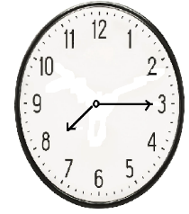1. Tell the time

It is quarter past 7 or 15 minutes past 7 o’clock

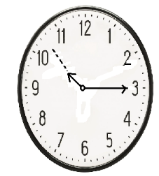2. What is the time?

The time is quarter past 11 or 15 minutes past 11 o’clock.

**Activity**

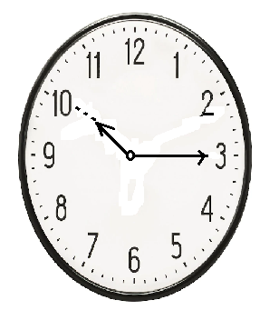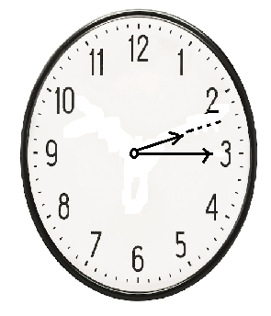1. What is the time?

a. b. 2.

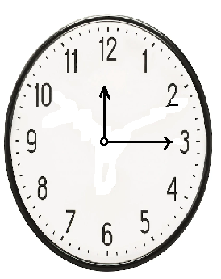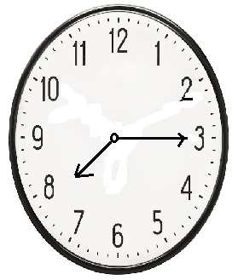

c. d.

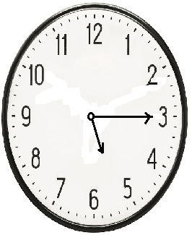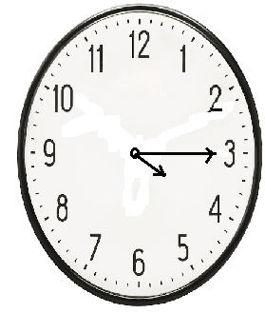

e. f.

**DRAWING CLOCK FACES TO SHOW QUARTER PAST**

**Examples**

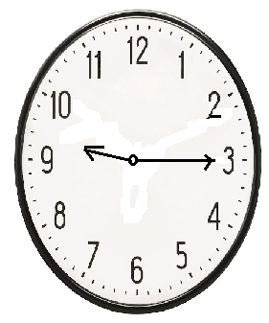1. Draw a clock face to show quarter past 9 o’clock

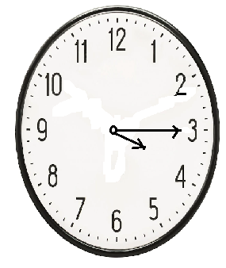2. Show 15 minutes past 3 o’clock.

**Activity**

**Draw clock faces to show the given time**

1. Quarter past **2** O’clock

2. **15** minutes past **8** O’clock

3. Quarter past **10** O’clock

4. Quarter past **4** O’clock

5. **15** minutes past 6 O’clock

6. Quarter past 12 O’clock.

**TELLING TIME USING “HALF PAST”**

**Note**: When telling time using half past, the minute hand must point to figure 6.

The hour hand will then point between two numbers

**Examples**

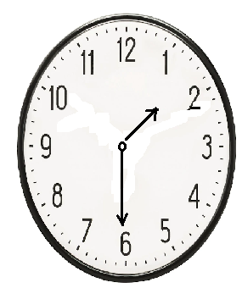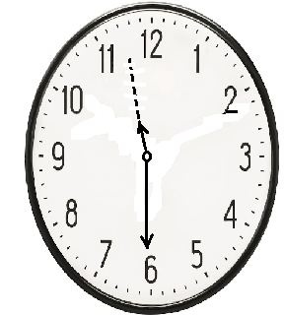 What is the time?

**Activity**

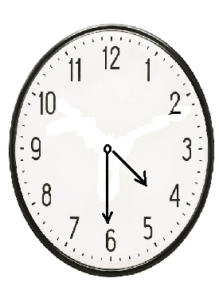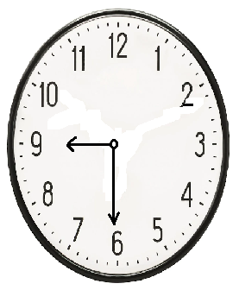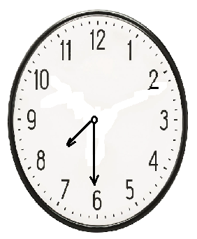**Tell the time using half past or 30 minutes past**

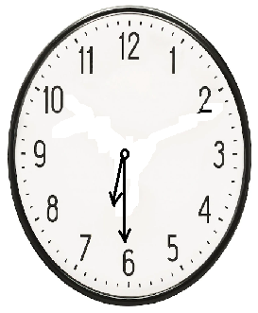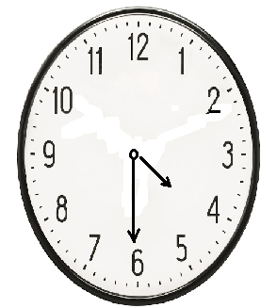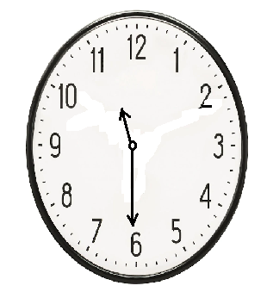

**DRAWING CLOCK FACES TO SHOW HALF PAST THE GIVEN TIME**

**Examples**

1. Draw a clock face to show;

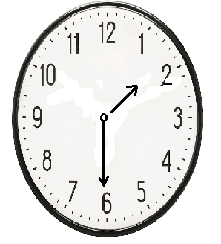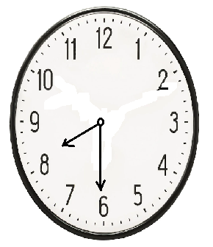(a) half past 8 O’clock (b) 30 minutes past 1 O’clock

**Activity**

**Draw the clock faces to show half past the given time**

(a) half past 4 O’clock

(b) 30 minutes past 10 O’clock

(c) 30 minutes past 4 O’clock

(d) half past 9 O’clock

(e) half past 12 O’clock

(f) 30 minutes past 3 O’clock

**MORE ON TELLING TIME USING “PAST”**

**Examples**

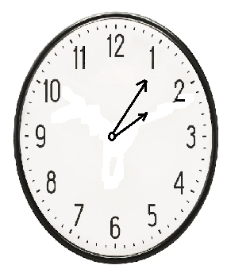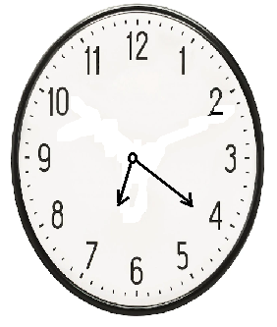 What is the time?

The time is 20 minutes past 7 O’clock The time is 5 minutes past 2 O’clock.

**Activity**

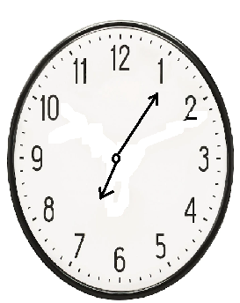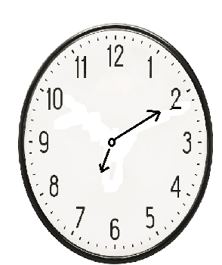Tell the time using “past”

1. 4.

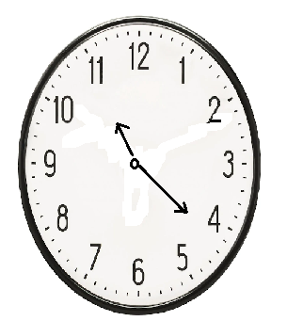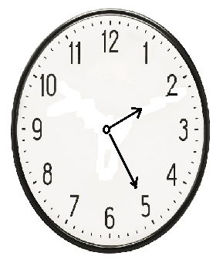

2. 5.

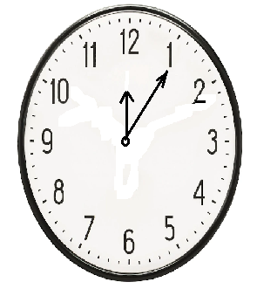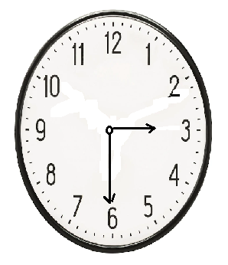

3. 6.

**TELLING TIME USING TO**

**Note**: the time after half past is told using to. The minute hand must be on the left hand of the clock face.

**Telling time using a quarter to**

When the time is a quarter to’ the minute hand must point to 9

A quarter to is 15 minutes to the next hour.

**Examples**

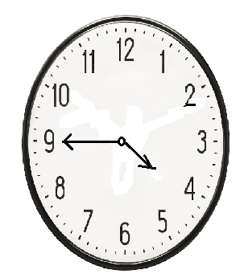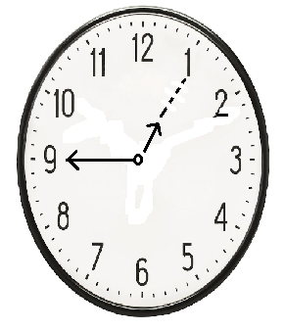1. What is the time 2. Tell the time

The time is a quarter to 1 O ‘clock It is a quarter to 4 O’clock

OR it is 15 minutes to 1 O’clock OR It is 15 minutes to 4 O’clock.

**Activity**

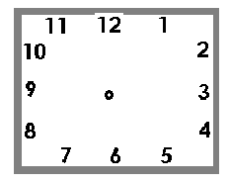Tell the time using a quarter to

1. 2.



3. 4.



5. 6.

**More on telling time using “to”**

1. **Examples**

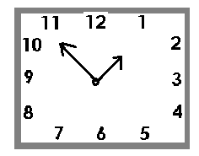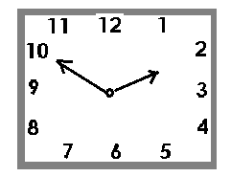 What is the time? The time is………………

It is 10 minutes to 2 O’clock it is 5 minutes to 1 O’clock.

**Activity**

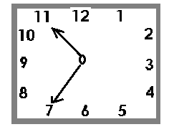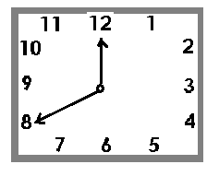Tell the time using to

1. 4.

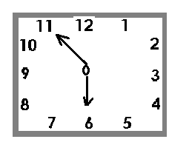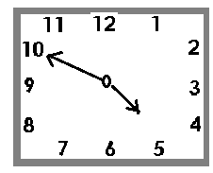

2. 5.

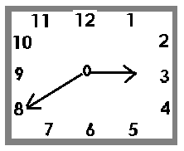

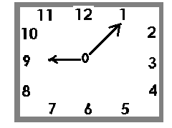3. 6.

**SHOWING TIME USING “TO” ON THE CLOCK FACES**

**Examples**

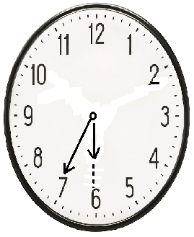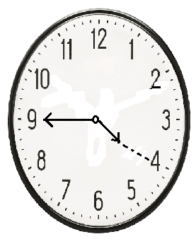 A quarter to 4 25 minutes to 6 O’clock

**Draw clock faces and show the following time**

(a) 9 half past 3 O’clock

(b) 9 quarter to 9 O’clock

(c) 5 minutes past 1 O’clock

(d) 20 minutes past 7 O’clock

(e) 10 minutes to 8 O’clock

(f) 15 minutes to 10 O’clock

(g) 25 minutes to 3 O’clock

**CALENDAR**

**January 2020**

|  |  |  |  |  |  |  |
| --- | --- | --- | --- | --- | --- | --- |
| **SUN** | **MON** | **TUE** | **WED** | **THUR** | **FRI** | **SAT** |
|  | 1 | 2 | 3 | 4 | 5 | 6 |
| 7 | 8 | 9 | 10 | 11 | 12 | 13 |
| 14 | 15 | 16 | 17 | 18 | 19 | 20 |
| 21 | 22 | 23 | 24 | 25 | 26 | 27 |
| 28 | 29 | 30 | 31 |  |  |  |

**QUESTIONS**

1. Which month is shown on the calendar?

2. How many days are in the month?

3. On which day of the week did the month begin?

4. How many Sundays are in the month?

5. Which day was 24th?

6. On which day did the month end?

7. How many Wednesdays are in the month?

8. Which day was 13th?

9. Which month comes after the month?

**APPLICATION OF TIME**

**Examples**

**Finding the age**

1. Mike was born in 1981. How old was he in1997?

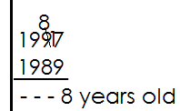 **Solution**

If the year is

He was

He was 8 years old.

1. 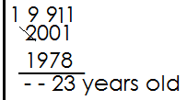A mother was born in 1978 and got her first born in 2001. How old was she when she got a baby?

She got baby-

She was born

She got her first baby at 23 years of age.

**Activity**

1. Deo was born in 1960. How old was he in 1985?

2. Mr. Obbo was born in 1970. How old was he in 1996?

3. A boy was born in 2005 and started school in 2009. At what age did he start school?

4. Mulema was born in 1974 and died in 2000. How old was he?

5. Joy was born in 1986 and got married in 2014. How old was she when she got married?

**MEASURES**

**MONEY**

Money is a medium of exchange.

Money is used as an exchange.

**RECOGNITION OF MONEY**

In Uganda we use coins and notes

|  |  |  |
| --- | --- | --- |
| **COINS/NOTES** | **VALUE** | **COMMON FEATURE** |
| **COINS** | | |
| Sh. 50 coins | Fifty shilling | Head of a cow |
| Sh. 100 coin | One hundred shillings | cow |
| Sh. 200 coin | Two hundred shillings | fish |
| Sh. 500 coin | Five hundred shillings | Head of crested crane |
| Sh. 1000 coin | One thousand shillings | Crested crane |
| **NOTES** | | |
| Sh. 1000 note | One thousand shillings | kob |
| Sh. 2000 note | Two thousand shillings | fish |
| Sh. 5000 note | Five thousand shillings | nest |
| Sh.10,000 note | Ten thousand shillings | Banana plant |
| Sh. 20,000 note | Twenty thousand shillings | bull |
| Sh. 50,000 note | Fifty thousand shillings | gorilla |

**CONVERSION OF MONEY**

**Example 1**

Jane had 4 five hundred shillings coins. How much did she have altogether?

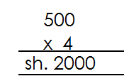**Solution**

1 note--------sh. 500

4 notes--------sh. 500x4

---------sh. 2000

**Example 2**

How many sh. 50 coin make a one hundred shillings coin?

**Solution**

= sh. 100 ÷ 50

= 2 fifty coins

**Activity**

1. Peter had 2 fifty shillings coins, how much did he have altogether.

2. How much money can one get from 6 one-hundred-shilling coins?

3. Okello had a bundle of 8 two-thousand-shilling notes how much did he have altogether?

4. How much altogether can be got from a 20 ten-thousand-shilling notes.

5. Sarah had 10 five-thousand-shilling notes how much money did she have altogether?

6. How many one-hundred-shilling coins will someone get for one thousand-shilling notes?

7. How many five-hundred-shilling coins make a one-thousand-shilling note?

8. Find the number of two-thousand-shilling notes that can be got from a one, ten-thousand-shilling note.

**ADDITION OF MONEY**

**Example 1**

Add: sh. 200 + sh. 50

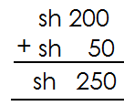 **Solution**

**Example 2**

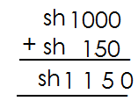 Add: sh. 1000+ sh. 150

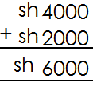 **Example 3**

**Activity**

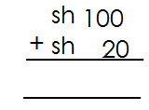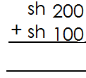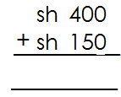 **Work out**

1. 2. 3.

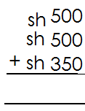

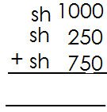4. 5.

6. Sh. 400+ sh. 350=__________ 7. Sh. 300 + sh. 480=______________

**WORD PROBLEMS ON ADDITION OF MONEY**

**Example 1**

Musa had sh. 500 coin and sh. 100 coin. How much did he have altogether?

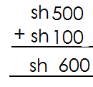 **Solution**

**Example 2**

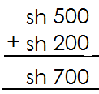I had 500 shillings. My father gave me 200 shillings more. How much money do I have now?

**Activity**

1. Grace had sh. 50. He father gave her sh. 50 more. How much money did grace have altogether?

2. Musoke had sh. 250. How was given another sh. 200. How much money had he altogether?

3. A trader had sh. 500. He sells his oranges for sh. 400. How much money has he now?

4. Namusisi got sh. 600. Her friend gave her sh. 500 more. How much money does she have now?

5. I had sh. 1000. My friend gave me sh. 100 more. How much money do I have now?

6. Akiiiki had sh. 750. Her friend gave her sh. 200. How much money does she have altogether?

7. Ada has sh. 400. Apio has sh. 3050 and Auma has sh. 500. How much money do they have altogether?

8. Mutungi sold a pineapple at sh. 550, a mango at sh. 200 and an orange at sh. 800. How much money did he get?

9. Ssembatya had sh. 2600. His friend gave him sh. 3800. How much did he have altogether?

**SUBTRACTION OF MONEY**

**Example1**

Subtract: sh. 100 - sh. 50

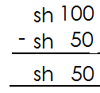 **Solution**

**Example 2**

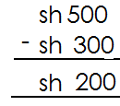Workout:

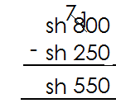**Example 3**

Subtract:

**Activity**

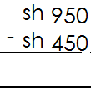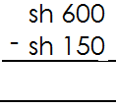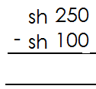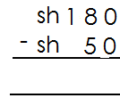1. 2. 3. 4.

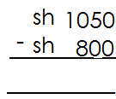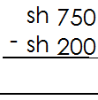5. 6.

7. Sh. 1450- sh. 100

8. Sh. 1850 – sh. 250

9. Sh. 1780 – sh. 1540

**WORD PROBLEMS ON SUBTRACTION OF MONEY**

**Example1**

1. Mukooza had sh. 350. He gave away sh. 100. How much money did he remain with?

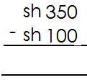 **Solution**

**Example 2**

My teacher had sh. 1000. He spent sh. 300. How much money remained?

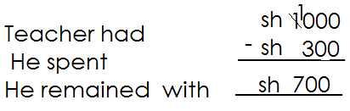**Solution**

**Activity**

1. My mother had sh. 500. She gave me sh. 200. How much money did she remain with?

2. Moses had sh. 5000. He bought a ball for sh. 3500. How much money remained?

3. Mary was given sh. 9000. She bought a book for sh. 5800. How much remained?

4. A boy had sh. 5500. He spent sh. 2500. How much money remained?

5. A girl had sh. 1000. She made a budget of 1 book for sh. 200 and 1 pen for sh. 300. How much will she remain with?

6. Lillian was given sh. 5000. She bought a book at sh. 4200. How much money remained?

7. Susan spent sh. 7300 o her trip to the national park. If she had sh. 10,000 altogether, how much money was she left with?

8. Father had sh. 2560. He bought sugar for sh. 1200. How much balance did he have left?

9. Ben had sh. 2450. He bought a shirt at sh. 1735. How much money did he remain with?

**MULTIPLYING MONEY**

**Example 1**

Multiply: sh. 150 x6

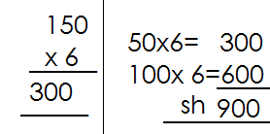 **Solution**

**Example2**

Workout: sh. 345 x5

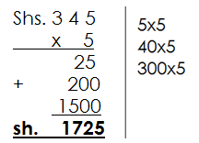 **Solution**

**Activity**

Workout:

1. Sh. 200 x 3 4. Sh. 298 x 3

5. sh. 250 x 3

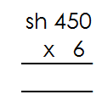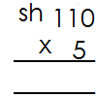2. =

6.

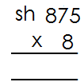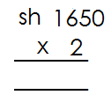

3. 7.

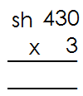8. sh. 2400 x 4 9. 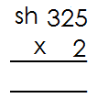

10.

**WORD PROBLEM ON MULTIPLICATION OF MONEY**

**Example 1**

One book costs sh. 50. How much money will Angela pay for two books?

**Solution**

One book costs sh. 50

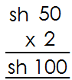2 books will cost sh.

One pen costs sh. 345. What is the cost of 4 pens?

1 pen costs sh. 345

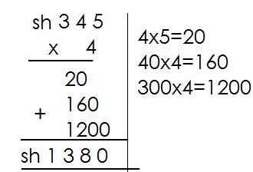4 pens cost sh. 345

**Activity**

1. One cake costs sh. 250. Find the cost 0f 3 cakes.

2. A pencil costs sh. 155. Find the cost of 7 pencils.

3. One small bottle of cough mixture costs sh. 298. What is the cost of 3 bottles?

4. A piece of sop costs sh. 350. How much will you pay for 5 pieces?

5. John sells a chapatti at sh. 1000. How much will he get if he sells 8 chapatis?

6. A kilogram of beans cost sh. 600. How much will mother pay for 6 kilograms?

7. A packet of salt costs sh. 250.how much money will Kate pay if she buys 2 packets?

8. Kapere bought 4 belts at sh. 2400 each. How much did he pay?

9. A bunch of matooke cots sh. 2015. How much will I pay for 3 bunches?

10. A pair of shoes costs sh. 2500. How much will john pay for 3 pairs of shoes?

**DIVISION OF MONEY**

**Examples**

1. Jane had sh. 600 and she shared it equally among 3 boys. How much did each boy get?

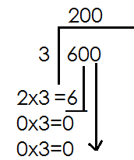Each boy= 600 ÷ 3

Each boy gets sh. 200

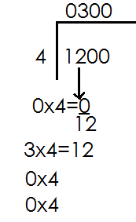2. Divide sh. 1200 ÷ 4

Sh. 1200 ÷ 4 = sh. 300

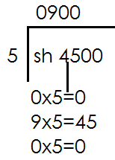**3.** Divide: sh. 4500 ÷ 5

**Activity**

1. Divide sh. 300 ÷ 2

2. Divide sh. 4800 ÷ 3

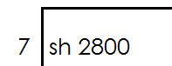3. Divide sh. 2400 ÷ 6

4. Divide:

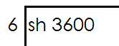

5. Divide:

6. 8 worker shared sh. 3200 equally, how much money did each get?

7. Peter had sh. 4200, he shared it equally among 3 girls, how much did each girl get?

8. Ten men shared sh. 4800 equally how much did each get?

9. Musa shared sh. 6400 among5 boys equally, how much money did each boy get?

10. 4 boys shared sh. 7200 equally, how much did each get?

**SHOPPING**

**Examples**

Below are the prices of different items at the shop.

1 book costs sh. 600

A pen costs sh. 500

A pencil costs sh. 200

(a) What is the most expensive item at the shop

A book

(b) Identify the cheapest item at the shop.

A pencil

(c) If Musa bought 2 books, how much did he pay altogether?

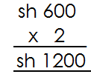 1book ------ sh. 600

2 books---- sh. 600 x 2

-------- sh. 1200

(d) If he bought all the three items, how much did he pay altogether?

A book ------ sh. 1600

A pen ------ sh. 500

A pencil **+ sh. 200**

Total = ------ **sh. 1300**

(e) Sarah bought 2 pens and 1 book; how much did she pay altogether?

|  |  |  |
| --- | --- | --- |
| **pens** | **book** | **total** |
| Sh. 500  + sh. 500  Sh. 1000 | Sh. 600 | Sh. 1000  + Sh. 600  Sh. 1600 |

(f) Opio had sh. 1000, how many pencils did he get?

Sh. 1000 ÷ 200

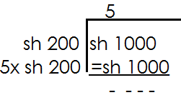 = 5 pencils

**Activity**

1. The table below shows the price list in Mukasa’s shop. Use it to answer questions.

|  |  |
| --- | --- |
| item | price |
| A book | Sh. 400 |
| A pencil | Sh. 250 |
| An egg | Sh. 300 |

(a) What is the most expensive item?

(b) Identify the cheapest item at the shop.

(c) Owino bought a book and a pencil. How much did he pay?

(d) Peter bought all the three items; how much did he pay altogether?

(e) Matama had sh. 2000, how many books did he get at the shop?

2. Below is the cost of different items at the supermarket

1 kg of sugar at sh. 4000

1 packet of omo at sh. 1500

A book at sh. 1000

(a) A man bought 1kg of sugar and 1 book. How much did he pay?

(b) If Ajambo bought 2 packets of omo and 3 books. How much did she pay?

(c) James had sh. 4500, how many packets of omo did he get?

3. The table below shows the price lists of different items at the shop. Use it to answer questions.

|  |  |
| --- | --- |
| **Item** | **Price** |
| A bar of soap | Sh. 4000 |
| 1 kg of rice | Sh. 2000 |
| A pen | Sh. 500 |

(a) How much does a pen cost?

(b) Find the cost of 1 kg of rice and a bar of soap.

(c) Moses bought 2 pens and 1 kg or rice, how much did he pay?

(d) Martha had sh. 20, 000, how many bars of soap did he get?

**LENGTH**

Length is how short or long something maybe.

**Parts of the body used to measure length**

palm, cubit, arm’s length, hand span, fathom, foot paces, strides

**Objects used to measure length**

ruler, strings, threads, banana fibres, sticks, measuring tapes

**Measuring length**

A teacher should involve all learners in measuring things in class room using the above objects. (Practical work)

**Changing metres to centimetres**

**Note:** 1 metre = 100cm

**Examples**

Change 4 metres to centimetres

**Solution**

1m = 100cm

4cm = (4 x 100) cm

**= 400cm**

Change 12 metres to centimetres

**Solution**

1 m =100cm

12m= (12x100) cm

=1200cm

**Activity**

Change the following metres to centimetres

1. 6m 6. 20m

2. 14m 7. 32m

3. 7m 8. 46m

4. 8m 9. 120m

5. 15m 10. 48m

**CHANGING CENTIMETRES TO METRES**

100cm = 1 metre

**Examples**

Change 400cm to metres

**Solution**

100cm=1m

1cm= ($\frac{1}{100}$) m

400cm= ( $\frac{1}{100}$ x 400) m

**= 4m**

Covert 1200cm to metres

**Solution**

100cm = 1m

1cm = ( $\frac{1}{100}$) m

1200cm = ( $\frac{1}{100}$ x 1200) m

**= 12m**

**Activity**

Change the following centimetres to metres.

1. 200cm 6. 12000cm

2. 350cm 7. 3200cm

3. 150cm 8. 800cm

4. 500cm 9. 1400cm

5. 700cm 10. 4800cm

11. Complete the table below.

|  |  |  |  |  |
| --- | --- | --- | --- | --- |
| M | 6 | ______ | 8 | ________ |
| CM | ________ | 200 | ________ | 900 |

**ADDITION OF METRES AND CENTIMETRES**

**Note:**

1 metre = 100cm

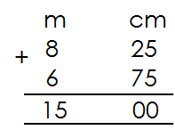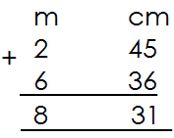 **Example 1**

1. Add: 2. Add:

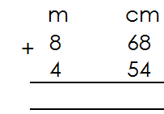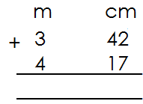**Activity**

1. 5.

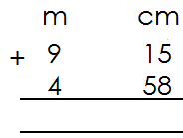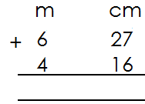

2. 6.

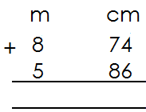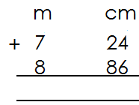

3. 7.

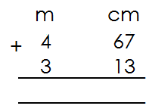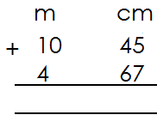

8. 9.

**WORD PROBLEMS ON ADDITION OF METRES AND CENTIMETRES**

**Example1**

The length of our blackboard s 1 m 35cm, the length of the p.3 class blackboard is 2m 10cm. Find the length of the two black boards.

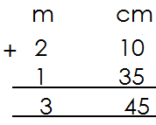**Solution**

P.3 black board

Our blackboard

Total length

**Example 2**

A shopkeeper has 4m 38cm of nylon cloth and 6m 30cm of cotton cloth. What is the total length of the pieces of cloth?

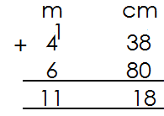**Solution**

Nylon cloth

Cotton cloth

Total length

**Activity**

1. Musa’s sugarcane is 1 m 15 cm, Ali’s sugarcane is 2m 26cm. find the length of the two pieces of sugarcane?

2. The length of our classroom verandah is 7m 48cm and the length of the p.2 classroom veranda is 6m 24cm. find total length of the two verandahs.

3. Amina is 1m 25cm tall and Cissy is 1m 8cm tall. Find the total height of the two girls.

4. Martha’s mat is 2m 51cm long and Nakato’s mat is 3m 36cm long. Find the total length of the two mats.

5. Asaba’s rope s 2m 56cm long and Mugisha’s rope is 3m 84cm. find the total length of the 2 ropes.

6. Dad’s table is 8m 46cm long and ours is 6m 38cm. find the total lengths of the two tables.

**SUBTRACTION OF METRES AND CENTIMETRES**

**Example 1**

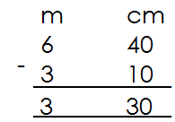 Subtract:

**Example 2**

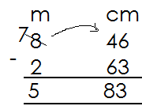Subtract:

**Activity**

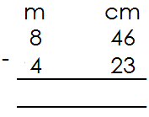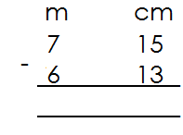**Subtract in metres and centimetres**

1. 5.

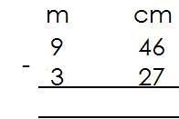

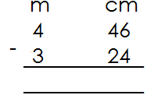 6.

2.

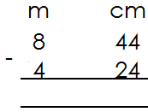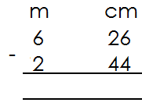

3. 7.

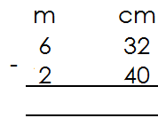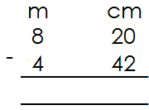

4. 8.

**WORD PROBLEMS ON SUBTRACTION OF METRES AND CENTIMETER**

**Example1**

Peter’s sugar cane was 2m 85cm long. He cut off 1m 10cm and gave it to his young brother. What length of the sugarcane remained?

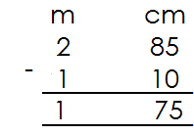

**Example 2**

A trader had 15m 53cm of cloth. He sold 5m 70cm of it. What length of the cloth was left?

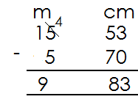**Solution**

**Activity**

1. Nakandi had s string of 8m 47cm. she cut of 2m 16cm. what length of the string was left?

2. A trader had 15m 53cm of cloth. He sold 5m 10cm of it. What length of cloth was left?

3. The height of 2 girls is 2m 42cm. if one of the girls is 1m 28cm tall, find the height of the other girls.

4. A trader had ribbon 12m 5cm long. He sold 4m 87cm. find the length of the remaining ribbon.

5. The length of 2 ropes is 13m 81cm. if one of the ropes is 6m 27cm, find the length of the second rope.

6. A carpenter had a piece of wood 10m 60cm long. He cut off 4m 15cm to make a bench. What length of the piece of wood was left?

**PERIMETER**

Perimeter is the total distance around a figure.

**FINDING PERIMETER OF FIGURES**

Perimeter is got by adding the length of the sides forming a figure.

**Example 1**

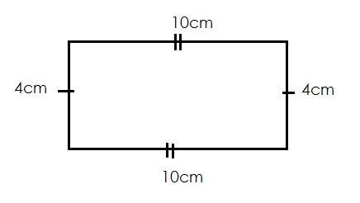 Find the perimeter of the figure below.

P= L+W+L+W

= 10cm +4cm +10cm +4cm

=14cm+14cm

=28cm

**Example2**

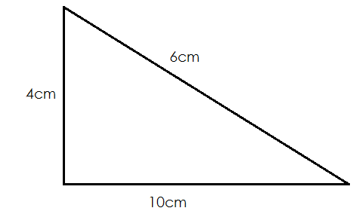 Find the total distance around the figures below.

**Solution**

Perimeter = s + s + s

= 10cm + 6cm + 4cm

= 20cm

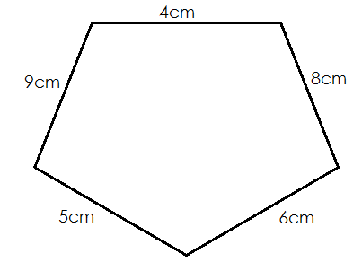**Example3**

**Solution**

Perimeter= s +s +s +s +s

= 5cm + 6cm + 8cm + 4cm + 9cm

**= 32cm**

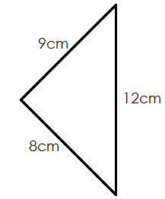**Activity**

**Find the perimeter of these figures**

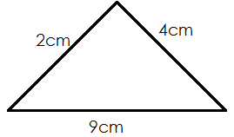1. 2.

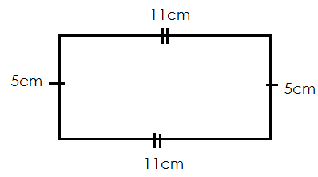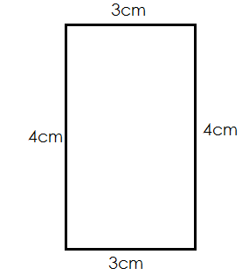

3. 4.

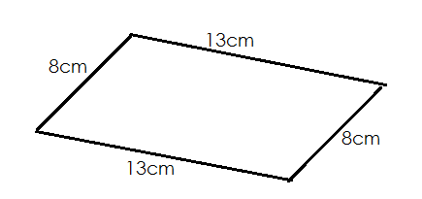

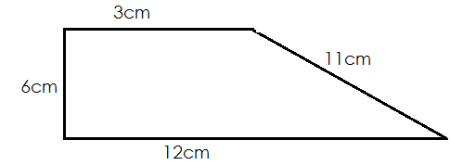

5. 6.

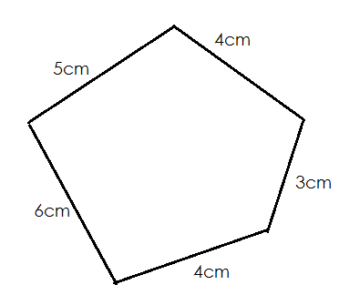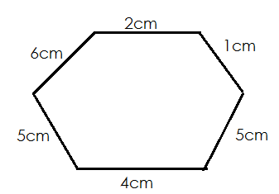

7. 8.

**AREA**

Area is the size of the space covered by an object on a flat surface.

**Finding area by counting squares.**

**Example1**

|  |  |  |
| --- | --- | --- |
|  |  |  |
|  |  |  |
|  |  |  |

Area= 9 squares

**Example2**

What is the area of the figure below?

|  |  |  |  |  |  |
| --- | --- | --- | --- | --- | --- |
|  |  |  |  |  |  |
|  |  |  |  |  |  |
|  |  |  |  |  |  |

**Solution**

Area=18 squares

**Activity**

Find the area of the following by counting squares

|  |  |  |
| --- | --- | --- |
|  |  |  |
|  |  |  |
|  |  |  |
|  |  |  |

1.

|  |  |  |
| --- | --- | --- |
|  |  |  |
|  |  |  |

2.

|  |  |  |  |  |
| --- | --- | --- | --- | --- |
|  |  |  |  |  |
|  |  |  |  |  |
|  |  |  |  |  |

3.

|  |  |  |  |  |  |  |  |  |  |
| --- | --- | --- | --- | --- | --- | --- | --- | --- | --- |
|  |  |  |  |  |  |  |  |  |  |
|  |  |  |  |  |  |  |  |  |  |

4.

|  |  |  |  |
| --- | --- | --- | --- |
|  |  |  |  |
|  |  |  |  |
|  |  |  |  |

5.

**FINDING AREA BY MULTIPLICATION**

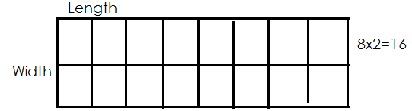Find area of the figure

**Solution**

|  |  |
| --- | --- |
| length | 8 squares |
| width | 2 squares |
| area | 16 squares units |

**Example 2**

Find area of the figure below.

Width

|  |  |  |
| --- | --- | --- |
|  |  |  |
|  |  |  |
|  |  |  |
|  |  |  |
|  |  |  |

Length 5x3=15

|  |  |
| --- | --- |
| length | 5 squares |
| width | 3 squares |
| area | 16 squares units |

**Activity**

|  |  |  |
| --- | --- | --- |
|  |  |  |
|  |  |  |
|  |  |  |
|  |  |  |

1. Length_______________

Width________________

Area________________

|  |  |  |
| --- | --- | --- |
|  |  |  |
|  |  |  |
|  |  |  |
|  |  |  |

2. Length=____________

Width=____________

Area=____________

|  |  |  |  |  |  |
| --- | --- | --- | --- | --- | --- |
|  |  |  |  |  |  |

3. Length=_____________

Width=_____________

Area=_____________

|  |  |  |  |
| --- | --- | --- | --- |
|  |  |  |  |
|  |  |  |  |
|  |  |  |  |
|  |  |  |  |
|  |  |  |  |
|  |  |  |  |

4. Length=_____________

Width=_____________

Area=_____________

|  |  |  |  |
| --- | --- | --- | --- |
|  |  |  |  |
|  |  |  |  |
|  |  |  |  |

5. Length=_____________

Width=_____________

Area = _____________

|  |  |  |  |  |
| --- | --- | --- | --- | --- |
|  |  |  |  |  |
|  |  |  |  |  |
|  |  |  |  |  |
|  |  |  |  |  |
|  |  |  |  |  |

6. Length = _____________

Width = _____________

Area = _____________

**FINDING AREA OF A SQUARE**

**Example 1**

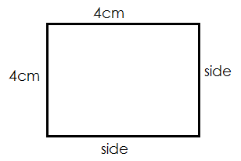Find the area of the squares below

|  |  |  |  |
| --- | --- | --- | --- |
|  |  |  |  |
|  |  |  |  |
|  |  |  |  |
|  |  |  |  |

=

Area = 4sq x 4sq

= 16squnits Area = side x side

= 4cm x 4cm

= 16sq cm

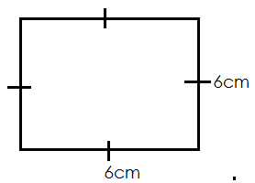 Find area of square below

Area = side x side

= 6cm x6cm

**= 36sqcm**

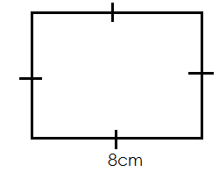 Below is a square, find its area

Area=s x s

= 8cmx8cm

**= 64 sq cm**

**Activity**

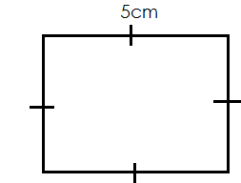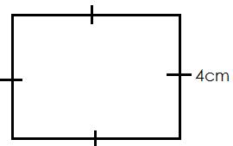 **Find the area of the following squares**

1. 2.

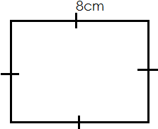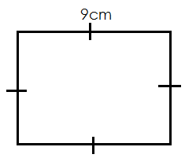

3. 4.

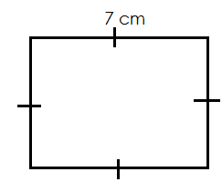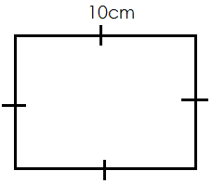

5. 6.

**FINDING AREA OF RECTANGLES**

**Examples.**

Find the area of the rectangle below.

|  |  |  |  |
| --- | --- | --- | --- |
|  |  |  |  |
|  |  |  |  |

Area=5sq x2sq

=10 sq units

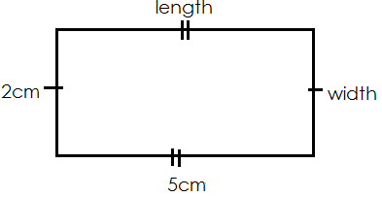

Area= length x width

=5cm x 2cm

=10 sq cm

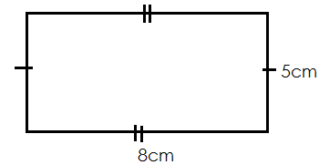Find area of the figure below.

Area= length x width

= 8 cm x 5 cm

= 40 sq cm

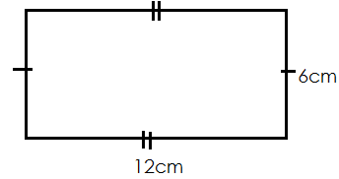Find the area of a rectangle below.

Area=L x W

= 12cm x 6cm

**= 72 sq cm**

**Example 4**

Find area of a rectangle whose length is 7cm and width 4cm

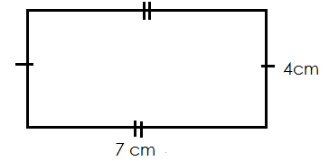 **Solution** Area = LXW

= 7cm x 4cm

= 28 sq cm

**Activity**

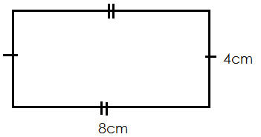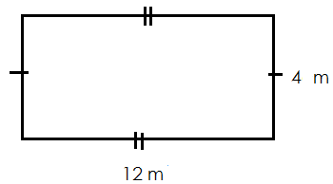 **Find the area of the following rectangles**

1. 2.

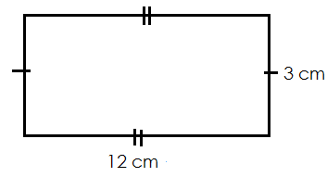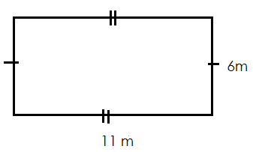

3. 4.

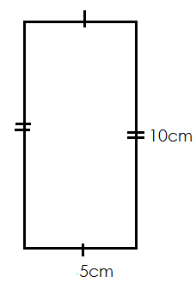

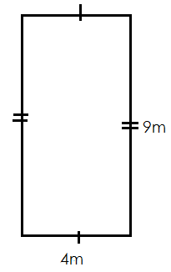5. 6.

7. Musa’s note book is 4cm long and 3cm wide. Find ist area.

8. The length of our compound is 20cm long and 6m wide. Find its area.

9. Find the area of a netball court whose length is 15m and width 5m.

10. A rectangular sheet of paper is 11cm long and 8cm wide. Find its area.

**MORE ABOUT FINDING AREA**

**Example 1**

(a) Find the area of the shaded parts

|  |  |  |  |  |  |  |  |  |
| --- | --- | --- | --- | --- | --- | --- | --- | --- |
|  |  |  |  |  |  |  |  |  |
|  |  |  |  |  |  |  |  |  |
|  |  |  |  |  |  |  |  |  |
|  |  |  |  |  |  |  |  |  |

**Solution**

Area of a shaded =10 squares

(b) Find area of the unshaded part.

**Solution**

Areas of unshaded =26 squares

**Activity**

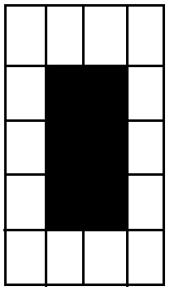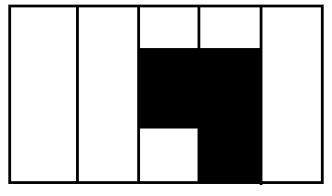 Find the area of the shaded and the unshaded parts in the following

1. 2.

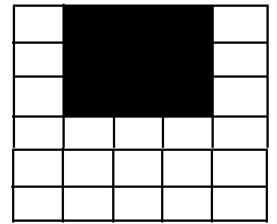3.

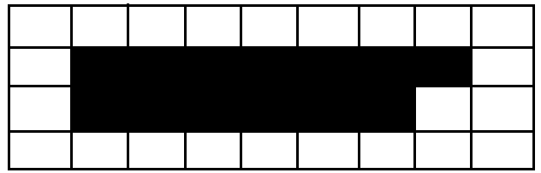 5.

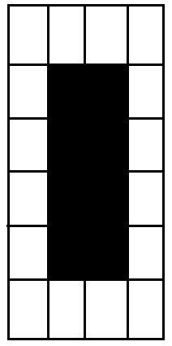

4.

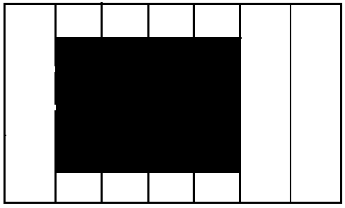 6.

**CAPACITY**

Capacity is the amount of things that a given container can hold.

The basic unit for capacity is litres

**COMMON LIQUIDS MEASURED**

Water milk oil paraffin medicine juice

**Things used to measure liquids**

Cups pots jugs spoons tins jerry cans measuring cylinder drums

**CHANGING LITRES TO CENTILITERS**

**Note**

1 litres=100 centilitres

We can write litres as L and centiliters as cl

**Examples1**

Change 4 l to cl

1l =100cl

4l=(4x100) cl

=400cl

**Example 2**

Change 12l to centiltres

**Solution**

1l=100cl

12l= (12x100) cl

=1200cl

**Activity**

Change the following litres to centiliters

1) 6l 5) 20l

2) 8l 6)16l

3) 14l 7)13l

4 9l 826l

**CHANGING CENTILITRES TO LITRES**

**Note:**

When changing small units to big units, divide

**Examples**

Change 400cl to l

**Solution**

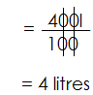 100cl= 1l

400cl

Change 1400cl to l

**Solution**

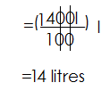100cl=1l

1400cl

Change the following centilires to litres

1. 600cl

2. 900cl

3. 2000cl

4. 1800cl

5. 1500cl

6 1200 cl

7. 700cl

8. 500cl

**Finding number of half litres in given containers**

**Examples**

How many $\frac{1}{2}$ litre bottles of water can fill a 10 litre jerry can.

**Solution**

1l=2 half litres

10l= (10x2) half litres

=20 half litre bottles

How many $\frac{1}{2}$ litre cups will fill 8l jug

**Solution**

1l=2 half litres

8l= (2x8) half litres

=16 half litre cups.

**Activity**

1. How many litre cups will fill a 9 litre jerry can?

2. How many litre bottles will fill 15 litres.

3. How many $\frac{1}{2}$ litre jerry cans will fill 30 litre sauce pan?

4. How many $\frac{1}{2}$ litre tins will fill a 22 litrew bucket?

5. Find the number of $\frac{1}{2}$ litre bottles can fill a jerry can of 20 litres.

6. Find the number of $\frac{1}{2}$ litre bottles that can fill a bucket of 16 litres.

7. How many $\frac{1}{2}$ litres can fill a jerry can of 60 litres?

**FINDING NUMBER OF QUARTER LITRES IN A GIVEN CONTAINERS**

**Note**:

1 litre= 4 quarter litres

**Examples**

How many $\frac{1}{4}$ litre bottles of milk can fill a jerry can of 3 litres

**Solution**

1l=4 quarter litres

3l= (3x4) quarter litres

=12 quarter litres

Find number of $\frac{1}{4}$ litre tins of honey that can fill a 5 litre bottle.

**Solution**

1l=4 quarter litres

5l= (4x5) quarter litre

=20 quarter litres

**Activity**

1. How many litre cups will fill a 9 litre jerry can?

2. How many litre bottles will fill 15 litres?

3. How many $\frac{1}{4}$ litre jerry cans will fill 30 litres saucepan?

4. Find the number of $\frac{1}{4}$ tins of honey that can fill a jerry can of 6 litres?

5. How many $\frac{1}{4}$ litre bottles of cooking oil will fill a jug of 15 litres?

**COMPARING CAPACITY**

**Examples**

How many 1 litre cups will fill three 5 litre jerrycans?

**Solution**

Number of 1l cups = 3x5

**= 15cups**

Find the number of 1 litre bottles that can fill six 5 litre jerrycans.

**Solution**

Number of bottles = (6x5)

= 30 bottles

**Activity**

1. How many litre cups will fill four 5 litre jerry cans?

2. Find number of 1 litre bottles that can fill three 10 litre jugs.

3. How many litres tins of water can fill five 20 litre buckets?

4. Find the number of 1 litre cups that can fill four 5 litre jugs

5. How many 1 litre cups of milk can fill seven 5 litre jerrycans?

6. How many 1 litre tins of honey can fill eight 10 litre jerrycans?

7. Find the number of 1 litre cups of cooking oil that can fill five 5 litre jerrycans.

**ADDITION IN CAPACITY**

**Examples**

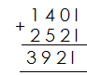 Add: 140l+ 252l

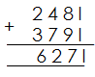Add: 248litres + 379 litres.

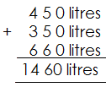 Add:

**Activity**

**Add the following**

1. 109 litre + 463 litres

2. 956 litres + 483 litres

3. 742 litres + 324 litres + 146 litres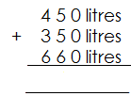

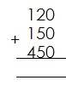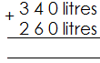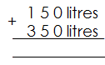4. 5. 6. 7.

**ADDITION OF LITRES AND CENTILITRES**

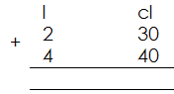**Examples**

Add:

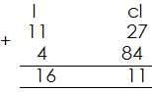Add:

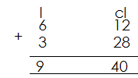

Add:

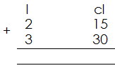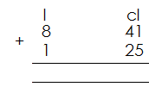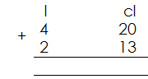**Activity**

1. 2. 3.

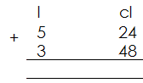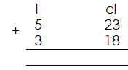

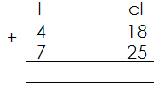4. 5. 6.

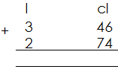

7.

**WORD PROBLEM IN ADDITION OF CAPACITY**

**Examples**

A drum holds 146litre of water and a bucket holds 94 litres of water. Find the total capacity of the two containers

**Solution**

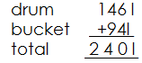

Mukasa’s jerrycan holds 3 litres and 12 centilitres of water and Jane’s jerry can

holds 6 litres and 40 centilitres of water.

Find the amount of water which they both hold.

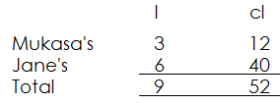 **Solution**

**Activity**

1. A small jerry can hold 20 litres of water and a container holds 46 litres of water, find the total amount of water that they both hold.

2. Musa’s jerry can hold 47 litres of water and peter’s jerry can holds 38 litres of water. Find the amount of water which both jerry can hold.

3. Mr. Okodi’s car uses 56l of petrol a week and Othieno’s car uses 97l. Find the amount of petrol used by both cars in a week.

4. St. Anthony p/s used 1462 litres of water in a week and excel p/s uses 1261 litres of water in a week. How many litres of water will the two schools use in a week?

5. On a farm 146 litres of milk are collected in the morning ns 112 litres are collected in the evening. How many litres of milk are produced in a day?

6. Martha made 24l and 86cl of juice and Jane made 62l and 46cl of juice. How much juice did the two girls brew?

7. Opio’s pot holds 72litres 85 centiltres of water and James’s pot holds 42 litres 25 centilitres of water. Find the amount of water both pots hold.

8. Mr. Okello’s cows produce 24l and 86cl of milk and Opio’s cows produce 36l and 76cl of milk. Find the amount of milk that is produced by all cows.

**SUBTRACTION OF LITRES**

**Example 1**

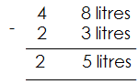 Subtract:

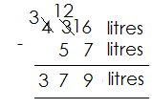 Subtract:

**Example 3**

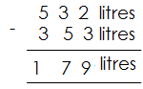Subtract:

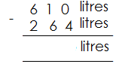**Activity**

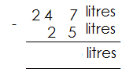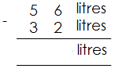Subtract the following 3.

1. 2.

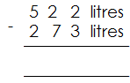

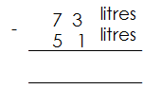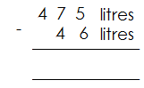 6.

4. 5.

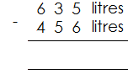

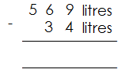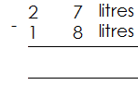 9.

7. 8.

**SUBTRACTION OF LITRES AND CENTILITRES**

**Example 1**

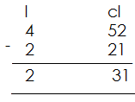 **Subtract:**

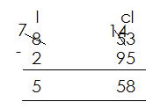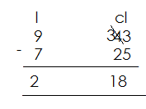**Subtract:** **Subtract:**

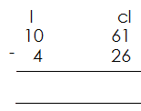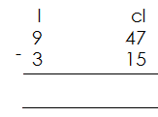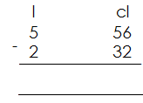**Subtract the following**

1. 5. 9.

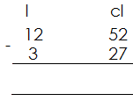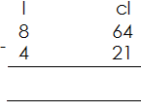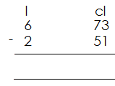

2. 6. 10.

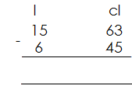

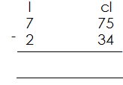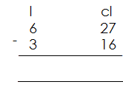3. 7. 11.

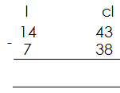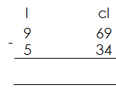

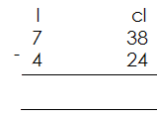 8. 12.

4.

**WORD PROBLEMS ON SUBTRACTION OF CAPACITY**

**Examples**

There were 82 litres of water in the pot. Mother used 20 litres when cooking. How much water was left in the pot?

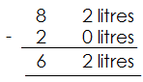**Solution**

There were 15l 82cl of water in the drum 5l 20 c were given to animals to drink. How many litres remained?

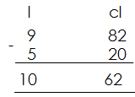**Solution**

**Activity**

1. Sarah bought 84litres of soda for her visitors. He served 62 litres of soda. How much soda was left?

2. Musa filled his car with 92 litres of petro. If he used 74 litres of petrol, how much petrol was left?

3. There were 165litres of water in the drum. 55 litres were given to animals. How many litres remained?

4. A shopkeeper had 565 litres of paraffin. 498 litres were sold. How much paraffin was left?

5. Mr. Nsimbi collected 52 l 63 cl of milk from his farm. He sold 40l 25cl. how much milk did he remain with?

6. Takeaway 39l 85cl from 128l 21cl of water.

7. A bus uses 64l 20cl of diesel. How much diesel was left if it had 89l 33cl?

8. There were 19l 62cl of water in the tank and 8l 86cl of water were used. How many litres remained?

**MASS**

Mass is the quantity of matter contained in an object.

Mass is how light or heavy an object is.

The basic unit of mass is gram(s).

**Common things that are measured**

Sugar beans maize flour soya beans etc.

**Things used to measure mass**

Weighing scale weighing balance spring balance cups

**Weighing things in class**

The teacher should help learners in weighing different things practically.

**Comparing weight using heavier or lighter**

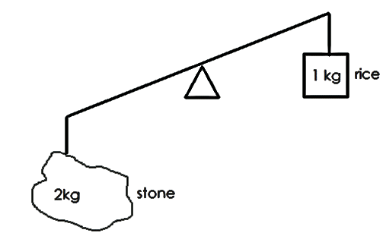 **Example 1**

**Use heavier of lighter**

(a) A stone is **heavier** than rice.

(b) Rice is **lighter** than a stone

(c) What is the weight of the stone?

**2kg**

(d) What is the weight of rice?

**1 kg**

(e) Find their total weight

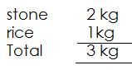 **Solution**

**Activity**

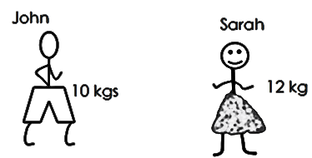1. Use heavier or lighter

(a) What is john’s weight?

(b) What is Sarah’s weight?

(c) John is____________ than Sarah.

(d) Sarah is____________ than john.

(e) Find the sum of their weight.

(f) What is the difference in their weight?

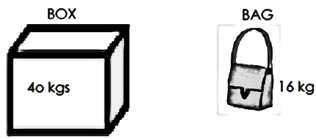2. Use heavier of lighter

(a) A bag is_________________ than a box.

(b) A box is______________ than a bag.

(c) Find the total weight of a box and a bag.

(d) Find the difference in their weight.

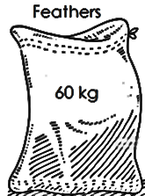3. Use heavier or lighter

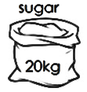

(a) A sack of feathers is___________ than a sack of sugar.

(b) A sack of sugar is____________ than a sack of feather.

(c) What is the weight of sugar?

(d) Find the weight of feathers.

(e) Find the difference in the weight of feathers and sugar.

**CHANGING KILOGRAMS TO GRAMS**

**Note:**

1kg = 1000g

**Examples.**

How many grams are there in 3kg?

**Solution**

1kg = 1000g

3kg = (3x1000) g

=3000g

Change 12 kg to grams

**Solution**

1kg =1000g

12kg = (12 x1000) g

=12000g.

**Activity**

**Change the following kg to g**

1. 4kg

2. 15kg

3. 6kg

4. 18kg

5. 8kg

6. 24kg

7. 16 kg

8. 36 kg

**CHANGING GRAMS TO KILOGRAMS**

**Note:**

1000g=1kg

**Examples**

Change 6000g to kg

**Solution**

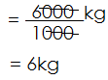 1000g =1kg

6000g

**Example 2**

Change 18000g to kg

**Solution**

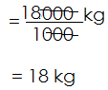 1000g=1kg

18000g

**Activity**

**Change the following grams to kg**

1. 8000g 5. 5000g

2. 16000g 6. 21000g

3. 28000g 7. 46000g

4. 36000g 8. 29000g

**Complete these tables**

|  |  |  |  |  |  |  |
| --- | --- | --- | --- | --- | --- | --- |
| kg | 1 | 2 | 3 | 4 | 5 | 6 |
| g | 1000 | 2000 | ________ | ________ | _______ | _______ |

|  |  |  |  |  |  |  |
| --- | --- | --- | --- | --- | --- | --- |
| g | 1000 | 2000 | 3000 | 4000 | 5000 | 6000 |
| kg | 1 | 2 | ________ | ________ | _______ | _______ |

**ADDITION OF WEIGHT (KG AND G)**

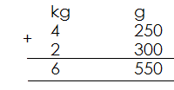**Example 1**

Add:

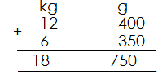 **Example 2**

Add:

**Example 3**

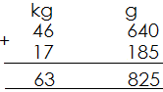 Add:

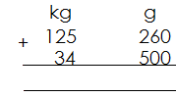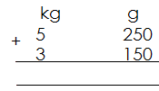 **Activity**

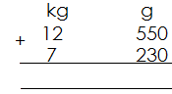

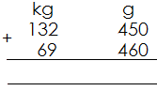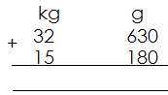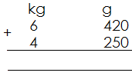

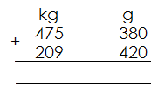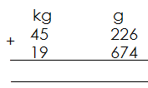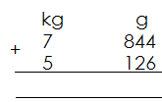

**WORD PROBLEMS ON ADDITION OF WEIGHT**

**Example 1**

Sarah has 4kg 250g of sugar. Her father gives her 3kg 500g. How much sugar does she have now?

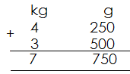**Solution**

Olupot carried 8kg 750g of millet flour. His sister carried 9kg 150g. How much flour did they carry altogether?

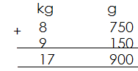**Solution**

**Activity**

1. Nabulime’s bag weighs 5 kg 150g. Her brother’s bag weighs 3kg 250. Find the total weight of the two bags

2. Kato weighs 17kg 280g. His sister weighs 20kg 25g. Find their total weight.

3. Katabula’s luggage weighs 15kkg 250g. What is the weight of the two luggage?

4. Wabwire’s goat weighs 15kg 350g. Nanzala’s goat weighs 16kg 500g. Find the weight of the two goats.

5. A lorry carried 500kg 425 of sand and another 250kg 180g. How much sand did the lorry carry altogether?

6. There were 450kg 250g of salt, 157kg 150 g of rice on the school pickup. Find the total weight on the pickup.

7. The head teacher bought 95kg 580g of maize flour. Her deputy bought 109kg 250 g. how much did they buy altogether?

**SUBTRACTION ON WEIGHT**

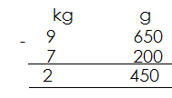 **Example 1**

Subtract:

**Example 2**

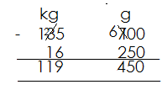Subtract:

**Activity**

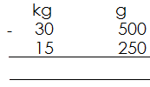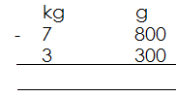 Subtract the following

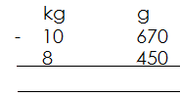1. 5. 2.

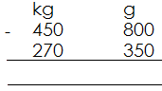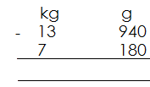

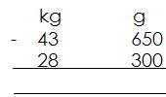 3. 7.

6.

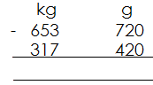

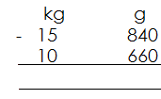 8.

4.

**WORD PROBLEMS ON SUBTRACTION OF WEIGHT**

**Example 1**

**Note:**

**Words related to subtraction include;**

Remain with

Left with

Difference between

Minus

Change /balance

Take away

**Examples**

1. Nagujja had 8kg 500g of beans. She gave 2kg 100g of beans to her grandfather. Find the amount of beans she was left with?

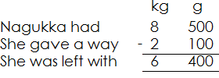 Solution

2. Ludigo had 25 kg 700g of groundnuts. He sold 20kg 250g. What amount of groundnuts did he remain with?

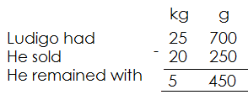 **Solution**

**Activity**

1. Nannono had 5kg 750g of salt. She gave 3kg 250g to her mother. How much salt did she remain with?

2. Ssali had 12kg 500g of tomatoes. He sold 8kg 250g. Find the amount of tomatoes he remained with?

3. Adyeri was given 22kg 900g of millet flour she cooked 15kg 150 g of it. How much millet flour was left?

4. Tumukunde made 33kg 750g of ghee. She sold 19kg 250g. How much ghee remained?

5. Akut had 45kg 500g of simsim. She gave 23kg 170g to her daughter. Find the amount of simsim she was left with?

6. Nansubuga weighs 18kg 700g and her brother weighs 24kg 250g. Find the difference between their weights?

7. What is 18kg 400g of simsim take away 14kg 250g of simsim.

8. Baliddawa had 72kg 800g of sugar in his shop. He sold 58kg 500g. How much sugar was left?

9. Mugagga had 185kg 650g of meat. He sold 129kg 500g of the meat. How much meat was left?

10. Subtract 34kg 250g from 420kg 350g.

11. Kiddu has 12kg 450g of sugar. Kalemera has 21kg 540g.

(a) Who has more sugar?

(b) By how much?

**ALGEBRA**

Algebra is the use of symbols or letters to represent quantity.

**Collecting like terms in addition**

**Examples**

Simplify: 2 pens + 6 pens

**Solution**

= 2pens + 6pens

= 8pens

Workout: 1 book + 6 books + 3 books

**Solution**

= 1 book + 6 books + 3 books

= 10 books

**Activity**

**Simplify the following**

1. 1 pen + 4 pens

2. 6 books + 4 books + 2 books

3. 1 shirt + 6 shirts + 3 shirts

4. 4 pencils + 2 pencils + 7 pencils

5. 3 girls + 2 girls + 1 girl

6. 2 keys + 1 key + 6 keys

7. 8 chairs + 4 chairs + 2 chairs

**Collecting like terms in subtraction**

**Examples**

Simplify: 8 books -3 books

**Solution**

= 8 books - 3 books

= 5 books

Simplify: 10 pens + 2 pens -4 pens

**Solution**

= 10 pens + 2 pens -4pens

= 12 pens -4 pens

= 8 pens

**Activity**

**Simplify the following**

1. 9 books - 3 books

2. 11 shirts - 2 shirts

3. 7 dresses - 4 dresses

4. 18 balls - 15 balls

5. 6 girls + 4 girls - 7 girls

6. 12 boys + 7 boys - 9 boys

7. 4 boxes + 3 boxes - 2 boxes

8. 15 pens + 4pens - 10 pens

9. 16 books + 5 books - 9 books

10. 3 boys + 7 boys - 5 boys

**Using letters for numbers that involve addition and subtraction**

**Examples**

Simplify: y + y + y + y

**Solution**

= y + y + y + y

**= 4y**

Simplify: 4k + 2k +k

**Solution**

= 4k+ 2k+k

**= 7k**

Simplify: 3m + 4m - 2m

**Solution**

3m + 4m - 2m

7m - 2m

**5m**

Simplify: 9w + 6w -3w

**Solution**

= 9w + 6w - 3w

= 15w - 3w

**= 12w**

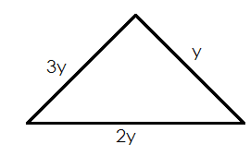 Find the perimeter of the figure

P = s + s + s

= 3y + 2y + y

**= 6y**

**Activity**

**Simplify the following**

1. k + k + k

2. 2y+y +2y

3. m + m + m + m + m

4. 4p+2p+p

5. 2w+3w+6w

6. 4m +6m-3m

7. 5w+ 6w-7w

8. 1ok +5k-8k

9. 15n+6n-9n

10. 12x+ 4x-10x

11. 4x+10x-6x

12. 3m+12m -8m

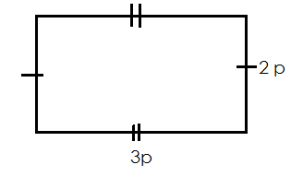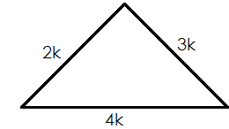13. Find the perimeter of the following

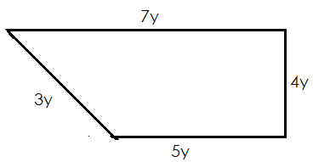

**Using letters for numbers that involve multiplication**

**Examples**

Simplify: 2 x m

**Solution**

2 x m = 2m

Simplify: 6 x 3m

**Solution**

6 x 3m = 18m

Simplify: 4k x 5

**= 20k**

**Activity**

**Simplify the following**

1. 2 x y

2. 9 x 4k

3 5 x 3k

4. 4 x w

5. 7 x 3y

6. 6 x 2m

7. 6xm

8. 4 x 5x

9. 5 x 2w

**SUBSTITUTION**

Substitute means to replace

**Examples**

If p = 3 find the value of p + 6

**Solution**

P + 6 = 3 + 6

= 9

(b) Find 2p = 2 x p

= 2 x 3

**= 6**

(c) Find p

**Solution**

p + p = 3 + 3

6

(d) Find the value of p x p

**Solution**

p x p = 3 x 3

**= 9**

**Example 3**

If y = 6 and k = 4. Find the value of

(a) 2k

**Soln.**

2k = 2 x k

= 2 x 4

= 8

(b) y + k

y + k = 6 + 4

**= 10**

(c) y-k

**Soln.**

Y - k = 6 - 4

 = 2

(d) $\frac{y}{3}$ = $\frac{6}{3}$ = 2 or $\frac{y}{3}$ = 6 $÷$ 3 =2

**Activity**

1. If k=8, find the value of

(a) k + 4 (d) k + k

(b) 2k (e)

2. Given that y=7 find the value of;

(a) y+7 (d)2y + 2

(b) y - 4 (c) 12y

3. If m=10, find the value of

(a) m + m (b) 4m (c) m-6 (d)

4. Given that a=2 and b=6, find the value of;

(a) a + b (b) 2b (c) (e) (f) b-a

5. If p =6 and y =4. Find the value of

(a) p + 4

(b) p + y

(c) 2y

(d) $\frac{p}{2}$

(e) p - y

**FINDING MISSING NUMBERS IN ADDITION**

**Example 1**

Find the missing number

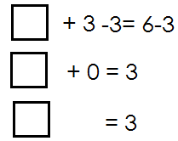 **Solution**

**Example 2**

Find the missing number in

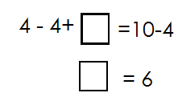**Solution**

**Example 3**

Find the missing numbers in

_____+8=11

____+8-8=11-8

_____=3

3+8=11

**Example 4**

Solve: m + 4 = 10

M + 4 – 4 = 10 - 4

M = 6

**Activity.**

Find the missing numbers in the following



1. 6.



2. 7.



3. 8.



4.



5.

**Activity.**

**Solve the following**

1. 9+4=6

2. Y + 10 = 16

3. m +6=8

4. X + 3 = 10

5. p +7 =15

6. Y + 8 = 12

**Word problems involving finding missing numbers in addition**

**Example 1**

1. Musa had 15 cows, Kapere gave him more cows. He now has 18 cows. How many cows did Kapere give him?

**Solution**

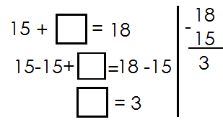 If Kapere gave him _____cows

2. There were 20 animals on the farm. Okello added on more to make a total of 20 animals. How many animals were added?

**Solution**

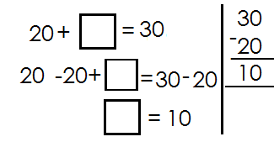 If _____more animals were added

**Activity**

1. Nakitto had some books. She was given 12 more, now she has 20 books. How many books had Nakitto at first?

2. Akello had some goats. Her mother gave her 4 more goats and she now has 10 goats. How many goats did she have at first?

3. There were 32 pupils in class more pupils joined and now the class has 46 pupils. How many pupils joined the class?

4. James had 15 mangoes. His sister gave him more mangoes, he now has 20 mangoes. How many mangoes did his sister give him?

5. Martin had some eggs, and his mother gave him 8 more eggs. if he now has 12 eggs, how many eggs did he have at first?

**Finding missing numbers in subtraction**

 **Examples**

Fill in the missing number.

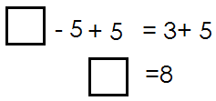 **Solution**

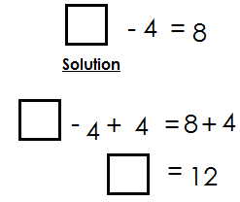Find the missing number

Solve: k-12=3

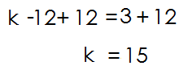**Solution**

Solve: y-6=19

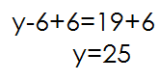**Solution**

**Activity**

1. Find the missing numbers in the following.

1. 6.

2. 7.

3. 8.

4. 9.

5. 10.

**2. Solve the following**

1. p – 2 = 4 4. k – 10 = 2

2. y – 4 = 6 5. n – 2 = 7

3. m – 7 = 4 6. w – 10 = 16

**Word problems involving finding missing numbers in subtraction**

**Example 1**

Jane had some pens, he gave away 4 pens and remained with 6 pens. How many pens did he have at first?

**Solution**

 If he had ____pens

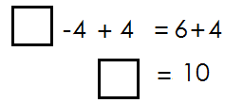

**Example 2**

In a bag, there were some mangoes. When I picked out 4 mangoes, 26 remained. How many mangoes were in the bag?

 **Solution**

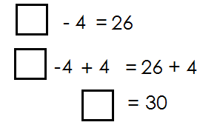 If there were mangoes

**Activity**

1. James had some eggs, he sold off 7 eggs and he remained with 13. How many eggs did he have?

2. There was passenger on the bus, 25 got off and 12 remained. How many passengers were on the bus?

3. Mum had a basket of oranges. She gave out 12 oranges from the basket and 18 remained. How many oranges were in the basket?

4. Mark had some books. He gave away 12 books and remained with 48 books. How many books had he before?

5. Aguti had some kilograms of rice. She sold 27kg and remained with 23kg. How many kilograms had she before?

**Finding missing numbers in multiplication**

**Examples**

 Find the missing number

 **Solution**

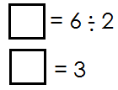

Find the missing number

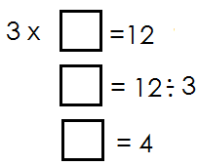**Solution**

**Activity**

Find the missing numbers

1. 6.



2. 7.



3. 8.



4. 9.



5. 10.



11. 12.

**Word problems involving finding missing numbers in multiplication**

**Examples**

When a number is multiplied by 4 the answer is 12 what is the numbers?

**Solution**

 When ____ is multiplied by 4 =12

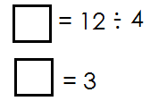

Find a number that when multiplied by 6 the answer is 48

**Solution**

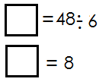

**Activity**

1. Find a number that when multiplied by 4 the answer is 28.

2. Which number can be multiplied by 5 to give 20 as the answer?

3. When 6 is multiplied by a number the answer is 24. Find the number.

4. After multiplying a number by 3 the answer is 36. Find the number

5. When 8 is multiplied by a number the answer is 32. Find the number.

**Finding the missing numbers in division**

**NOTE**:

If the box or unknown is in the middle, divide the bigger number by the small number and if the box is at the beginning, multiply the given numbers.

**Example 1**

 Find the missing number in

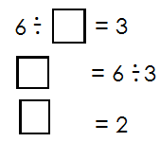 **Solution**

 Find the missing number

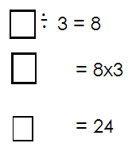

**Activity**

Find the missing numbers in the following

1. 11.



2. 12.



3. 13.



4. 14.



5.



6.



7.



8.



9.



10.

**Word problems involving finding missing numbers in division**

**Examples**

Opio had some mangoes, he divided them equally between 2 girls each getting4 mangoes. How many mangoes did Opio have?

**Solution**

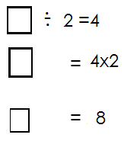 If Opio had _____mangoes

Therefore, Opio had 8 mangoes.

Find the number of boys who can share 12 mangoes equally and each gets 3 mangoes.

**Solution**

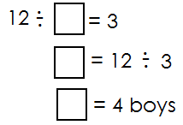If number of number boys is ____

**Activity**

1. Betty had some oranges, she shared them equally between 2 children. Each child got 6 oranges. How many oranges had she before?

2. A boy had some pancakes. She shared them equally between 2 friends each getting 12 pancakes. How many pancakes did he have?

3. Kato had some sweets. He shared them equally among 3 children and each child got 5 sweets. How many sweets had he before?

4. Alex had some pencils. He shared them equally among 3 pupils and each got 9 pencils. How many pencils had he before?

5. Find the number of girls that can share 15 sweets equally each getting 5 sweets.

6. How many people can share 24 mangoes equally for each to get 3 mangoes?

7. Find the number of boys that shared 36 oranges and each got 9 oranges.

***CORRECTIONS AND FINDINGS***

|  |  |
| --- | --- |
| ***CONTENT*** | ***PAGE*** |
|  |  |
|  |  |
|  |  |
|  |  |
|  |  |
|  |  |
|  |  |
|  |  |
|  |  |
|  |  |
|  |  |
|  |  |
|  |  |
|  |  |
|  |  |
|  |  |
|  |  |
|  |  |
|  |  |
|  |  |
|  |  |
|  |  |
|  |  |
|  |  |
|  |  |
|  |  |
|  |  |
|  |  |